Motorcycle Jump  TI-Nspire™ CX Family | Time required  30 minutes

Activity Overview
This activity presents a scenario in which a motorcycle rider jumps off a ramp and travels along a quadratic path through the air. In Problem 1, students use a graphical model to explore the effect of setting the ramp at different angles to discover that the relationship between the angle of the ramp and the horizontal distance of the jump can also be described by a quadratic function. Students use this function to find the angle that maximizes the horizontal distance of the jump. In Problem 2, students build their own model relating the angle of the ramp and the airtime of the jump, and then they use a similar process to discover that the airtime of the jump increases without bound as the angle of the ramp approaches 90°. Finally, they use their results to make recommendations for the rider.

Topic: Quadratic Functions & Equations
- Approximate the real zeros, vertex and extrema of a quadratic function graphically.
- Calculate the maximum and minimum value of a quadratic function.
- Use a quadratic function to model data.

Teacher Preparation and Notes
- This activity is designed to be used in an Algebra 2 or Precalculus classroom. Suggestions are given for more advanced students to explore the model in more depth. This activity could also be modified and used with Calculus students.
- Prior to beginning this activity, students should have been introduced to quadratic equations and their graphs.
- Notes for using the TI-Nspire™ Navigator™ System are included throughout the activity. The use of the Navigator System is not necessary for completion of this activity.

Associated Materials
- MotrocycleJump_Student
- MotorcycleJump.tns
- MotorcycleJump_Soln.tns

Problem 1 – Maximizing Horizontal Distance
In this problem, students use a model of the motorcycle jump to find the angle of the ramp that maximizes the (horizontal) length of the jump.  Pages 1.2 through 1.4 describe the scenario and model, which allows students to view the path taken by the rider for different values of θ (theta), the angle that the ramp makes with the ground (assuming all other variables, such as speed, stay constant).  On page 1.5, students should click the slider to set the value for theta. | 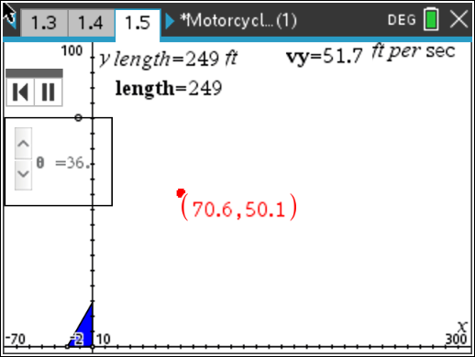
(Note: Due to window settings, the angle of the ramp may not appear to be to scale.)
Pressing play begins an animation that displays the path of the rider. The length of the jump is shown at the top of the screen.  Allow students time to experiment with the model for different values of θ. They should observe that as θ increases from 0° to 90°, the length of the jump first increases and then decreases.  Challenge students to use the model to approximate the value of θ that yields the jump with the longest length, and have them answer the questions on pages 1.6 and 1.7. | 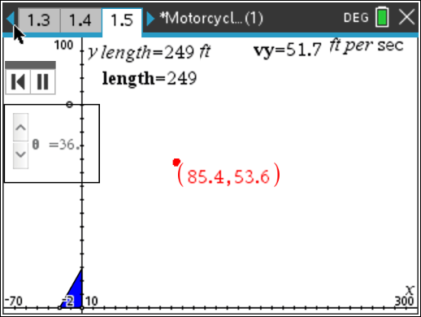  /
TI-Nspire Navigator Opportunity: Live Presenter and Class Capture
See Note 1 at the end of this lesson.
Students should return to page 1.5 and capture 20 different data points by adjusting the θ slider and pressing / + ^.  Note: Caution students not to capture the θ  -value of 90°. Doing so yields an undefined length that prevents the regression from being performed later in the activity.  Further Note: There are already three data elements in the spreadsheet so that no error balloons appear as a quadratic regression,  needed for later, is occurring in the background. | 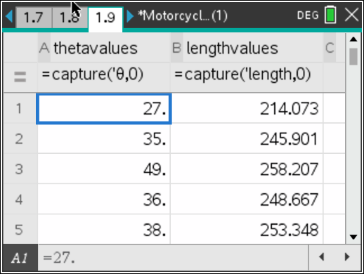

After gathering the points and confirming that they are stored on page 1.9, students should advance to page 1.11 and observe the data in a scatter plot.  Discuss the shape of the points as a class. The shape of this graph is similar to the model of the jump, so be sure to review what each axis represents and what is shown here.  Ask: Where is the length of the jump the greatest? The least? Is there a maximum point? | 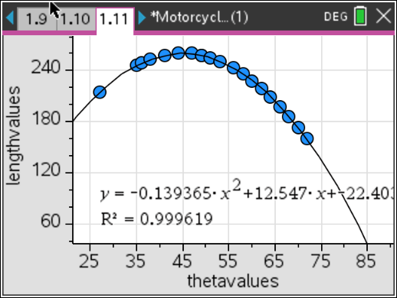
Have students answer the question on page 1.12 and then return to page 1.11 to perform a quadratic regression on the graphed data by pressing MENU > Analyze > Regression > Show Quadratic.
Note: the regression equation will be stored in f2(x) and is of the form ax² + bx + c.
TI-Nspire Navigator Opportunity: Class Capture
See Note 2 at the end of this lesson.
Discuss with students how to use the formula obtained from the regression to find the angle that maximizes the length of the jump.  Ask: Where on the parabola does the maximum occur? How can you identify the coordinates of this point?  Encourage students to determine that the  x-coordinate of the vertex may be found using  the formula x =− b and that the y-coordinate  2a  may then be found by substituting the x- coordinate into the regression equation, f2. One quick way to perform this calculation is shown, but students could also find the coordinates  with pencil and paper. | 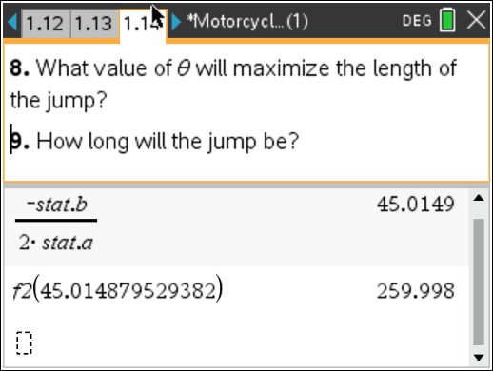

Student .tns File Solutions
- Sample Answer: The distance and height of the rider changes when the angle changes.
- The “best” value of θ should be close to 45°.
- The horizontal axis represents horizontal distance in feet, and the vertical axis represents vertical distance in feet. The model is effectively a picture of the jump.
- The model is not completely realistic because it would not be possible to ride up a perfectly vertical (or near vertical) ramp (when θ = 90°).
- The independent variable is θ, and the dependent variable is length. The length of the jump is determined by θ.
- The scatter plot is in the shape of a curve that opens downward.
- There is an angle that maximizes the length of the jump, because the graph of angle vs. length has maximum point.
- Answers will vary, but should be close to 45°
- Answers will vary, but should be close to 260 feet.
- The rider should set up the ramp at a 45° angle.
Problem 2 – Maximizing Airtime
In this problem, students use the same process they used in Problem 1 with a quite different result.  This time, though, the students are challenged to build the model themselves. This step is simplified greatly by the fact that the variables vy and h, which depend on θ, are already stored in memory.  You might wish to have advanced students write the more complicated equation in terms of θ instead of vy and h, using the definitions of horizontal and vertical velocity, as discussed  earlier. | 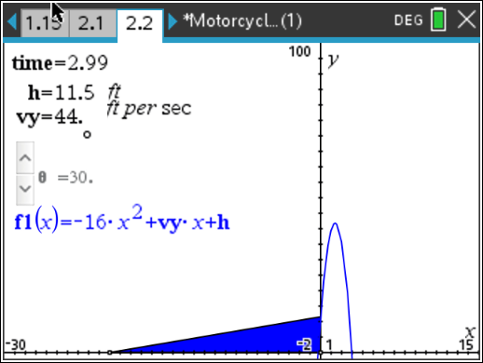

Have students graph their model on page 2.2 by clicking on the f1(x) text and entering their model. Have students answer the questions on page 2.3. The ramp provides a control of error. Their function should intersect the y-axis at the same point as the ramp.  After checking that their models are correct, allow students some time to experiment with different values of θ. Discuss the results as a class.  Students should notice that as θ approaches 90°,  the longer the time of the jump, but that when  θ = 90º, the airtime is undefined. | 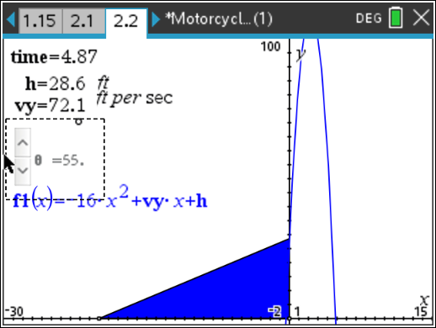
TI-Nspire Navigator Opportunity: Class Capture
See Note 3 at the end of this lesson.
In the spreadsheet on page 2.4, have students repeat the process of capturing data values for θ and time, again avoiding θ = 90° and displaying the data a scatter plot on page 2.6.  Discuss the shape of the scatter plot with the class. They should determine that this curve increases to infinity and thus does not have a maximum point. | 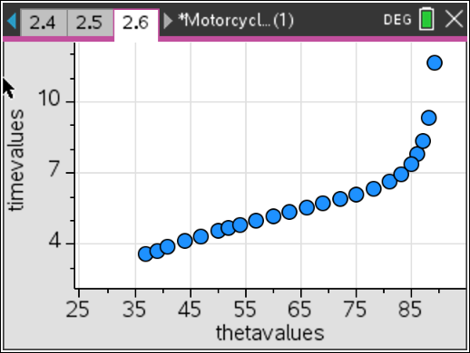
Student .tns File Solutions
f1(x) = −16x2 + vy ⋅ x + h or f1(x) = −16x2 + (88 cos θ ) ⋅ x + (20 tan θ )
- The horizontal axis represents time in seconds and the vertical axis represents vertical distance of height in feet. (So in this case, x is really t.)
- As the value of θ increases, the height of the graph increases.
- There is no value of θ that maximizes airtime because the graph of angle versus airtime does not have a maximum.
- The rider should set the ramp as close to 90° as possible such that she can still (and safely) ride up it at 60 mph.

TI-Nspire Navigator Opportunities

Note 1
Question 1, Live Presenter and Screen Capture
Use Live Presenter to demonstrate to students how this page works (pressing play, the red moving dot is the motorcycle jumper, automatic updating of variables, etc.). Use Class Capture to monitor student progress on determining the θ-value that maximizes the jump length.

Note 2
Question 1, Class Capture and Quick Poll
Prior to discussing the graph, send the students a quick poll asking for the ramp angle that results in a maximum jump length. Use Class Capture to display student works and to facilitate discussion on finding the correct angle for the ramp to maximize the jump length

Note 3
Problem 7, Class Capture
Use a quick poll asking students for the maximum jump time in the air. After displaying the responses, use Class Capture to display the scatter plot and begin discussing how the graph helps us answer this question. Pay particular attention to the shape of the graph and how it goes to infinity as the ramp angle gets closer to 90º.

