GEOMETRY AT ITS BEST

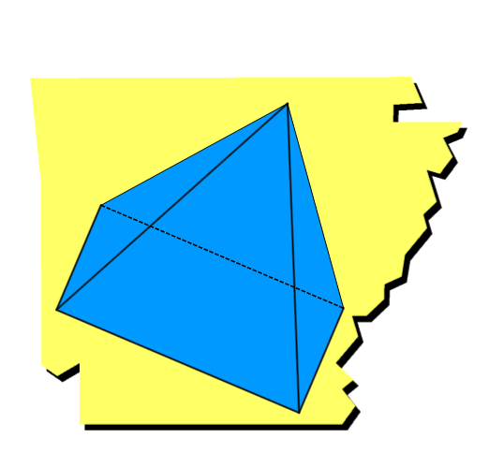

“The Tale of Two Tangents”

Created by Michelle Bonds

Table of Contents:
Introduction | 3
Activity Begins | 4

This activity allows students to investigate the relationship between the angle formed by two tangents to a circle and the arcs they intercept.

Not responsible for misspelled words, mathematical mistakes, or anything else you might not like.

 | Create a point in a new Geometry page | 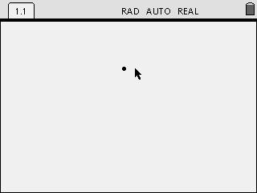
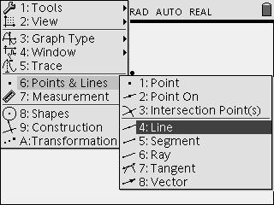 | Create a line through the point. | 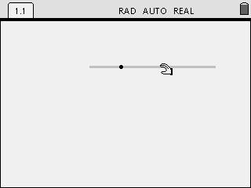
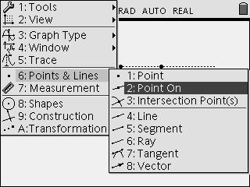 | Create a point on the line. | 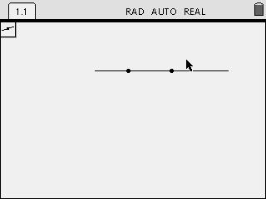
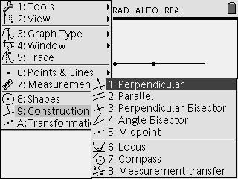 | Create a perpendicular line through the point. | 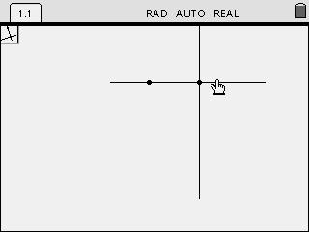

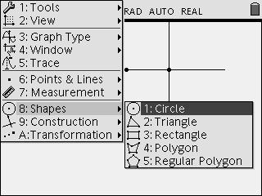 | Create a circle using the two points. | 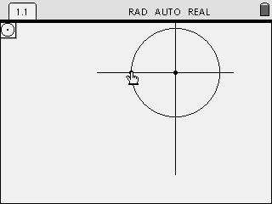
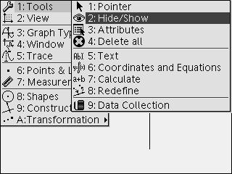 | Hide the two lines. | 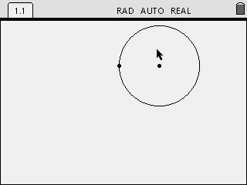
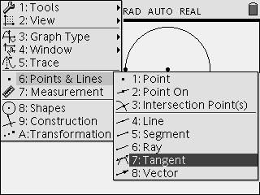 | Create two separate tangent lines to the circle. | 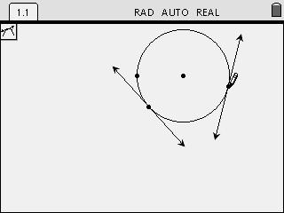
 | Extend the two tangent lines until they intersect. | 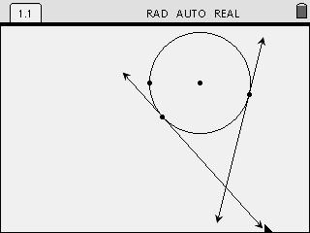

 | Hide the original point that is on the circle. | 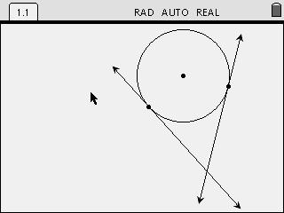
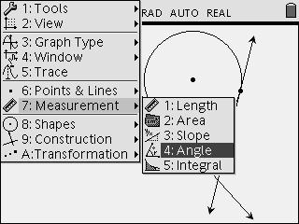 | Measure the minor arc by measuring the central angle and place the measure close to the arc. | 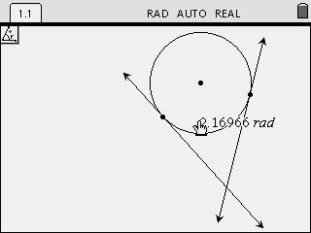
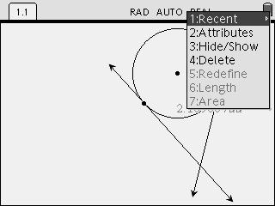 | Change the accuracy to tenths place by clicking on the measure and pressing /b2. Then use the ¡ and ¢ to adjust the number of decimal places. | 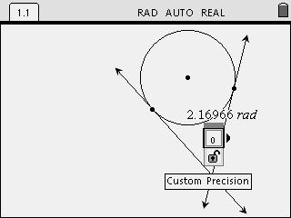
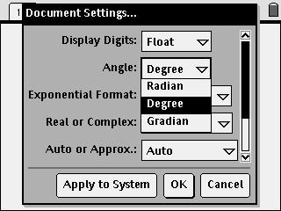 | Change the document settings from radians to degrees by pressing c then clicking on System Info. | 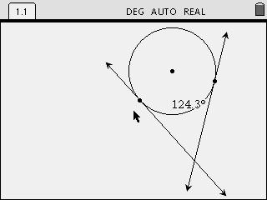

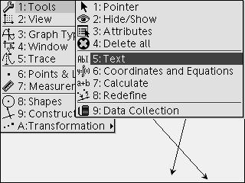 | Create the text 360-a. Place the text in the upper left corner of the screen. | 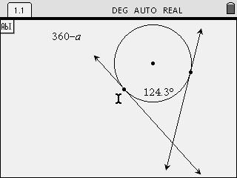
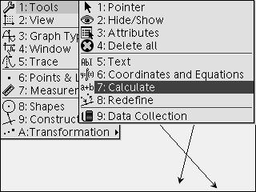 | Calculate the measure of the major arc by using b7. Next click the text then the measure of the minor arc for variable a. Place the new measurement at the top of the circle for the major arc. | 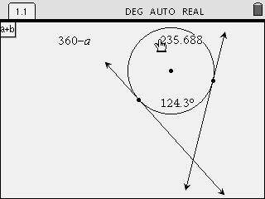
 | Change the accuracy to the tenths place. | 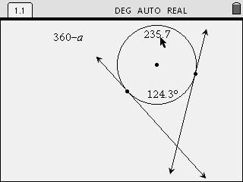
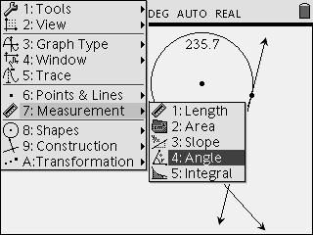 | Measure the angle formed by the two tangents, and place the measurement next to the angle. | 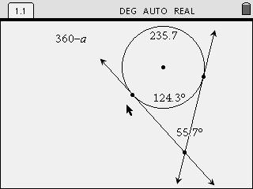

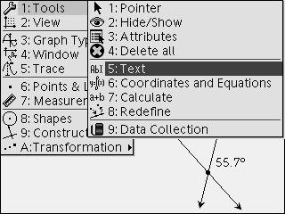 | Create the text ½(b-a) and place it to the left of the screen. | 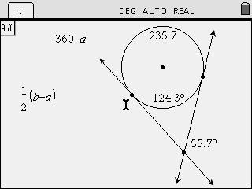
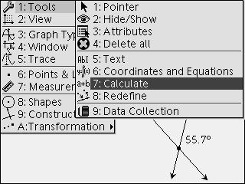 | Evaluate the expression by using the Calculate function. Click on the text. | 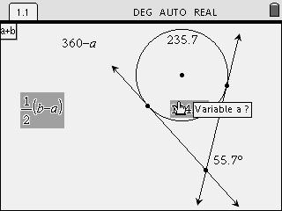
 | Click on the minor arc measure again as a and the major arc measure as b. | 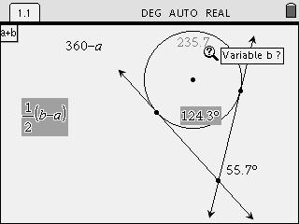
 | Place the calculation next to the text. | 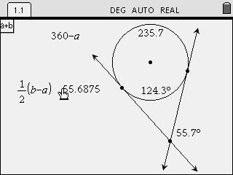

 | Change the accuracy of the calculation to the tenths place.  What do you notice about the calculation and the measure of the angle formed by the tangents? | 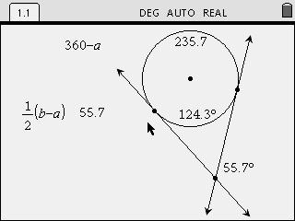
 | Move either of the tangent points along the circle.  What happens to the measure? Does the expression and the angle measure always stay the same? | 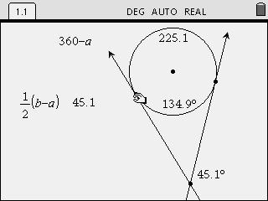

Notes:

