Beebopper Shoe Store Michele Burke
Teacher Directions Woodland Park High School
e-mail: mburke@wpsdk12.org
website: wpsdk12.org/~mburke
Purpose:

Although the main emphasis of this activity is Data Collection and Analysis, I find this is a great introduction to using graphing calculators list and scatter plots in Algebra 1 classes. This activity was adapted for use with either a TI-84 viewscreen or the TI Smartview calculator emulator software. I have also included directions for adapting this activity to the TI Navigator system.

In this activity, the students will investigate the relationship between people’s height and their shoe size. The students will use the information collected to make decisions on how to efficiently stock the Beebopper Shoe Store. They will be asked to justify their reasoning with information gathered from the data list and graph. Students will differentiate between two sets of data represented on one graph. They will use the graph to investigate the “old woman’s” conjecture and make predictions about the relationship between shoe sizes and heights.
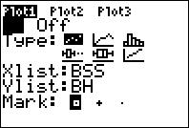
A little preparation before this activity makes it go smoothly. It is a good idea to have the list named and the Stat plot information already entered before starting the activity.

Pre-Activity Preparations using a TI-84 viewscreen or the TI Smartview software:

1) Clear all list and the Y= screen. To clear the list: ` ´ , 4: ClrAllLists.

- Create 4 list to contain student data:
  - BSS Boys Shoe Size
  - BH Boys Height
  - GSS Girls Shoe Size
  - GH Girls Height
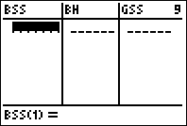
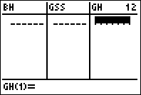

* You may use four of the already named list (L1-L6), but I have found that using the labeled list reduces data entry errors by the students.

** Instructions for creating list names and contents are found on pages 284-289 of the TI-84 manual.
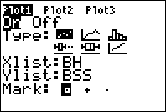
- Set up Stat Plot information:
  - Plot 1 – contains Boys data

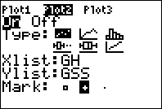
  - Plot 2 – contains Girls data

* Instructions for creating Stat Plots are found on pages 322-325 of the TI-84 manual.

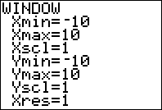
- Have the graph set up to the standard window.

Pre-Activity Preparations using the TI Navigator system:

1) Before starting make sure all previous data is cleared from the activity center. Select the Edit dropdown and Clear Activity Data

2) You will be collecting the students data using a form. In the activity center you
will need to select: form from the Contribute: dropdown. It is a good idea to
have the form configured and ready to go before the students start the activity.

3) Next you will Configure the form.

Main Settings: Number of Pages 1
Number if inputs per page 4

Input name Destination list name
Boy Shoe Size L1
Boy Ht (in) L2
Girl Shoe Size L3
Girl Ht (in) L4

Students Submit Data: All at once

4) When you are done with the configurations, click OK.

5) Select the List-Graph view. Choose Configure Plots. The dropdown should
show: Data Set 1: (L1,L2,L3,L4). Choose 2 different plot types to represent the Boys and Girls data. For the Boys data the X-List is L2 and the Y-List is L1. For the Girls data the X-List is L4 and the Y-List is L3. Make sure the Graph window is set to the standard view.

6) Start with the List view in the activity center so you can see all 4 lists as they come in.

7) Have the students log into Navigator and go to the activity center. You can start the activity when you are ready. The form will be sent to the students, ready to fill out. Each cell must contain a value so have the students enter 0 in the cells that do not apply to them. Make sure that the students are entering their height in inches. When the students are ready they can send their data. The data will show up in the list. Once all of the students have sent their data switch to the List-Graph view.

During the Activity:

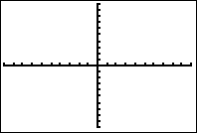
- When you show the graph of the data the graph
will be empty. This can lead to a great discussion
about what the tick marks mean and the need for
correct scaling of the x & y axis in order to
observe the data collected. Have the students
determine what the correct window information
should be and make the corrections.

- Once you have the graph window set up so that all of the collected data is
represented the students may begin to work on the worksheet questions.

  - If you are using a viewscreen make sure to go back and forth between the list and graph in order for the students to make the connections between the data and graph.

  - If you are using the TI-Smartview software, set the View³ to show the Stat Plot, List, and Graph screens. This is done using the View³ Options found in the View tool bar.

c. If you are using the Navigator system you can choose to send the complete list
back to the students. Stop the activity and configure lists for Existing activity
lists. Restart the activity and the students will receive the new list.

After the Activity:

- This data can also be used as an extension to investigate correlations, discrete vs.
continuous relationships and linear regressions.

