Open the TI-Nspire document Chi-Square_Tests.tns.  In this activity, you will look at a problem situation that involves categorical data and will determine which is the appropriate chi-square test to use: the chi-squared goodness of fit or the chi-squared two-way test. | 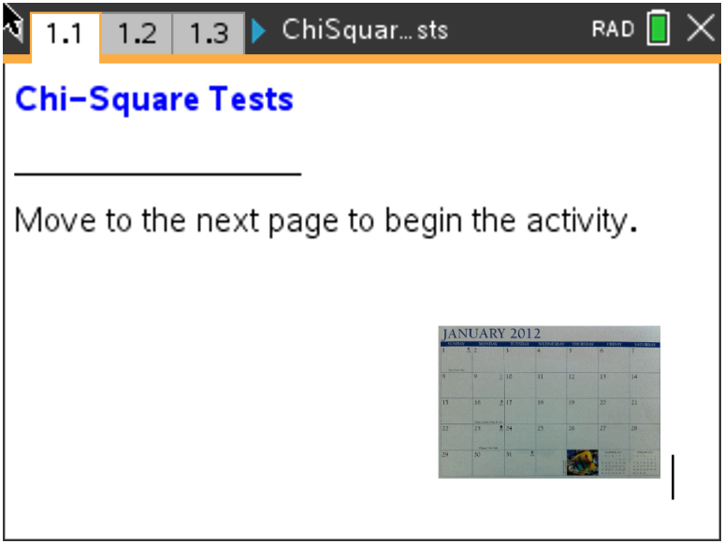

Three different chi-squared tests will be discussed in this activity:
- χ² Goodness-of-Fit (1): Compares sample counts (sometimes given as proportions) to expected counts based on a given population distribution.
- χ² Two-way tables (2 & 3): There are two chi-squared tests using two-way tables—independence and homogeneity. The two tests differ in their hypotheses and conclusions but are mechanically identical. Determining which to use depends on how the data were collected.
- Test of Independence: Compares two categorical variables in a single population to determine whether there is a significant association between the two variables.
- Test of homogeneity: Compares categorical variables from two or more different populations to determine whether proportions are the same across different populations.

1. a. Suppose that in a typical week the number of absences from a large high school was 805.
State about how many you would expect per day. Explain your reasoning.

b. The school wants to see whether student absences are the same on different days of a randomly selected week of school. State the type of hypothesis test that should be used. Explain your answer.

c. Write the null and alternative hypotheses for this test.

Move to page 1.2.

2. The left side of Page 1.2 shows the average number of observed absences per day of the week in the column A. Column B is the expected number of absences if the null hypothesis were true.
a. Explain how the observed number of absences compares to your conjecture in question 1a.
b. Describe how the expected number of absences are calculated, and state what they represent. Fill in the table with the values you found.

Day of  week | Observed  absences | Expected  absences
Monday | 173
Tuesday | 157
Wednesday | 138
Thursday | 149
Friday | 188
Total:

c. State the conditions for this test. State if the conditions are met.

d. The chi-square statistic is dependent on the degrees of freedom. The number of degrees of freedom for a χ² Goodness of Fit test is found using the number of categories minus one. State the degrees of freedom that should be used in this situation.

3. The chi-square test statistic and the associated p-value appear on the right side of the page with the graph of the chi-square distribution
a. Describe the graph.

b. Describe why the chi-squared is always a positive value.

c. State the area of the shaded region. Explain your answer in the context of the problem.

d. Make a decision to reject or fail to reject your null hypothesis using an alpha value of 0.01. Write your conclusion in context.

Move to page 1.3.

4. An advertiser for television shows suspected males and females had different television viewing preferences. The company commissioned a survey of 100 males and 120 females asking their preferences among crime, reality and comedy formats.
a. Describe why the advertiser would care about such a difference.

b. State the type of hypothesis test the advertiser should use to analyze the results. Explain your answer.

c. Write the null and alternative hypotheses for this test.

5. a. The table below shows the survey results. Scroll down on Page 3.1 to find the expected counts calculated by the TI-Nspire. Fill in the totals of the first table and the expected values of the second table.

Program Format | Males from survey | Females from  survey | Totals
Crime | 29 | 49
Reality | 31 | 45
Comedy | 40 | 26
Totals

Program Format | Males expected | Females expected | Totals
Crime
Reality
Comedy
Totals

b. Describe how you think the expected count for Males—Crime was calculated. Explain why this makes sense.

c. Explain what is meant by the expected count for the cell Males—Crime.

d. State the conditions for this hypothesis test and state if the conditions are met. Explain your answer.

e. State if it appears from the results of the survey that there is a difference in the viewing preferences of men and women. Explain your reasoning.

f. The degrees of freedom for a χ² two-way table is found using (# rows – 1)(# columns –1). State the number of degrees of freedom for this test.

6. a. Interpret the results given on Page 1.3 for the χ² test.

b. Make a decision to reject or fail to reject your null hypothesis using an alpha value of 0.05. Explain your reasoning.

c. Write your conclusion in the context of the problem.
Wrap-Up/Assessment

The following questions can be used as part of the lesson as a self-check for students or can be used as an assessment to determine how well students understand the concepts.

1. Choose the appropriate chi-squared test for each situation and explain your choice:

a. A school wants to compare how its students did on the AP Statistics exam this year compared to the
national scores.

b. A restaurant samples customers to determine if there is a relationship between customer age and
satisfaction with the restaurant’s service.

c. A consumer safety organization wants to see if there is a difference in seat belt use in Los Angeles,
California; Miami, Florida; and Dallas, Texas.

d. A survey asked men and women how confident they were, on a scale from 1 to 5, that they could
change a flat tire.

e. The proportion of each color of M&M’s in a bag are compared to the color distribution that the
manufacturer claims to make.

2. Decide whether the following statements are always, sometimes or never true. Explain your reasoning
in each case.

a. The ${}^{2}$ curve is right-tailed.

b. A p-value is the probability of making a correct decision.

c. The number of degrees of freedom is n – 1 for ${}^{2}$tests, where n is the sample size.

