Topic 3: Geometry and Trigonometry | Angles and Arcs of Circles
- The following diagram shows part of a circle with center $O$ and radius 6 cm.  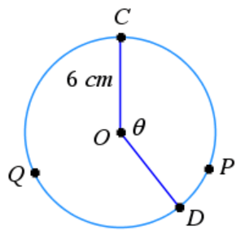  Arc $CPD$ has a length of 7 cm and $C\hat{O}D=θ$.  - Find the value of $θ$, giving your answer in radians.  - Find the area of sector $CODQ$. |  | (2 marks)  (3 marks)
Mark scheme:  - $S=θr$  $$7=θ(6) \\ θ=\frac{7}{6}$$  - $A=\frac{1}{2}θr^{2}$  $$A=\frac{1}{2}{(6)}^{2}\left(2π-\frac{7}{6}\right)$$  $A=18\left(2π-\frac{7}{6}\right)=36π-21$ |  | (M1)  (A1)  (M1)(A1)  (A1)

