Lesson Overview
Modeling is often associated with fitting a formula to data in a way that can be used for prediction. Scatter plots are used to display paired data, and regression is a mathematical tool for finding a function that best fits the plot. However, data come from a contextual situation, and simply “goodness of fit” is not the only measure of the appropriateness of a model. The model should also make sense in the context. That is, we should be able to explain why a particular formula or curve is reasonable in terms of the meaning of the independent and dependent variables in context. | Learning Goals
Students will be able to:
1. Use functions to model relationships between quantities.
2. Summarize, represent, and interpret data on two quantitative variables.
3. Describe qualitatively the functional relationship between two quantities by analyzing a graph.
4. Fit a function to data and use functions fitted to data to solve problems in the context of the data.
About the Lesson and Possible Course Connections:
This activity is appropriate for students with basic knowledge of linear and quadratic functions typically covered in an introductory algebra course. It is not necessary for students to have had experience with linear regression, but the activity affords a natural opportunity to consider regression models. The important point is the consideration of the multiple zeroes in the data values, handling them appropriately with a model, and making sense of them in the context of the problem. In particular, a “split formula” function (whose expression changes for different subintervals of its domain) is an important mathematical concept that should be part of students’ algebraic experiences. Students with a background in statistics might analyze the residuals and/or the sum of the squared residuals to judge the fit of their models.

CCSS Standards

Function Standards:

8.F.B.4
- HSF.LE.A.1
- HSF.LE.A.2
- HSF.LE.B.5

Interpreting Data Standards:
- HSS.ID.B
- HSS.ID.B.6
- HSS.ID.C.7

Mathematical Practice Standards

SMP.4

Lesson Materials
- Compatible TI Technologies:
TI-84 Plus*; TI-84 Plus Silver Edition*; TI-84 Plus C Silver Edition; TI-84 Plus CE
* with the latest operating system (2.55MP) featuring MathPrint TM functionality.
TI-Smartview CE software
- Modeling Mantid Striking_Student.pdf
- Modeling Mantid Striking_Student.doc
- Mantid Striking Data.8xp
- Modeling Mantid Striking_Teacher_84CE.pdf
- Modeling Mantid Striking_Teacher_84CE.doc
Background
There seems to be a relationship between how hungry a praying mantis (also called a “mantid”) is and the distance at which the praying mantis will strike (jump) at prey. Here are some data for 15 mantids presented in GAIMME (Guidelines for Assessment & Instruction in Mathematics Modeling Education) that can be explored to investigate this relationship. Based on these data, can you find a function that predicts the distance a praying mantis will strike based on how much food is in its stomach?
Food in stomach in centigrams (cg) | Striking distance in millimeters (mm)
11 | 65
18 | 52
23 | 44
31 | 42
35 | 34
40 | 23
53 | 23
59 | 8
66 | 4
70 | 0
72 | 0
75 | 0
86 | 0
90 | 0

Teacher Tip: Students should use the .8xp program to send the data to lists. If they enter the data by hand, they may make errors, but it is an option.

Facilitating the Lesson
This problem is a great follow-up to problems where the students have been making use of the regression features of the calculator for curve fitting. It illustrates the limitations of using a “global” curve fit for all the data with all of zero distances present in the table. The decision to split the definition of the function, i.e., choose different curve fits for different subsets of the data is the focus of this problem.

The data lend themselves to some discussion before diving into graphing or analysis. For example, a natural question is “How much food does it take for a praying mantis to feel full? What is your reasoning?”

Introduction:
Present the class with the data – either projected or paper copies. Begin the discussion by asking students:

How much food does it take before a praying mantis is no longer hungry? What is your reasoning?
After the initial discussion of the data, have students enter the data into their calculators either manually or by using the program with the data. See Figure 1. | 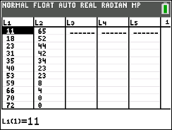  Figure 1 Setting up the data
Set an appropriate graphing window (Figure 2).  (Note: A window of [-10,100] x [-5,80] will include the axes and all the data points.) | 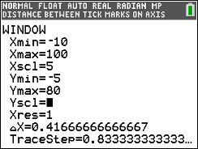  Figure 2 Setting the window
Set up a scatter plot (Figure 3). | 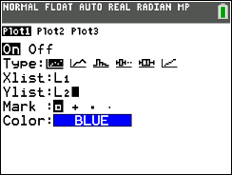  Figure 3 Setting up a scatter plot

Plot a scatter plot of the striking distance versus the amount of food in a mantid’s stomach (Figure 4).  If desired, press trace to trace on the graph. |  |  | 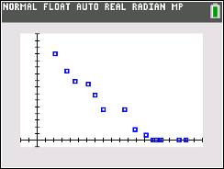  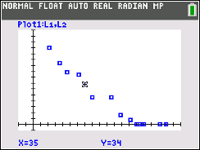  Figure 4 Scatter plot (amount of food in stomach, striking distance)
 | What to Expect: Example Student Solutions
 | Students can create their own line in the graph window by pressing stat > CALC and selecting D:Manual-Fit (Figure 5). | 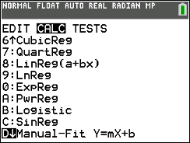  Figure 5 Manual-Fit
 | Use the arrow keys to move on the screen, and select two points that could lie on a line representing the relationship between striking distance and food (Figure 6). | 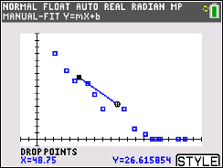  Figure 6 Drawing a Manual-Fit line

Pressing enter displays the equation of the line at the top of the screen with the value for m (the rate of change) highlighted. Selecting enter again displays m at the bottom of the screen (Figure 7) and allows the user to enter a value for the rate of change. | 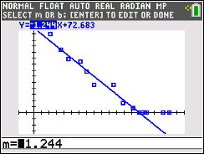  Figure 7 Selecting a rate of change
Pressing the right arrow key will highlight the intercept and allow the user to enter a value for the y-intercept.  Figure 8 shows the graph of the line y = -x + 70. Students might try other values for the slope and y-intercept to see whether the line seems to give a better fit. | 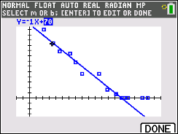  Figure 8 Manual-Fit line y= -1x+70
If students have experience with least squares regression, they can use the linear regression feature to plot the least squares line. Figure 9 shows the result of using the least squares linear regression line compared to the manual-fit line. | 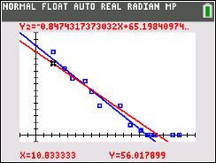  Figure 9 Linear Regression

Teacher Note: To easily graph the regression line, use stat > CALC > LinReg(ax+b) as shown at the right. (Note that LinReg (a+bx) works as well.)  To store the regression equation in yi, press ƒ a, and select yi. This will paste the equation into that function, and the graph of the line will be displayed on the scatter plot when graph is selected. Note that as different regressions are calculated, some of the functions may need to be shut off so they are not all displayed at the same time. | 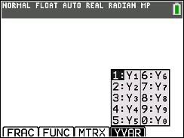  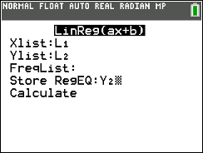
Some students might try to fit a quadratic function visually or by using the regression feature of the calculator. See Figure 10. | 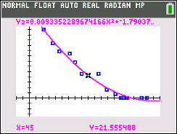  Figure 10 Quadratic Regression
But does a quadratic (or cubic or exponential) function make sense for the situation? The zero striking distances corresponding to values greater than 66 centigrams of food make evident that the praying mantis does not even attempt to strike at food if it is already sufficiently full. The discussion can lead to consideration of a function with a formula that applies only when the mantis is not hungry, with the striking distance being 0 (zero) when it is full. Figure 11 shows an example of such a split formula (piecewise linear/constant) function:  For$0 < x ≤ 69, y=-1.04 x+72;$ for $69 < x ≤ 90, y= 0$. | 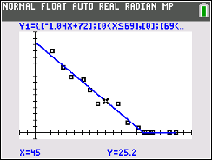  Figure 11 Fitting a split formula (piecewise linear/constant)

Some possible questions to pose to students about this split formula model:
- What does the y-intercept represent in this context?
- Interpret the slope of the line for the interval $0 < x ≤ 69$in this context.
- Interpret the slope of the line for the interval x > 69 in this context.
- When does the mantid feel full? How do you know?
- If a mantid has about 45 centigrams of food in its stomach, about how far would it strike to attack its prey? Explain how you found your answer.
Modeling involves more than fitting curves to (x,y) data points. Thinking about what the data represent in their context is critically important!
Validating the Models
Students should validate their models either by asking whether the models make sense in different scenarios related to the context or by finding other information to reflect against the model. One strategy might be to have each group consider whether the models created by other groups make sense.
- How might you approach achieving a better fit to the data?
- Why is the slope steeper for the equation over the interval 0 < x < 67 than for the regression equation for all of the data?
Extension

A nice data set for which a split formula model makes sense to consider is the “human age equivalence” for dogs, which depends on the size of the dog.
See https://www.akc.org/expert-advice/health/how-to-calculate-dog-years-to-human-years/
Resources
The GAIMME report is available here:
http://www.siam.org/Portals/0/Publications/Reports/gaimme-full_color_for_online_viewing.pdf?ver=2018-03-19-115454-057

