Lesson Overview
This activity uses data on monthly carbon dioxide (CO₂) levels collected from the Mauna Loa Observatory in Hawaii. It provides an opportunity to engage students with data that are relevant to contemporary discussions of climate change. Evident in the data are at least two change patterns: one reflecting cyclic variation across the seasons of the year, and another reflecting an overall general increase in average CO₂ levels for each year. This affords a variety of interesting questions the teacher can pose aimed at sorting out these two patterns. | Learning Goals
Students will be able to:
- Model a contextual situation mathematically and use the model to answer a question
- Summarize numerical data in relation to their context
- Represent and interpret graphical representations of data
- Use functions to model relationships between quantities
About the Lesson and Possible Course Connections:
The activity can be used with middle school students who could plot certain subsets of the data using dot plots or box plots. The activity can be used with high school students comparing multiple box plots of the data across years, analyzing scatter plots, or fitting models to the data.
CCSS Standards

Statistics and Probability Standards:
- 6.SP.B.4
- 6.SP.B.5

Interpreting Data Standards:

S-ID.A, S-ID.B

Function Standards

8.F.B.4

Mathematical Practice Standards

SMP.4
Lesson Materials
- Compatible TI Technologies:
TI-84 Plus*; TI-84 Plus Silver Edition*; TI-84 Plus C Silver Edition; TI-84 Plus CE
* with the latest operating system (2.55MP) featuring MathPrint TM functionality.
TI-Smartview CE software
- Modeling CO2_Levels_Student.doc
- Modeling CO2_Levels _Student.pdf
- Modeling CO2_Levels_Data.8xp
- Modeling CO2_Levels_Teacher Notes.doc
- Modeling CO2_Levels_Teacher Notes.pdf

Background
One aspect of climate change is the level of carbon dioxide (CO₂) in the atmosphere. CO₂ emissions, measured in parts per million (ppm), are largely caused by burning fossil fuels like coal, oil and natural gas. This CO₂ keeps heat that would normally disappear into space, trapped on Earth. This results in an increase in the temperature of the earth.

Scientists compute daily averages from selected hourly values at stations around the world. Daily means are used to calculate weekly and monthly averages. Two independent CO₂ monitoring programs produce a daily CO₂ report at CO₂.Earth using data collected at the Mauna Loa Observatory in Hawaii. The daily averages are based on local time in Hawaii.

As an introduction to the work, students might write a paragraph describing what they see in the graph below of the daily and weekly mean CO₂ levels over a year, including what the different components of the graph mean.

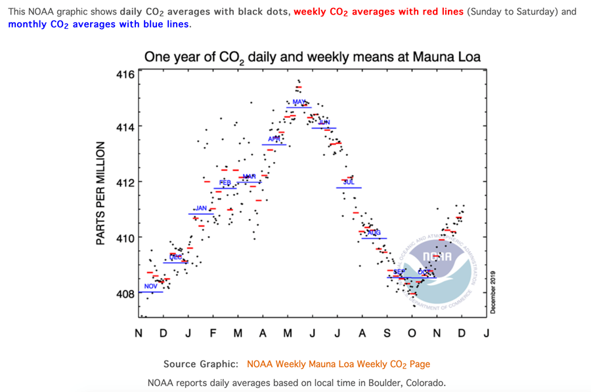
Teacher Tip: Students should run the C02DATA prgram containing the data. This stores the data in named lists. If they enter the data by hand, they are likely to make errors, but it is an option.

Facilitating the Lesson
There are several ways this lesson can be implemented in the classroom:
Introduction: Present the class with the data – either projected or paper copies (See Appendix). Begin the discussion by having each student write down the answers to the following questions.
1. What do you notice?
2. What do you wonder about?
3. Students may note the cyclic pattern to the numbers in each column in contrast to a steady increasing pattern to the numbers in each row of the table. These patterns become much more evident in the graphs students create from the data.
1) Open-Ended Approach:
First, have students think alone for a few minutes and then write down how they would start to answer the question: How is the CO₂ level changing? Depending on the class, they might work individually or in randomly selected pairs.
The goal is to use the data in some way to describe the change, if any, in the CO₂ levels reported at Mauna Loa, Hawaii.
Student Instructions: In your groups,
- Exchange your ideas.
- Decide as a group how you will begin to analyze the data. Give each member of the group a job to do that will help you in the work.
- Decide whether your approach seems reasonable for the data. Explain why you think your model is good. What are the drawbacks, if any, to your model?

2) More-Structured Approach to Finding a Model:
Put students in teams and ask the following questions in a whole group discussion (after teams have had a chance to do some brainstorming):
- What do you notice about the data?
Possible responses:
- Each year the levels seem to be higher in the winter and fall and lower in the summer;
- For most years the level in January is higher than the level from the previous January;
- The pattern seems almost cyclic;
- What do you wonder about?
Possible responses:
- Is the change consistent over the years?
- If we stop burning fossil fuels, will the trend reverse?

- What kind of a graph might help?
Possible responses:
- A plot of the levels per month for each year;
- A dot plot of the mean levels per year;
(Note to teacher: figuring out how to plot such a large amount of data with repeating labels may take some creative thinking.)
4. Can you create a formula(s)?

What to Expect: Example Student Approaches
EX 1: Plotting monthly averages  Plotting the monthly averages for every year (or every other year as in Figure 1) shows the average level of CO₂ in ppm for each month has consistently increased since 2006. The pattern each year is cyclic, increasing from January to May, decreasing from May to September, and then increasing again, and is consistent from year to year. | 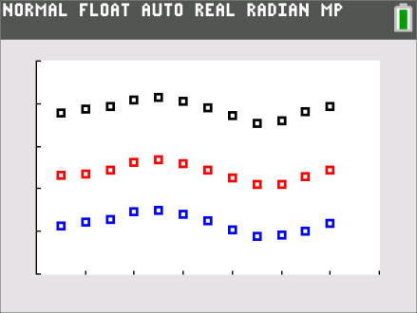  Figure 1. Mauna Loa average CO₂ levels in ppm for '06, '12 and '18 with the blue dots representing data from ’06 up to the black dots representing data from ‘18
EX #2: Plotting Yearly means  Looking at a scatter plot of the mean levels per year (Figure 2) shows a linear pattern with a steady increase per year. The slope of the least squares regression line is 2.26, which indicates that each year the predicted increase in the average level of CO₂ is about 2.26 ppm. However, the residuals have a pattern suggesting that the model over predicts for the earlier and later years and under predicts for the years in the middle. Students may want to try transforming the data and look for other possible models. | 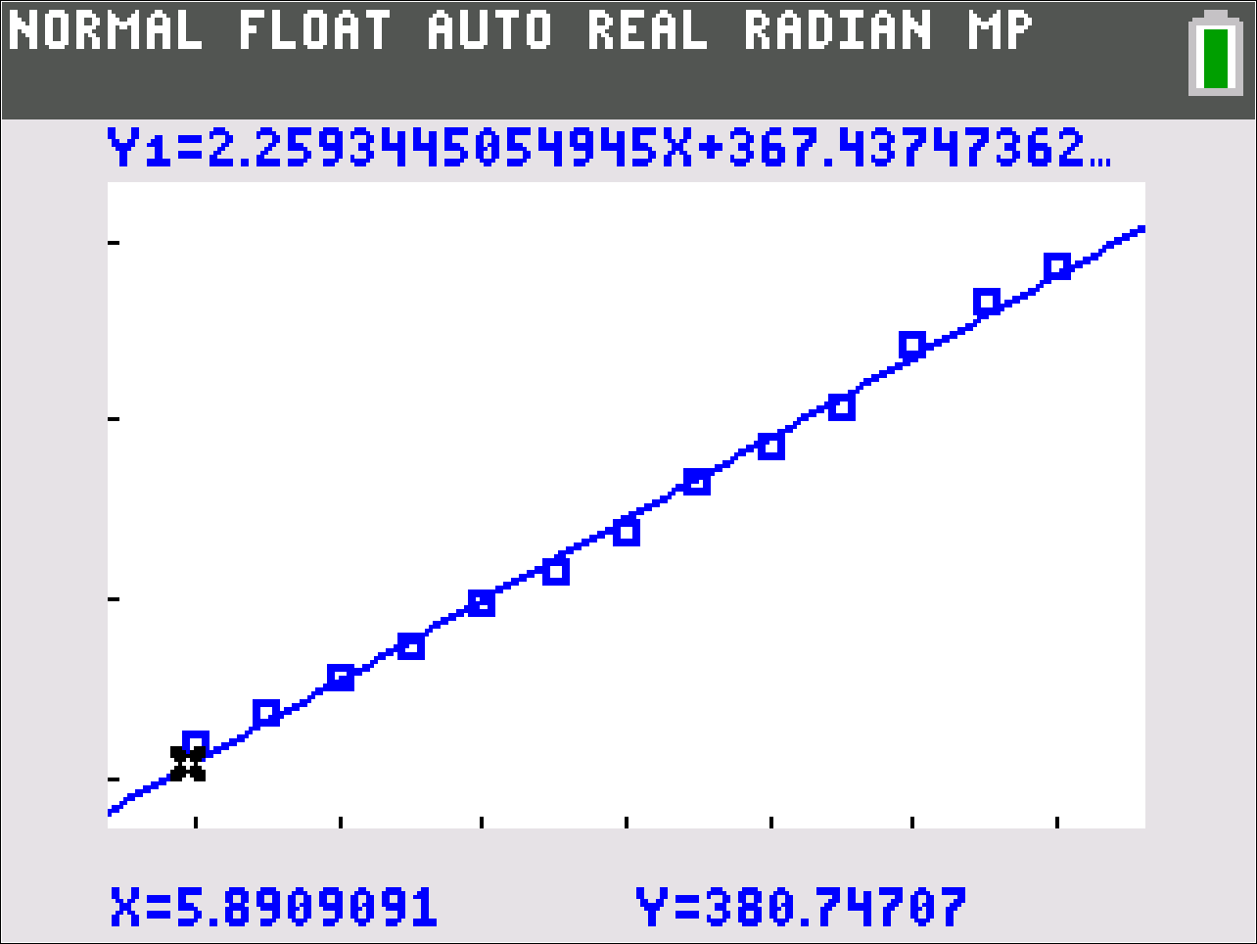  Figure 2. Regression line for mean CO2 levels per year.  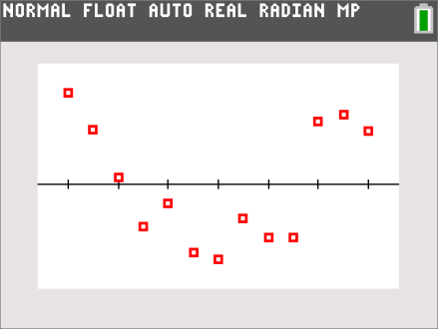  Figure 3 The corresponding residual plot.
EX #3: Exploring Variability  The variability in the data per year shows no pattern in the standard deviations for each year (Figure 4), with the largest variation occurring in 2016 and the smallest in 2008 and 2011. | 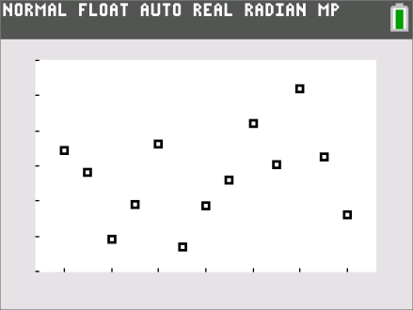  Figure 4. Standard deviation for mean CO₂ levels per month vs. year
The box plots in Figure 5 show about the same interquartile range over the years. The medians of the monthly averages over the years steadily increased. | 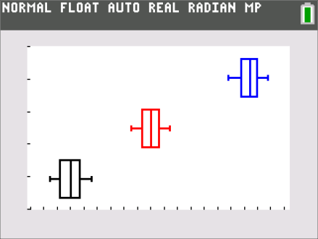  Figure 5. Box plots of average monthly CO₂ levels by year
EX #4: Sinusoidal Regressions  Because the data appear cyclic, fitting a sine curve might be a way to write an equation that captures the relationship between the months each year and the CO₂ levels. Students may note how similar the functions are among the different years with the only significant difference being the constant. For example, note the amplitude, period and phase shift are quite similar, but the constant in '06 is lower (382.04) than the constant in '18 (408.77). | 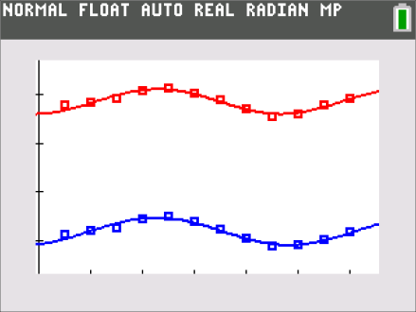  Figure 7. Using a sine function to model CO₂ levels

Validating the Models
Students should validate their models either by asking whether the models make sense in different scenarios related to the context or by finding other information to reflect against the model. One strategy might be to have each group consider whether the models created by other groups make sense.
Some questions are suggested below that might be useful in helping students think about whether their model was reasonable:
- Students might find data from other sites and see if the same trend was apparent (e.g., http://www.exploratorium.edu/sites/default/files/snacks/SouthPoleCO2data.pdf);
- They might look for data from before 2006 to see how that data fit into the pattern.
- They could check their model and thinking against the 2019 data and consider what might have caused any notable changes.
Extension

1. Support or refute each of the newspaper headlines:
a. “CO₂ levels in atmosphere higher than any point since evolution of humans,”
U.S. & WORLD, Tuesday, May 14, 2019 https://abc7chicago.com/science/co2-levels-rise-to-highest-point-since-human-existence-/5300197/
b. “Throughout the last decade, the average rate of increase has been around 2.3 parts per million per year”
Chelsea Harvey, March 13, 2017. Carbon dioxide in the atmosphere is rising at the fastest rate ever recorded https://www.washingtonpost.com/news/energy-environment/wp/2017/03/13/carbon-dioxide-in-the-atmosphere-is-rising-at-the-fastest-rate-ever-recorded/?noredirect=on&utm_term=.054caae660ee
c. “The rate of CO₂ growth over the last decade is 100 to 200 times faster than what the Earth experienced during the transition from the last Ice Age.”
https://e360.yale.edu/digest/co2-levels-continue-to-increase-at-record-rate
2. Explore a data set on the National Centers for Environmental Information National Oceanic and Atmospheric Administration (https://www.ncdc.noaa.gov/data-access/paleoclimatology-data/datasets/ice-core).
Resources
https://www.co2.earth/daily-co2
https://www.popsci.com/record-breaking-co2-graph-climate
https://serc.carleton.edu/eslabs/carbon/3c.html
https://www.climate.gov/news-features/understanding-climate/climate-change-global-temperature-projections

Appendix: Data Set for Lesson
Table 1: shows the monthly average levels of carbon dioxide in ppm measured at Mauna Loa, Hawaii, since 2006.
 | Mean monthly CO₂ levels (ppm)
Month/year | 2006 | 2007 | 2008 | 2009 | 2010 | 2011 | 2012 | 2013
1 | 381.38 | 382.89 | 385.44 | 386.94 | 388.50 | 391.25 | 393.12 | 395.51
2 | 382.19 | 383.90 | 385.73 | 387.42 | 389.94 | 391.82 | 393.60 | 396.79
3 | 382.67 | 384.58 | 385.97 | 388.77 | 391.09 | 392.49 | 394.45 | 397.31
4 | 384.61 | 386.50 | 387.16 | 389.44 | 392.53 | 393.34 | 396.18 | 398.35
5 | 385.03 | 386.56 | 388.50 | 390.19 | 393.04 | 394.21 | 396.78 | 399.76
6 | 384.05 | 386.10 | 387.88 | 389.45 | 392.15 | 393.72 | 395.83 | 398.58
7 | 382.46 | 384.50 | 386.43 | 387.78 | 390.22 | 392.42 | 394.30 | 397.20
8 | 380.41 | 381.99 | 384.15 | 385.92 | 388.26 | 390.19 | 392.41 | 395.15
9 | 378.85 | 380.96 | 383.09 | 384.79 | 386.83 | 389.04 | 391.06 | 393.51
10 | 379.13 | 381.12 | 382.99 | 384.39 | 387.20 | 388.96 | 391.01 | 393.66
11 | 380.15 | 382.45 | 384.13 | 386.00 | 388.65 | 390.24 | 392.81 | 395.11
12 | 381.82 | 383.95 | 385.56 | 387.31 | 389.73 | 391.83 | 394.28 | 396.81
 | 2014 | 2015 | 2016 | 2017 | 2018
1 | 397.80 | 399.96 | 402.52 | 406.13 | 407.88
2 | 397.91 | 400.26 | 404.04 | 406.42 | 408.61
3 | 399.58 | 401.52 | 404.83 | 407.18 | 409.35
4 | 401.29 | 403.26 | 407.42 | 409.00 | 410.80
5 | 401.77 | 403.96 | 407.70 | 409.65 | 411.48
6 | 401.15 | 402.80 | 406.81 | 408.84 | 410.8
7 | 399.00 | 401.30 | 404.39 | 407.07 | 409.05
8 | 397.01 | 398.82 | 402.25 | 405.07 | 407.07
9 | 395.26 | 397.64 | 401.03 | 403.38 | 405.48
10 | 395.93 | 398.29 | 401.57 | 403.64 | 406.00
11 | 397.13 | 400.16 | 403.53 | 405.14 | 407.98
12 | 398.78 | 401.85 | 404.42 | 406.82 | 409.27
Resources
Our Changing Atmosphere www.exploratorium.edu/snacks/our-changing-atmosphere https://www.exploratorium.edu/snacks/our-changing-atmosphere

