One of the many ways in which you can think of a derivative is as a function that uses x as an input and returns the slope of the line tangent to f at x. The derivative of a function is often another function with a formula that can be used and applied. In this activity, you will investigate the derivatives of some common functions by approximating the instantaneous rate of change (using the symmetric difference quotient) at many inputs. You will also use the table and graphing capabilities of your graphing handheld.

Throughout this activity, make sure your handheld is in Radian mode.

Problem 1 –
In this first problem, we will investigate the derivative of $f\left(x\right)=sin⁡(x)$ with the table on your handheld and the symmetric difference quotient.
1. (a) Input the equation $f1(x)= sin (x)$.
(b) Build a virtual slope finder into $f2(x)$. This slope finder will use the symmetric difference quotient
(with h = 0.001) to approximate the instantaneous rate of change of the function stored in $f1(x)$.
(c) Input this into $f2(x)$: $\frac{f1\left(x+0.001\right)-f1(x-0.001)}{0.002}$
(d) Set up the table as shown in the screen shot below. (Note: Table Step = 0.1)
(e) View the table.
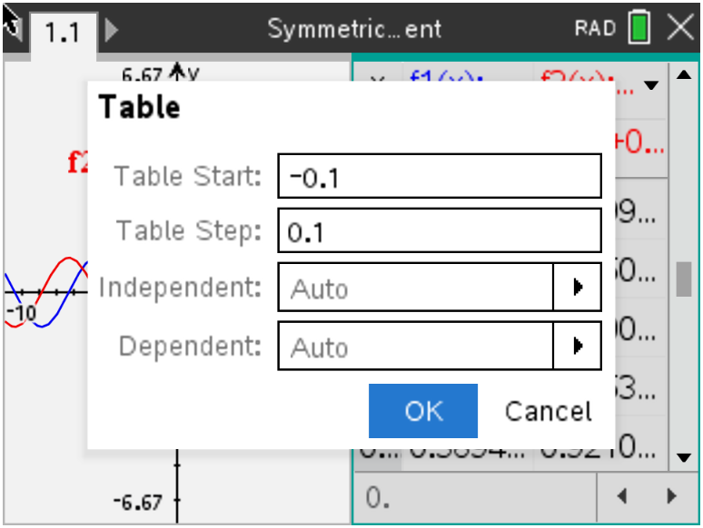

(f) The first column (x) contains the input values, the second column $(f1\left(x\right))$ contains the output of
$f\left(x\right)=\sin{(x)}$ at the corresponding input value, and the third column $(f2\left(x\right))$ contains the
approximation of the derivative of $f\left(x\right)=sin⁡(x)$ at the corresponding input value. Now, try to find a
common function that has outputs close to the values in the third column.

2. State the maximum value of $f2\left(x\right)$ in the table. State the minimum value of $f2\left(x\right)$ in the table.

3. State the input values the first three positive roots of $f2\left(x\right)$ fall.

4. State the common function you predict to be $f'(x)$.

Use your graphing handheld to generate a graph of f and the symmetric difference quotient for f (graph $f1\left(x\right)$ and$f2\left(x\right)$). Use the following suggested window settings.

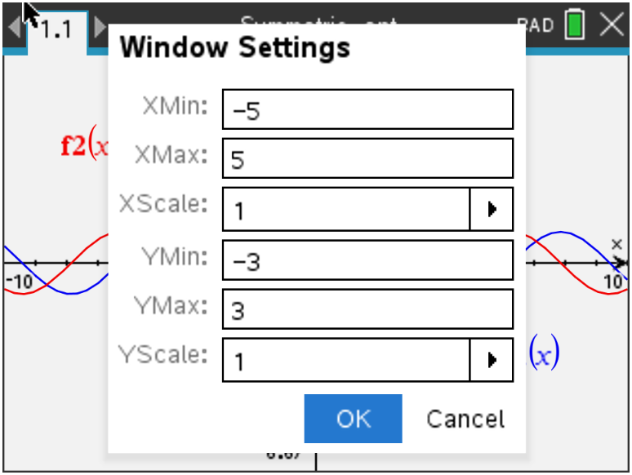

5. State if the graph of the symmetric difference quotient for f looks like the graph of the
function that you answered in Question 4. If not, state your new prediction for $f'(x)$.

To see how close your prediction for $f'(x)$ is to the symmetric difference quotient of f, store the function that is your prediction for the derivative of f into$, f3(x)$, and look at the table.

6. Describe how close your prediction of $f'(x)$ is to the symmetric difference quotient. State
how many decimal places they match for most entries.

The advantage of building a general slope finder in $f2\left(x\right)$ based only on $f1\left(x\right)$ is that the process can be applied to investigate the derivatives of other functions by merely changing$f1\left(x\right)$.

Problem 2 –

Input $f1\left(x\right)$ as $cos⁡(x)$, and look at the table.

7. State your prediction for $f'(x)$. Explain.

Use your graphing handheld to generate a graph of f and the symmetric difference quotient for f ($f1\left(x\right)$and $f2\left(x\right)$).

8. State if the graph of the symmetric difference quotient for f looks like the graph of the
function that you predicted in Question 7. If not, state your new prediction for $f'(x)$.

Store the function that is your prediction for the derivative of f into $f3(x)$, and look at the table.

9. State how close your prediction of $f'(x)$ is to the symmetric difference quotient. State how
many decimal places they match for most entries.

Problem 3 –

Input $f1\left(x\right)$ as $ln⁡(x)$, and look at the table.

10. State your prediction for $f'(x)$. Explain.
(Hint: Look at the x and $f2\left(x\right)$ columns.)

Use your graphing handheld to generate a graph of f and the symmetric difference quotient for f ($f1\left(x\right)$and $f2\left(x\right)$).

11. State if the graph of the symmetric difference quotient for f looks like the graph of the
function that you predicted in Question 10. If not, state your new prediction for $f'(x)$.

Store the function that is your prediction for the derivative of f into $f3(x)$, and look at the table.

12. State how close your prediction of $f'(x)$ is to the symmetric difference quotient. State how
many decimal places they match for most entries.

Problem 4 –

Finally, input $f1\left(x\right)$ as $e^{x}$, and look at the table.

13. State your prediction for $f'(x)$. Explain.

Use your graphing handheld to generate a graph of f and the symmetric difference quotient for f ($f1\left(x\right)$and $f2\left(x\right)$).

14. State if the graph of the symmetric difference quotient for f looks like the graph of the
function that you predicted in Question 13. If not, state your new prediction for $f'(x)$.

Store the function that is your prediction for the derivative of f into $f3(x)$, and look at the table.

15. State how close your prediction of $f'(x)$ is to the symmetric difference quotient. State how
many decimal places they match for most entries.

Ticket Out the Door –

16. Write a short paragraph summarizing what you have learned from this activity. Include all
derivative formulas that you have conjectured.

