Paying Off a Loan
In this lesson, you will create a program to calculate the time it takes to pay off a loan. Your program will use lists to track the months, amount paid and balance. You will import theses lists to the graphs page. You will fit linear, piecewise, step and recursive function to model the data. | Objectives:
Programming Objectives:
- Use the input function and a variable to collect and store data from a user
- Use lists to store data
- Use a while loop to repeat interest and loan payments until the loan is paid off
- Export lists to the native TI system
Math Objectives:
- Use linear, piecewise, step and recursive functions to model data
Math Course Connections:
This project could be used either in Algebra 1 or Algebra II to review linear, piecewise, recursive and stepwise functions.
For this project, you will write a program that asks for the principle, annual interest rate and monthly payment. The output will display the approximate number of months it will take to pay off as well as the total amount paid.
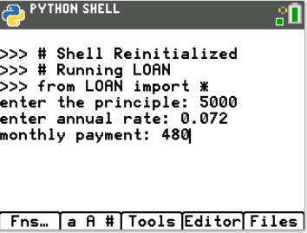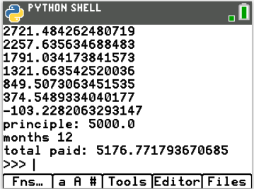

The program will export the data for use in other native TI-84 Plus CE Python documents.
You will add the data to a scatterplot on a graphs page.
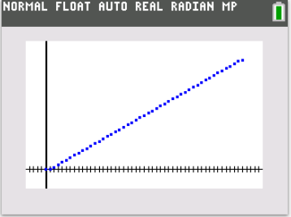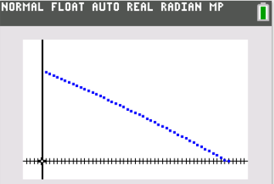
You will find different types of functions to model the data.

- Start a new Python program. Name the project LOAN.  This project will export lists of data.  To export lists, the program will need the library ti_system.  Select Data Sharing as the type.  This will add the ti_system library. |  | 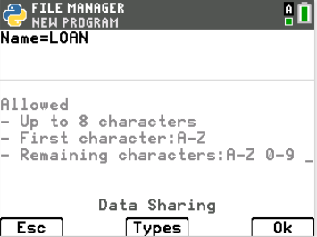
- Make sure the ti_system library was imported.  If you forgot to select Data Sharing, you can go to  Fns> Modul> TI System > from ti_system import*  The comments, denoted by the # appear in light gray. These lines of code are optional. They do not affect how the program executes. Instead, they are notes to you, the programmer.  Comments are used to describe sections of code. This can be useful when debugging or modifying a program later. They help a programmer remember the purpose for different sections of code. These comments tell you the coder; this library is used for data sharing. |  | 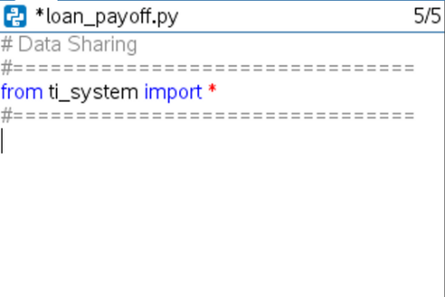
Teacher Tip: If students failed to initially include the ti_system library, step 2 will not add the three lines of comments. Students may add these lines or choose to leave them out. They do not affect the code’s execution.
- For this project, assume you want to purchase a car. You have found the perfect car, but need to take out a loan.

What are some of the factors you need to consider when taking out a loan?

What are some questions you might ask the bank?

- Look at your list:
Does it include the principle, the initial amount borrowed?
How about an interest rate or a monthly payment?
A bank loan charges interest on the amount borrowed. For example, if you borrow $10,000 with an annual interest rate of 8.9%. Each day, the loan balance increases using the following process.

Day | Initial  Balance | Interest | New Balance
1 | 10000 | 1000*.089/365 = 0.23 | 10000 + 0.23 = 10000.23
2 | 10000.23 | 1000.23*.089/365 = 0.23 | 10000.23 + 0.23 = 10000.46
3 | 10000.46 | 1000.46*.089/365 = 0.23 | 10000.46 + 0.23 = 10000.69
.. | … | .. | ..

Each day, interest is added to the balance. This increases the
balance.

Each month, one payment is made. This will decrease the
balance.

This process of adding interest and making a payment are
repeated until the balance is zero.

- The first step to create your loan calculation program is to ask the user for the principle, the annual interest rate and the monthly payment.  To request information, use input(“Enter question here”). You will store this information in a variable with a descriptive name.  The statement:  principle = input(“Enter the principle amount: “)  will ask the user the question then store the answer as  characters.  Use the command float()to store the principle as numbers  instead of characters.  principle = float(input(“Enter the principle amount: ”))  The equation above asks the question and stores the result as a  number.  Fns> Type> float()  Fns> I/O > input()  Write 3 lines of code.  1. Ask for the principle, store the value in principle.  2. Ask for the annual interest rate, store it as arate.  3. Ask for the monthly payment and store it as payment.  The picture to the right shows the first line of code.  ***Tech Tip*** Using the [a A #] menu by pressing the [window] button  might help when typing text. |  | 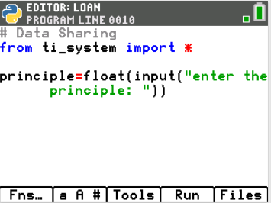
- The program will calculate the total amount paid at the end of the loan.  Create and set a variable total to zero. This variable will store the total amount paid.  total = 0 |  | 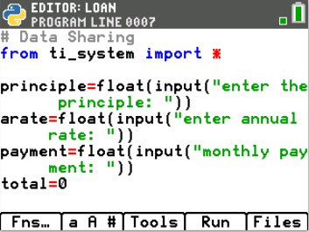
- Use lists to store each month’s balance, the total paid as of the end of each month and the number of months.  Add a comment to remind you the purpose of these lists:  [a A #] menu, press the [window] button  Create lists m_balance, m_total, and m_count.  Make the initial value in each list 0. |  | 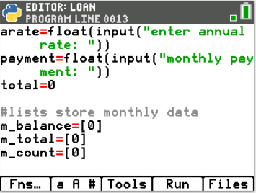
- Store the principle in a variable named balance.  balance = principle  Principle will stay a constant value, the initial amount borrowed.  Balance will increase each day with interest. It will decrease each month with a payment. |  | 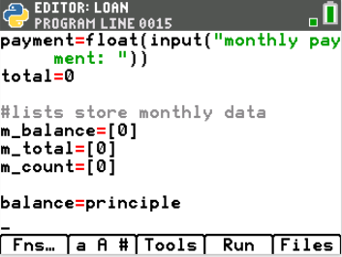
- Each month, approximately 30 days of interest are added to the balance. One payment is made.

- Use the variables balance and arate, write an expression that represents the new balance after one day of interest.
b. Modify your expression to represent the balance after 30 days of interest.
c. Modify your expression to remove one payment for the balance after 30 days of interest.

- Do your expressions look similar to the ones below?
a. balance + balance*arate/365
or
balance*(1 + arate/365)
b. balance*(1 + arate/365)³⁰

c. balance*(1 + arate/365)³⁰ – payment

- While the balance is greater than zero, the loan will increase by the interest and decrease by the payment.  Add a while statement to calculate and print the monthly  balance.  while balance > 0:  balance = balance*(1 + arate/365) **30 – payment  print(balance)  Fns> Ctl > while  Fns> I/O> print  *Note: In python, use ** to represent the ^ symbol for exponents.  The code inside the while loop is indented two spaces. In Python,  the indent is used to denote the lines that should be included in  the loop. Make sure both lines of code are indented two spaces.  The TI-84 CE Python prints two diamonds, , to visually show the  indentation. |  | 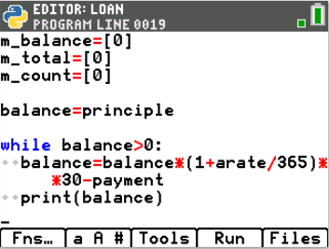
- Let’s check your code so far. In large projects such as this one, programmers execute the code often to check for errors.  Execute the program. Run  Set:  Principle = 1000  Annual Rate = 0.07 (Make sure you enter 0.07 for 7%)  Monthly Payment = 90  Make sure the output matches the output to the right.  **It’s ok if you get stuck in an infinite loop** You just need to know how to get out:  On the handheld calculator, hold down the On button for a few  seconds. |  | 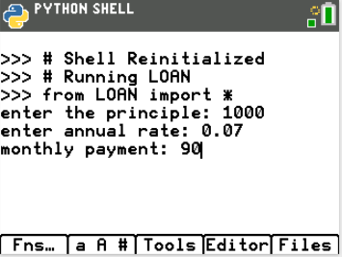  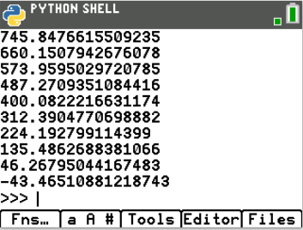
- Look at the example on the right. Notice the final balance is negative. What does a negative balance indicate?

- The negative balance indicates an overpayment on the last payment. The last payment was more than the balance owed.
To find the total for the payments made, each time through the loop, the payment should be added to the total.
After the loop, the amount overpaid on the balance should be subtracted from the balance.

- Add one line of code in the loop to add the payment to the total.

- After the loop, add a line of code to remove the overpaid amount from the total.

- Does your code look similar to the code on the right?  In Python, the line  total = total + payment  can be written as  total += payment  The line  total = total + balance  can be written as  total += balance  The format used is up to the programmer’s preference. |  | 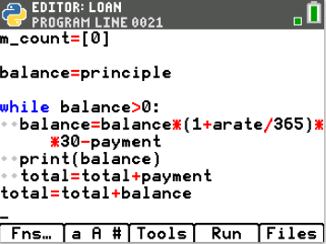
- The program uses a loop to repeatedly add daily interest and make a monthly payment. The balance value is replaced each time through the loop. The total is also replaced each time through the loop.  Use lists to keep track of each balance and each payment total.  Add three blank lines at the beginning of the loop.  Use the append() function to add each balance to a list of balances in the list m_balance.  Add: m_balance.append(balance)  Use the append() function to add each month’s total .  Add: m_balance.append(total)  Fns> Lists> append |  | 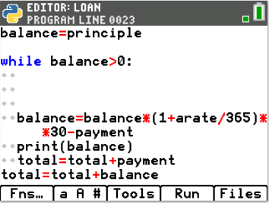  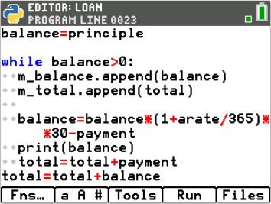
- This list m_count will keep track of the number of months by keeping the values 0, 1, 2… Initially, the code stored 0 in the list m_count. That means the length of the list m_count is one.  Each time through the loop, the line  m_count.append(len(m_count))  will add the length of the list to the list each time through the loop.  Fns> > Lists> len |  | 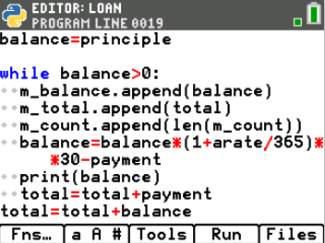
- After the loop, the balance is zero.  Add the 0 balance to the m_balance list.  Add the final total amount paid to the m_total list.  Add one more month to the m_count list.  m_balance.append(0)  m_total.append(total)  m_count.append(len(m_count)) |  | 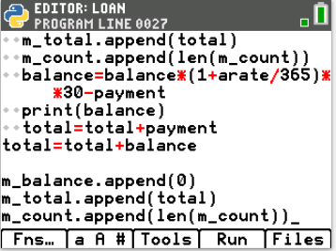
- Add three print statements.  One statement should print the initial amount borrowed.  The second statement should print the number of months it took to pay back the loan. The last item in the list m_count contains the last month. To access the last month in the list, use m_count[-1].  The last statement should print the total amount spent to pay back the loan.  Fns> I/O> print() |  | 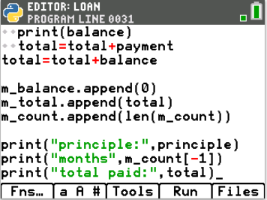
- Use the program to answer the following questions.
If you borrow $15,000 at an annual interest rate of 6% and make monthly payments of $300, how many months does it take to pay off the loan? What is the total amount paid back?
If you borrow $15,000 at an annual interest rate of 6% and make monthly payments of $400, how many months does it take to pay off the loan? What is the total amount paid back?

- Export the lists using the store_list() command from the ti_system library. This will allow you to use the lists on non-Python pages.  Fns> Modul> TI System> store_list  Export all three lists.  Store:  m_balance in list1  m_total in list2  m_count in list3 |  | 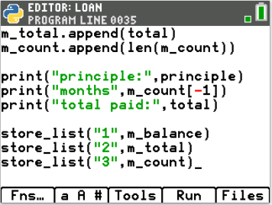
Execute the program for a $20,000 loan with 8% annual interest and a $500 monthly payment.  Exit the Python Shell and Editor. [2nd] Quit [Ok] |  | 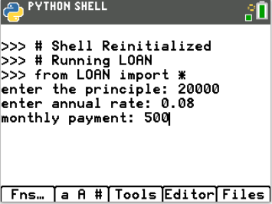
- Recall m_count is stored in L3 and m_total is stored in L2.  You will plot the month count as the independent variable on the x-axis and the month total as the dependent variable on the y-axis.  Check your Stats Plots setting. Turn only Plot 1 On.  [2nd] Statplot  For Plot 1:  Turn the Plot On  Choose scatter plot for the type.  Add L3 as the independent variable (xlist)  Add L2 as the dependent variable (yList) |  | 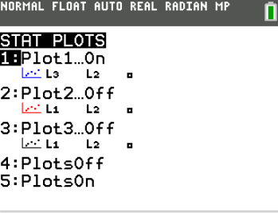  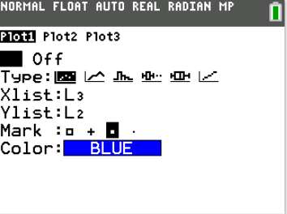
- Go to y=.  Clear the functions. |  | 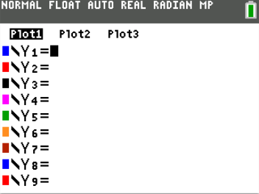
- Graph the data.  The graph scale is set to the settings from your last graph. To fit the window to your data press [zoom]. Choose ZoomStat. This will automatically set the x-axis and y-axis based on your data. |  | 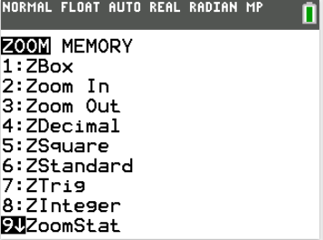
- Use the [trace] feature to complete the table below:
m_count | m_total
0
1
2
3
4
5

What is the total amount repaid?

Identify the domain for this problem.
Identify the range for this problem.

- Press [y=]  Menu> Graph Edit/Entry> Function.  a. Write a linear equation to model the data.  Enter your equation into the calculator.  Verify it matches the data in the graph  b. Write the equation to a piecewise function that models the data.  Enter your equation into the calculator.  Verify it matches the data in the graph  c. Write a step function to model the data.  Enter your equation into the calculator.  Verify it matches the data in the graph  d. Write a recursive function to model the data.  (Change the graph from function to sequence.  [Mode] contains the Function/Seq option)  Enter your equation into the calculator.  Verify it matches the data in the graph  Look at the functions written above. Which function(s) would  you pick to model the data? Explain why you picked this  function(s).  List one of the functions above you would not use to model the  data. Explain why you picked this function. |  | 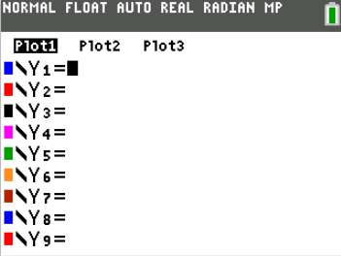
Teacher Tip:
To graph a piecewise function such as f(x) = $\left\{\begin{matrix}x+8, x<5 \\ x^{2}-5, x>6\end{matrix}\right.$ , type y1 = (x+8)*(x<5) + (x² – 5)*(x>6)

To graph a stepwise function such as f(x) = [x], type y1 = int(x) int can be found in the [MATH] menu.

- Change the plotted ylist to m_balance.  Remember m_balance is stored in L1.  Adjust the window to fit the new data.  [zoom] ZoomStat |  | 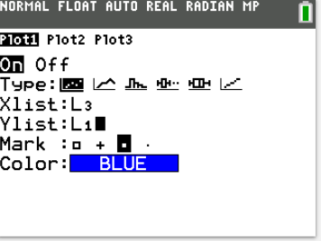
- Use the [trace] feature to complete the table below:
m_count | m_balance
0
1
2
3
4
5

Identify the domain for this problem.
Identify the range for this problem.

Write a function to model the data.

Explain why you chose this function.

