Open the TI-Nspire document Moving_Air.tns  Because of the spherical shape of the earth, the energy from the sun is not evenly distributed on earth’s surface. This difference in heating causes predictable patterns in earth’s weather. In this simulation, you will discover how this uneven heating affects the patterns of air circulation in Earth’s atmosphere. |  |  | 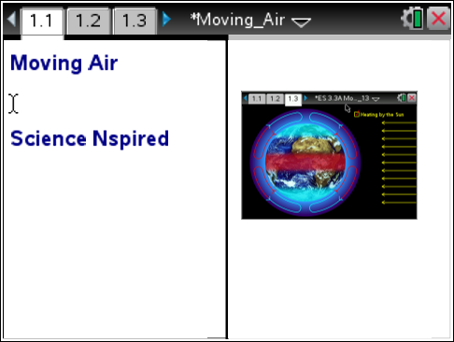
Read the background information below.

Light from the sun moves in straight lines towards Earth’s surface, causing it to heat up. However, because Earth is spherical, rays of sunlight heat up various regions of the earth differently. When sunlight strikes the equator, the rays of light strike the equator directly in a concentrated area. This causes the equator region to become very hot. In regions closer to the poles, sunlight strikes Earth’s surface indirectly and the rays of light are spread out over a larger area. Because of this, these areas do not heat up as much and have a cooler temperature.
Earth

equator

The air just above Earth’s surface is heated by Earth’s surface. So, the air at the equator becomes very warm. Warm air is less dense than cool air, so the warm air rises up into the atmosphere. This leaves an area of low pressure at the equator. Air at the north and south poles is very cool and dense, so the air pressure in these regions is high. Air always moves from regions of high pressure to low pressure. As a result, air at Earth’s surface tends to move from the poles towards the equator. The warm air that has risen into the atmosphere over the equator cools as it rises, and it moves towards the poles where it sinks back down to Earth’s surface. This cycle of air movement is called a convection cell. It is the cause of global winds that move across Earth’s surface.

Move to page 1.2 and answer question 1 below and/or on your device.
Q1. Which region of the earth receives the most light energy?

A. the poles
B. the areas between the poles and equator
C. the equator
D. all three receive the same amount of energy

Move to page 1.3.
Read the directions for the simulation.
 | 1. Observe the simulation before selecting the Heating by the Sun button.  2. Select the Heating by the Sun button to observe what happens when Earth is heated by the sun. The red, shaded area around the equator represents an area of warmer air.  3. Observe the atmospheric circulation arrows. Note the direction and color of the arrows in the convection cells. | 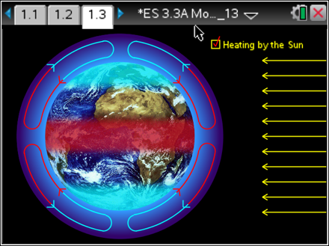
 | Tech Tip: To access the Directions again, select b or Document Tools () > Moving Air > Directions.
 | Tech Tip: To access the Directions again, select > Moving Air > Directions.
 | Move to pages 1.4 - 1.8 and answer questions 2 - 6 below and/or on your device.
Q2. How did the air in the atmosphere move when there was no heating by the sun?

A. There was no air circulation.
B. Rising air at the equator moved toward the poles.
C. Sinking air at the equator moved toward from the poles.
D. Rising air at the poles moved toward the equator.

Q3. How did the air in the atmosphere move when Earth was heated by the sun?

A. There was no air circulation.
B. Rising air at the equator moved toward the poles.
C. Sinking air at the equator moved toward from the poles
D. Rising air at the poles moved toward the equator

Q4. There are two colors representing the air circulation in the convection cells. What does the red color represent?

A. warm air
B. cold air

 | Q5. Describe the movement of the air in a single convection cell.
 | Q6. What is happening to the temperature of the air as it moves between the equator and the poles?
 | Move to pages 1.9 -1.12. Read the information and examine the diagrams shown. Then move to pages 1.13 - 1.14 and answer questions 7 and 8 below and/or on your device.
Q7. What is the direction of the trade winds?

Q8. Where are the doldrums located?

