Introduction
As you move in front of the CBR 2 your motion can be recorded. A plot of this motion can easily be seen on your TI graphing calculator. Speeding up and slowing down are some of the factors that can affect a plot. In this activity, you will explore the effects those factors have on a plot.
Objectives
In this activity you will decide how to move in front of a CBR 2 (or move the CBR 2 in front of a target) to:

- Observe the effect speeding up has on a Distance-Time plot.
- Observe the effect slowing down has on a Distance-Time plot.

You’ll need
- TI-84 Plus CE, with Vernier EasyData™ App
- CBR 2™ motion sensor unit with mini-USB connecting cable
Using the CBR 2™ motion sensor and Vernier EasyData® App  1. Connect the handheld with the CBR 2 using the USB cable. EasyData will immediately open, and the CBR 2 will begin collecting distance data every time it clicks. In the EasyData App, the tabs at the bottom of the screen indicate the menus that can be accessed by pressing the actual calculator keys directly below the tabs. | 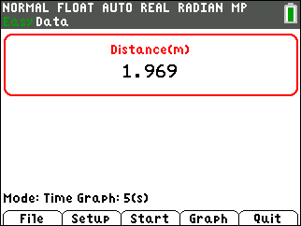
Collecting the Data
During these observations you will explore the effects that gradually speeding up and gradually slowing down the rate at which you walk have on a Distance-Time plot. Time will be plotted on the horizontal axis, and the distance from the CBR 2 to the walker (in meters) will be plotted on the vertical axis. When collecting data in these observations, be aware that the CBR 2 measures from 0.15 meters (6 inches) to 6 meters (about 18 feet).
Trial 1 (close to far)  2. Write how you would walk in front of the CBR 2 in order to make the distance-time graph at the right. Record your description using accurate terms (where you started, which direction you walked, what changes in speed, etc.). | 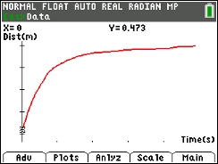
3. Try walking according to your description. When you are ready, select by pressing q. If you get a message about overwriting the latest run, select by pressing s key, and the CBR 2 will immediately start collecting data. | 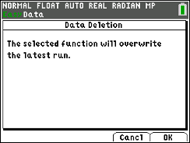
4. If the graph is not what you want, go to the Main Menu by pressing s to start again. Select to overwrite the latest run. Before repeating, think about what you need to do differently to change the shape of the graph. Were you able to make the right shape? Describe how you walked.

Trial 2 (close to far)  5. Write a description of how you would walk in front of the CBR 2 to make the distance-time graph at the right. Be precise using accurate terms (where did you start, which direction, how fast, changes in speed, etc.). | 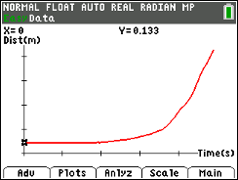
6. Try walking according to your description. If the graph is not what you want, go to the Main Menu by pressing s to start again. Select to overwrite the latest run. Before repeating, think about what you need to do differently to make changes in the shape of the graph. Describe how you walked.

Looking at the Results
1. Each plot in Trial 1 and Trial 2 contains a section that is level or flat in appearance. What were you doing during this part of each plot?

2. Look at the plot for Trial 1. Compare how you walked during the first second of the graph with how you walked the rest of the time (t = 1 sec to t = 5 sec).

3. Discuss the similarities between the two trials. What causes them to curve? (Be sure to use the words “time,” “distance,” and “rate” in your answer.)
4. Describe in words how the plots above would have looked if you started at about 2 meters away and moved toward the CBR 2 with the same variations in speed as in Trials 1 and 2.
Trial 1 (far to close):

Trial 2 (far to close):

5. Sketch your written descriptions of walking Trial 1 and 2 toward the CBR 2 in the graphs below:
Trial 1 (far to close) Trial 2 (far to close)
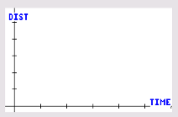
6. Try walking your descriptions from question 5 using the CBR 2. Take your place at a distance of about 2 meters. Go back to the menu. When you are ready, select . If you get a message about overwriting the latest run, select and the CBR 2 will immediately start collecting data. Record what happened below.
Discuss the differences in your predictions and your walks and what you did make the graphs have the same changes in speeds (Trial 1: begin fast, end slow; Trial 2: begin slow, end fast).

7. In your own words, what is the effect of speeding up and slowing down on the distance-time plot?
Going Further
1. Describe what a plot of the following motion would look like. Stand approximately 2 meters from the CBR 2. When data collection begins, move toward the CBR 2 at a medium pace but then slow down until you come to a stop about 0.5 meter from the CBR 2. This motion should take almost 2 seconds. After a 0.5 second pause begin slowly moving away from the CBR 2. Then steadily increase speed until moving at the same medium rate that you began with. The total collection time will be about 5 seconds.

2. Make a sketch of your prediction about the motion in question 1 on a set of axes. Next, try it. Make a sketch of the plot you created on a second set of axes.

3. Discuss any differences between your prediction in question 1 and your plot in number 2 and why the differences occurred.

