Introduction
Everyday occurrences, such as the melting of ice in a drinking glass, can provide a window into the world of chemistry. As ice melts, thermal energy is transferred from the environment to individual molecules of water. Scientists can use this information to calculate other quantities, such as the heat of fusion of ice. |  |  |  | 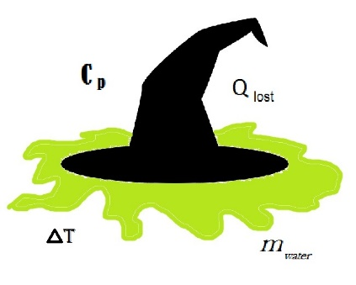
Objectives
In this activity, you will:
• use the Vernier EasyTemp™ temperature sensor
• determine the change in thermal energy for a given mass of ice
• determine the heat of fusion of ice
• determine percent error

You’ll Need
- TI-84 Plus CE calculator  - Vernier EasyTemp®  - Balance  - Room temperature water | - Paper towel  - 100 mL graduated cylinder  - Plastic foam cup  - 2-3 large ice cubes
Collecting the Data
- Measure and record the mass of the empty foam cup. Measure 100 mL of room-temperature water with the graduated cylinder, and add it to the cup. Measure and record the mass of the cup and the water.
- Plug the EasyTemp probe into the USB port on the calculator. The calculator will turn on automatically, and the EasyData App will display the ambient room temperature. At the bottom of the screen, just above the menu buttons, the current experimental setup will be displayed. The default experimental setup for the EasyTemp probe is to collect one sample every second for 3 min. This should be enough time for the temperature of the water in the foam cup to drop from room temperature to near 0°C (the temperature of melting ice). |  |  | 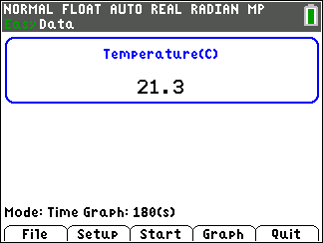
- Place the temperature probe into the water in the cup.
- Read the temperature of the water from the display on the Main screen. When the temperature is constant, record it in the data table below as the initial water temperature.
- Obtain two to four ice cubes on a paper towel, and bring them back to your lab table. Wait until the ice begins to melt. (This tells you that the temperature of the ice is 0°C.)

6. Press q to select START to begin collecting data. If you get a message about overwriting stored data, select OK. Data collection will run for 3 minutes. During the data collection, a graph of temperature vs. time will be displayed. If the screen goes blank during or after the data collection, press É to restore it. |  | 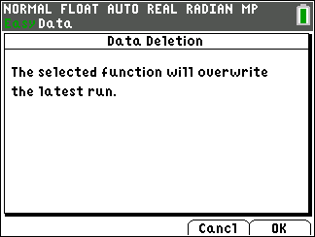
7. After selecting START, dry the ice cubes with the paper towel, then add them to the water in the cup. Stir carefully with the temperature probe.

8. As you stir, watch the temperature display. If it reaches 0°C before the 3 min are up, quickly remove any excess ice and shake as much water (clinging to the ice) as possible into the cup. Remove the temperature probe from the cup and carefully place the probe on the lab table. If the water does not reach 0ºC by the end of the 3 min, that is OK. |  | 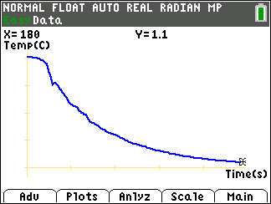
9. At the end of the 3 min data collection period, remove the temperature probe, if you haven’t already, and carefully put it on the table. Then remove any remaining ice from the cup. Shake any water clinging to the ice into the cup.
10. Measure the final mass of the cup plus water using a balance. Record the data in the table. The final mass should be greater than the initial mass because some of the ice melted and added water to the cup.
11. Your calculator screen should be displaying a graph of temperature vs. time for your data. You can use the arrow keys to move the cursor along your temperature vs. time graph. As the cursor moves along the curve, the x-value (time in seconds) is displayed at the top of the screen next to X=, and the y-value (temperature in degrees Celsius) is displayed next to Y=. Use this method to find the minimum temperature (the temperature when you removed the ice). For example, in the screen to the right, the initial temperature (X=0) is 20.0°C. Record the minimum temperature in your data table. |  | 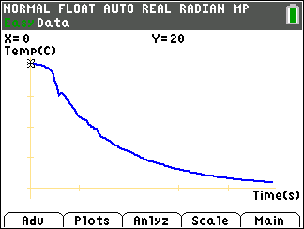
12. Exit the EasyData App. Press s to select MAIN and return to the main screen. Select QUIT, then OK to return to the home screen. Remove the temperature probe.

Data Table
Initial water temperature | °C
Minimum (final) water temperature | °C
Change in temperature of water | °C
Mass of empty cup | g
Initial mass of water and cup | g
Final mass of water and cup | g
Initial mass of water | g
Final mass of water | g
Mass of ice that melted | g

Data Analysis
1. Use the measurements in your data table to calculate the following: change in temperature of water, initial mass of water, final mass of water, and mass of ice that melted. Record your calculations in the data table above.

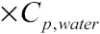
2. Calculate the change in thermal energy of the water due to the melting ice cubes, using the equation

The answer will be in Joules. The specific heat (Cp) of water is 4.18 J/g•°C.
Hint: Remember that only the initial mass of water in the cup cools when the ice melts.

3. Where did the energy that the water lost go?

4. Calculate the specific heat of fusion for ice (the energy required to melt 1.0 g of ice), using the equation given in question 2.

5. If the accepted value for the heat of fusion of ice is 334 J/g. Use the following equation to calculate the percent error in your value for the specific heat of fusion of ice

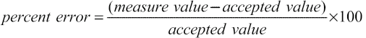

6. List possible sources of error in your experiment. Number each source.

