Overview
In this activity, you will create a table and graph for a binomial distribution for a given sample size and given probability of success.

Materials
• TI-Nspire™ handheld or Computer Software

Part 1—Preparing the document  1. Open a new document by pressing c > New Document > Add Notes. | 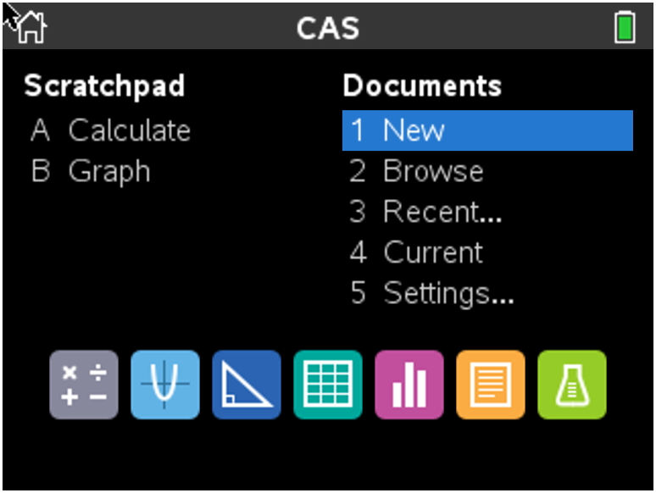
2. Type Binomial Pdf Eye Color.  3. Press ~ > File > Save As … and type the file name Binomial_Pdf Eye Color. e to ¾ , and press ·.  Note: To obtain capital letters on the handheld, press the g key, then the letter. | 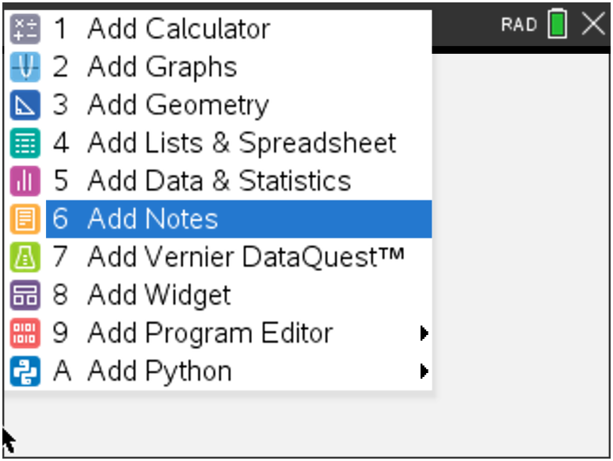
Part 2—Creating a Table for Binomial Distribution
4. Add a new page by selecting / ~ > Add Lists & Spreadsheet.
5. Move the cursor to the top cell for Column A, and type successes.  - Move down to the next row with the diamond at the far left (the formula cell), and type =seq(x,x,0,50,1).  - Press · to create a list of integers from 0 to 50 progressing in steps of 1. | 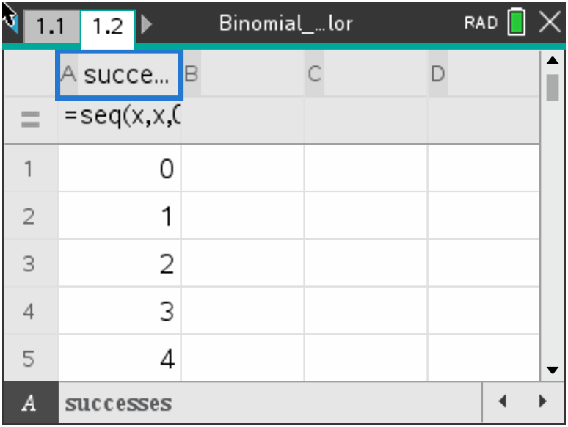
Assume that you have 50 binomial trials, where the probability of success is 0.30.  6. Move the cursor to the top cell for Column B, and type pdf.  - Move down to the next row with the diamond at the far left, and type = binompdf(50, 0.30, successes).  - Press · to create a binomial distribution for integers from 0 to 50 where the probability of a success is 0.30. | 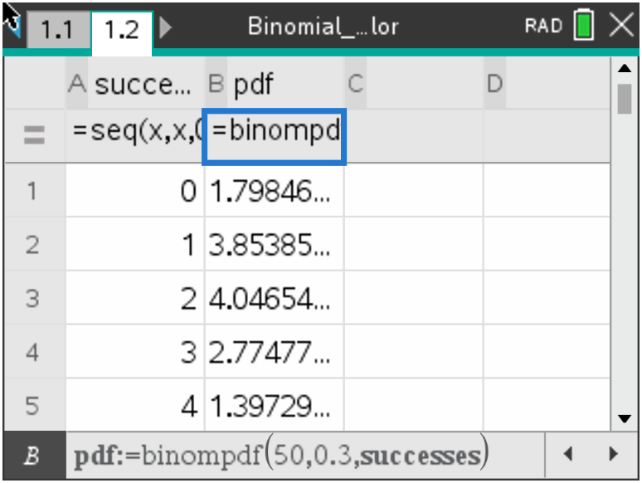
Part 3—Creating a Graph of a Binomial Distribution  7. Add a new page by selecting / ~ > Add Data & Statistics. | 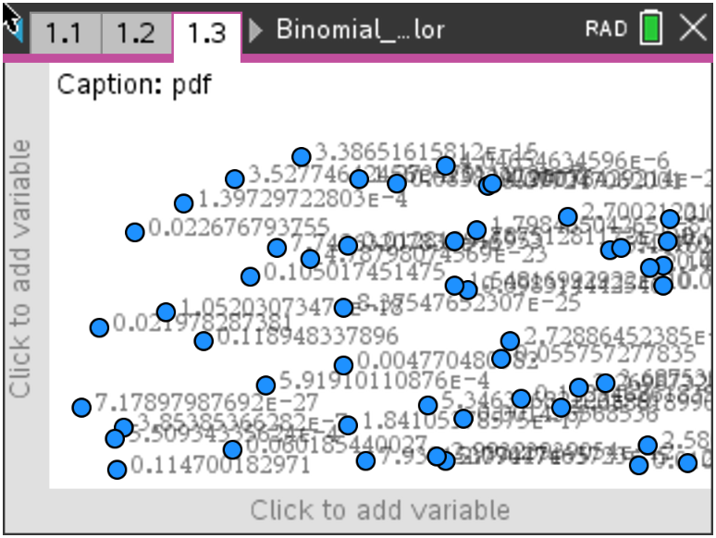
8. Move your cursor to the bottom middle of the screen over the text Click to add variable and choose successes.  9. Press b, and choose Plot Properties > Add Y Summary List.  - Choose pdf | 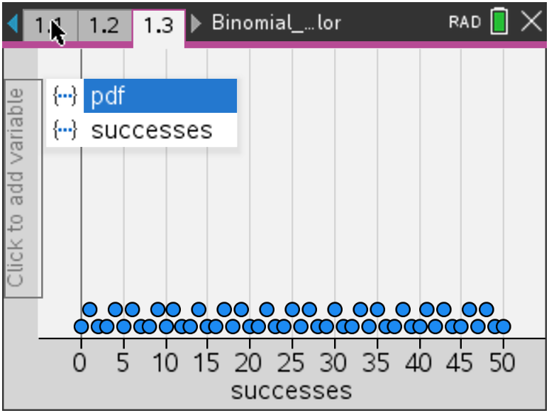
The screen to the right shows the resulting graph of a binomial distribution. | 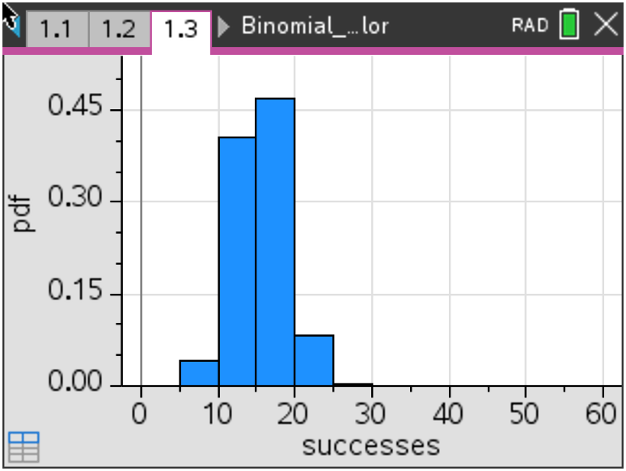
13. To set the bin widths, select MENU > Plot Properties > Histogram Properties > Bin Settings and press ·.  14. Set the bin width to 1, the alignment to 0.5, and select OK or press ·.  Note: The alignment allows the bin to be centered over the whole numbers [14.5, 15.5) making it clear that the value is 15. An alignment of 1 would position the bin as [15, 16), which might be harder to read. | 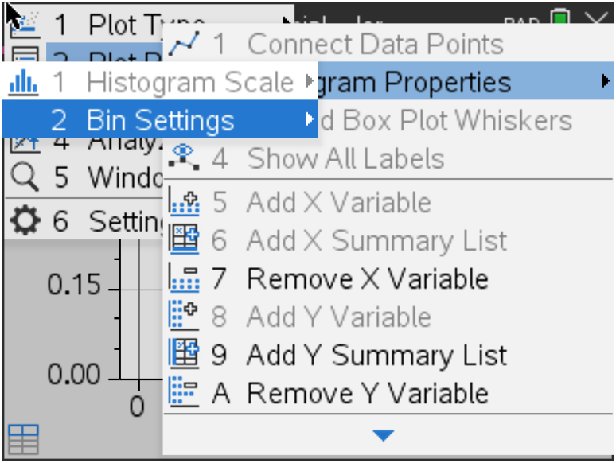  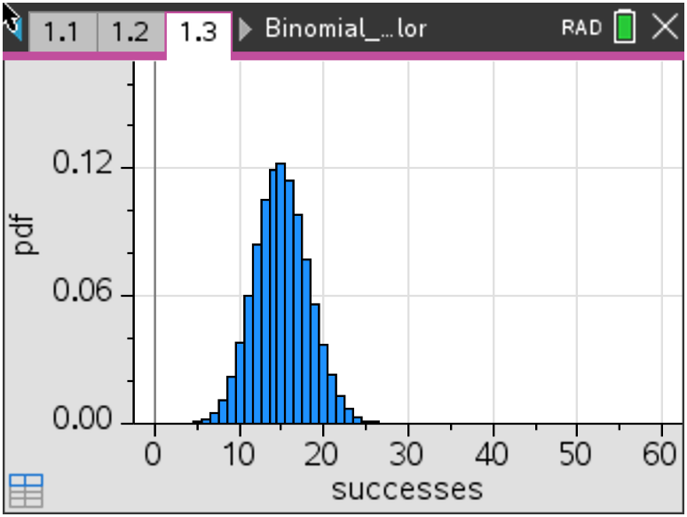
15. Students: Go to the Binomial Pdf Eye Color worksheet, and follow your teacher's directions to answer the questions.

Part 4—Extension  The file you created can be generalized by replacing both the sample size, n, and the given probability, p, with variables.  16. Move to the histogram on Page 1.3.  17. Select MENU > Actions > Insert Slider to create a slider.  18. Drag the slider to the upper right side of the panel, and click to position the slider box.  19. Type n in the cell containing v1 (which replaces v1 with n) and press ·. | 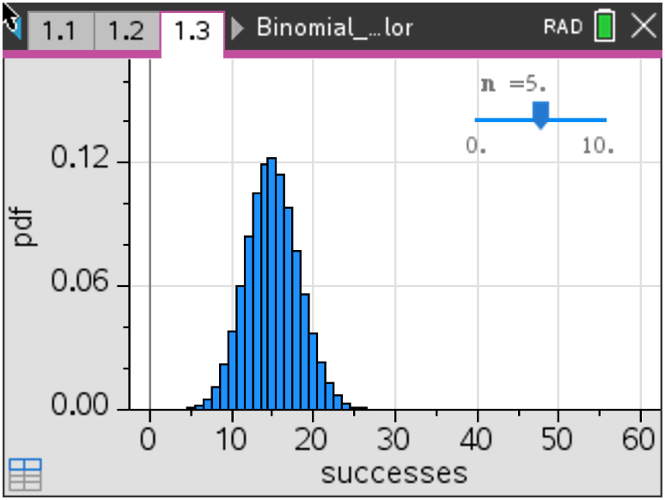
20. Click inside the slider box, and press / b > Settings. | 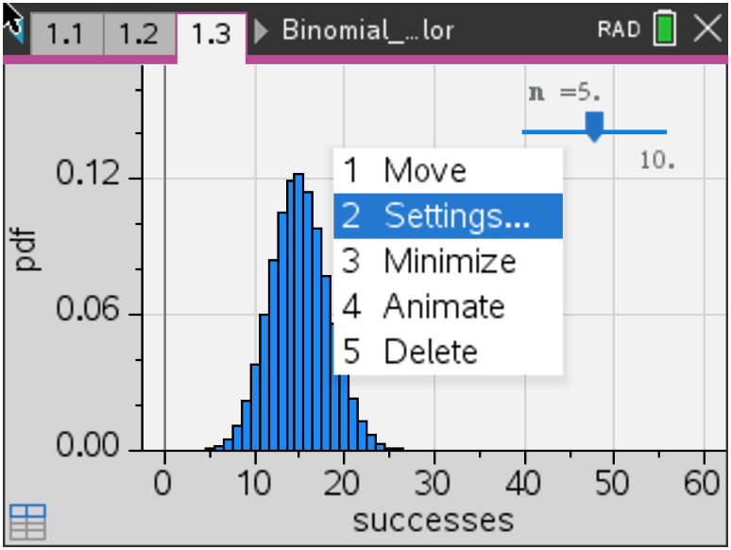
21. Change the following settings:  - Variable: n  - Value: 50  - Minimum: 0  - Maximum: 100  - Step Size: 5 | 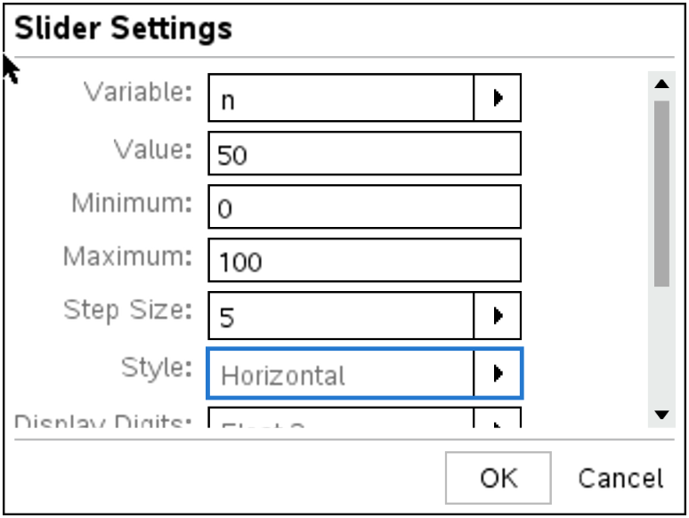
22. While still in the settings dialog box, use the scroll bar to move down and check the Minimized option. Select OK, or press ·.  Note: These settings will allow you to generate samples from size 0 to 100 in increments of 5. | 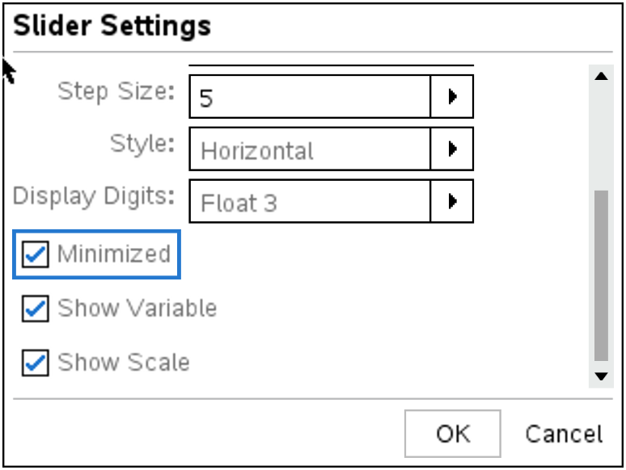
23. Create a second slider following the steps above, but replace v1 with p and use the following settings:  - Variable: p  - Value: .3  - Minimum: 0  - Maximum: 1  - Step Size: 0.01  - Use the scroll bar to move down and minimize the slider. | 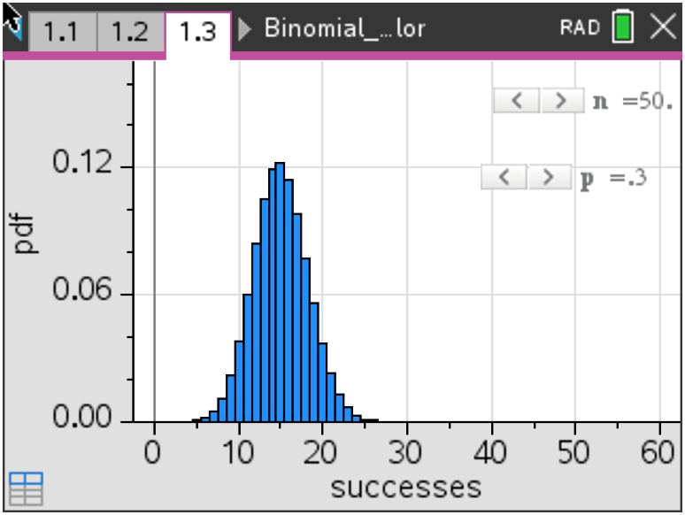
Note: The settings will allow you to use any probability from 0 to 1 in increments of 0.01.
To link these variables to your spreadsheet on Page 1.2,  24. Move to the second row of Column A.  25. Press · to activate the cell, and move the cursor to the bottom of the screen (not the bottom of the spreadsheet itself) where the formula is displayed.  26. Move to the 50, replace it with n, and press ·.  - The screen will show a dialogue box that asks if you want to override the data. | 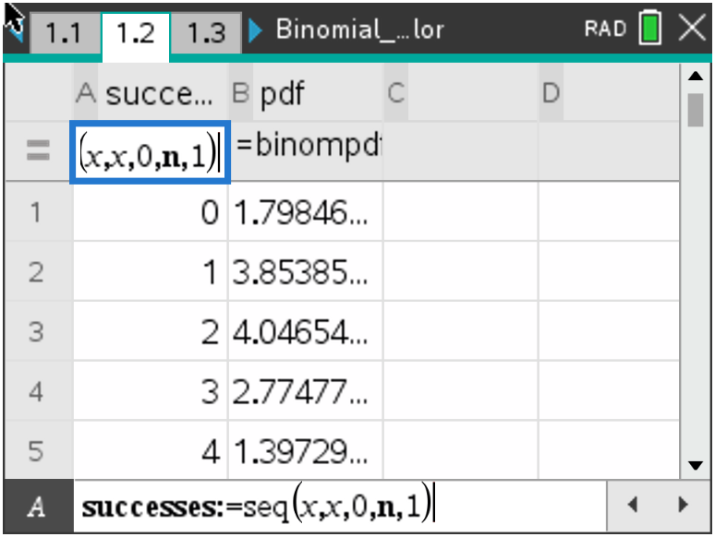
28. Select OK and a new dialogue box will appear that asks whether you want a column reference or a variable.  29. Choose Variable Reference, and select OK. | 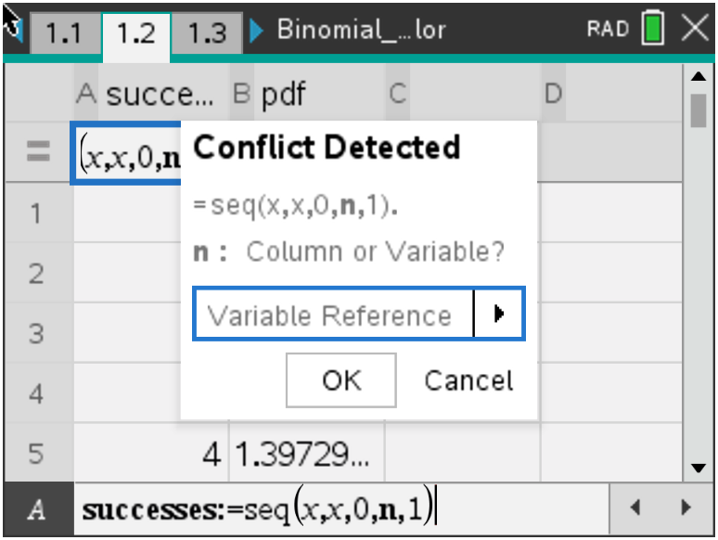
30. Repeat this process for Column B, replacing the 50 with n and the .3 with p. | 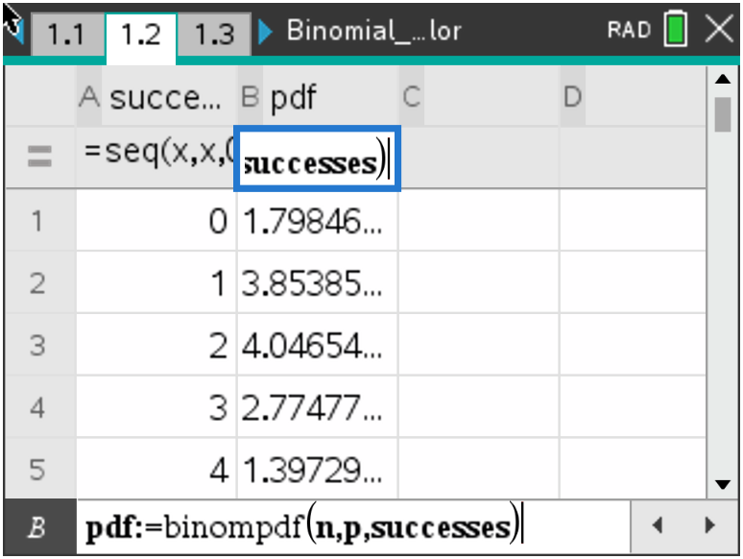
31. Using the sliders, you can change either the sample size or the given probability by clicking on the arrows or by moving the cursor into the box and using the right and left arrows on the TouchPad. The distribution on Page 1.3 will update automatically as you change the variables.

