|  |  |
| --- | --- |
| **Open the TI-Nspire document *Compound_Interest.tns.***  The purpose of this activity is to investigate the effects of interest rate and the number of times interest is paid each year on compound interest. |  |
| **Move to page 1.3.** |
| Let be the initial amount (**Principal**) deposited, the annual interest rate expressed as a decimal, the number of times interest is paid each year, and the total amount in the account at time (in years). The formula for compound interest is . | |
| 1. Suppose $50,000 is deposited in an account paying 2% () per year (). These values have been entered for and on Page 1.3.  Move to Page 1.4 to see information about this account. Column A displays the total amount in the  account after each interest pay period. Column B displays the amount of interest earned after each  pay period.  **Note**: row 1 corresponds to the initial deposit; row 2 corresponds to the first pay period, etc.  a. Explain why the interest earned after each pay period increases.  b. Use Column A to estimate the number of years until the initial deposit doubles.  (Hint: Press / 3 to page down.)  c. Go back to Page 1.3, and change the interest rate so that the initial deposit doubles after 15 years. | |

|  |  |  |  |  |  |  |  |  |  |  |  |  |  |  |  |  |  |  |  |  |  |  |
| --- | --- | --- | --- | --- | --- | --- | --- | --- | --- | --- | --- | --- | --- | --- | --- | --- | --- | --- | --- | --- | --- | --- |
| 2. Suppose $10,000 is deposited in an account paying 5% () semi-annually (). Enter the values for and on Page 1.3.  a. Complete the following table to find the amount in the account after two years. Change the value of as necessary on Page 1.3.     |  |  |  |  |  |  | | --- | --- | --- | --- | --- | --- | |  | 2 | 4 | 6 | 12 | 52 | |  |  |  |  |  |  |   As increases, explain how you would expect the value of to change for a fixed value of *t.*  b. Explain the meaning of each of the following: $n=365$ ; $n=\left(365\right)\left(24\right)=8760$ ; $n=\left(365\right)\left(24\right)\left(60\right)=525,600;$ and $n=\left(365\right)\left(24\right)\left(60\right)\left(60\right)=31,536,000$ .  c. Insert a Calculator page, and complete the following table.   |  |  |  |  |  | | --- | --- | --- | --- | --- | |  | 365 | 8760 | 525,600 | 31,536,000 | |  |  |  |  |  |   d. As increases, describe the compounding period. Explain how the amount in the account changes for a fixed value of as increases.  e. Using your results from Questions 1 and 2, describe the characteristics you would like in an account in order to earn the most interest after every pay period. |

|  |
| --- |
| 3. Suppose $25,000 is deposited in an account paying 4% () quarterly (). Enter the values for and on Page 1.3.  Move to Page 1.5. Column B displays the amount in the account,after each pay period.  Column A contains values of the function for each corresponding pay period, where  , the base of the natural logarithm. This function does not depend upon  Column C contains the difference between the two values for corresponding pay periods.  Note: row 1 corresponds to the initial deposit, row 2 corresponds to the first pay period, etc.  Move or animate the slider on the right side to increase the value of Use the slider to change the value of As increases, explain the relationship between and |
| **Move to page 2.1**. |
| 4. The graph of is displayed as a solid curve, and the graph of is displayed as a dashed curve. Move or animate the slider to change the value of .   1. Explain the relationship between the two curves as increases. State if your answer is consistent with your response to question 3. If not, explain why.   **Note:** you might need to zoom in to examine the relationship between the two curves.   1. Find the values for and such that for some value of *t.* |
| **Using the Finance Solver on the handheld:**  Insert a calculator page. Press **Menu < 8 Finance, < 1 Finance Solver**. The Finance Solver box will open for you to use in place of the compound interest formula used earlier in this activity.  **Sample:**  Find the future value of a $20,000 invested for 5 years at 6% compounded annually.  This is what it should look like on the handheld: |

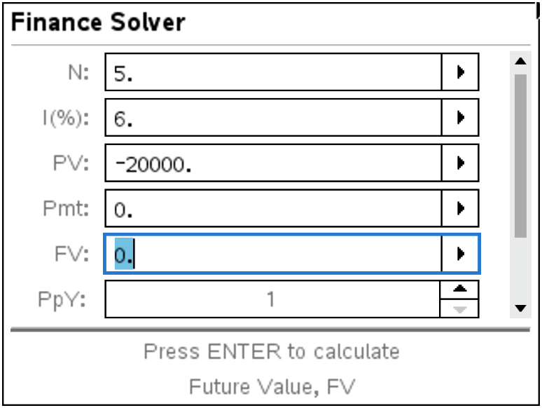 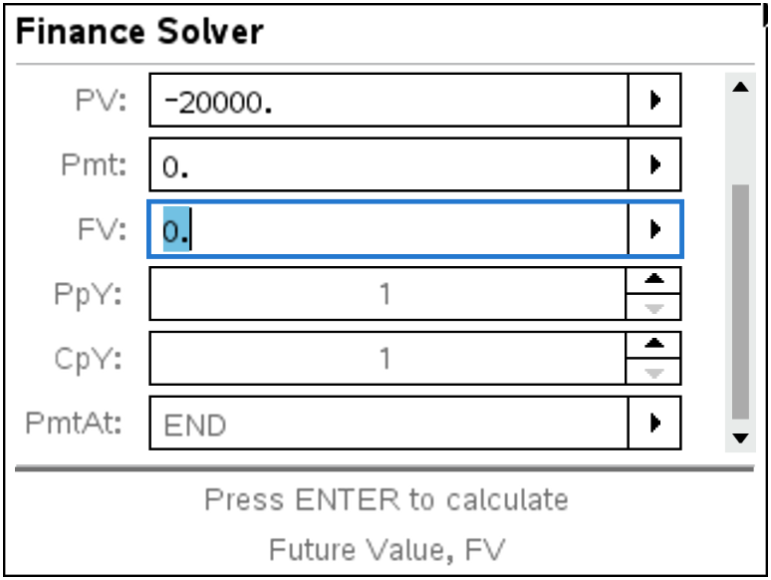

Please notice that the **PV** (Principal Value) is entered as -20000 because cash outflows are considered negative. Place your cursor over **FV** and press enter to find the Future Value.

**FV = $26,764.51**

5. Find the future value of $2000 invested for 5 years at 6% compounded quarterly.

6. Find the value of $8000 invested for 6 years at 8% compounded monthly.

7. Find how much you would have to invest in a savings account paying 6% compounded quarterly in

order to have $3000 in 5 years.