Problem 1 – The Basics
On page 1.2, graph 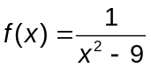 by clicking the slider value of a to 9.
1. Is the function defined over all values of x?

On page 1.4, use the table of values for the function to answer questions 2 and 3.
2. How does the table of values indicate that the function is undefined at a certain value of x?

3. What x-values have no corresponding y-value(s)?

4. In order to understand why a function is undefined at certain values of x, it is helpful to look at the function in factored form. Factor the denominator of the function 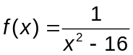.

5. How does the factored form of the denominator relate to the “skipped” x-values on the graph of the function ?

6. When the “skipped” x-values are substituted into the function, what happens to the denominator? What effect does this have on the function at these x-values?

These x-values that result in the denominator becoming equal to zero (and the function undefined) are referred to as singularities.

“Lines” on the graph which the graph of the function approaches, getting closer and closer, but never reaching are called asymptotes. There are two vertical asymptotes, at x = 3 and x = –3, for the function graphed on page 1.2.

Problem 2 – Asymptotes
Asymptotes are generally represented with dashed lines. On page 2.2, use the Perpendicular tool to insert vertical asymptotes (dashed lines) at x = 3 and x = –3.

When the degree of the numerator is less than or equal to the degree of the denominator of a rational function, a horizontal asymptote may exist.

- Once the rational function is simplified, then when the degree of the numerator equals the degree of the denominator, a horizontal asymptote exists at y = (ratio of leading coefficients of numerator and denominator).
- When the degree of the numerator is less than that of the denominator, a horizontal asymptote exists at y = 0.

7. Does the function on page 2.2 have a horizontal asymptote? If so, what is the equation of the asymptote?

Problem 3 – Asymptotes
8. Examine the graph on page 3.2. Where is/are the vertical asymptote(s) for the function?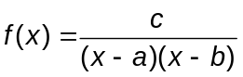?

Problem 4 – Asymptotes
For the following questions, examine the graph of the function 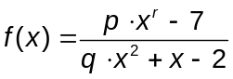 on page 4.2.
9. When only the value of r is changed, when may horizontal asymptotes not be present?

10. When the degree of the numerator and denominator are equal (once the rational function is simplified), what is the equation for the horizontal asymptote?

11. When the degree of the denominator is greater than the degree of the numerator, where does a horizontal asymptote exist?

12. Define/explain the following terms.
a. Singularity:

b. Asymptote:

Problem 5 – Practice
13. Factor the denominator of the function, 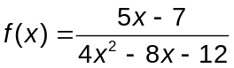. At what values of x is the function undefined?

Graph your function on page 5.2.
14. Do any horizontal asymptotes exist for this function? If so, where are they?

15. Sketch a graph of the function. Include asymptotes as dashed lines. Label asymptotes with their equations.
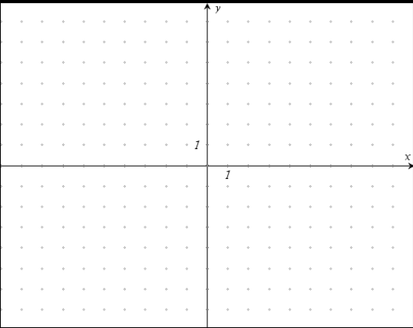

16. Factor the denominator of the function, 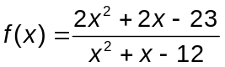.

17. What are the singularities for this function?

18. Do any horizontal asymptotes exist for this function? If so, where are they?

The function can be rewritten as 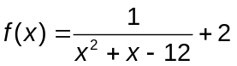.
19. How does the second representation of the function,, yield information about the horizontal asymptote of the function? As you consider the original function, does this agree with the information provided on page 2.4 regarding the ratio for the leading coefficients of the numerator and denominator when degrees are equal?

20. Sketch a graph of the function. Include asymptotes as dashed lines. Label asymptotes with their equations.

Additional Practice Problems
Identify the singularities, vertical asymptotes, and horizontal asymptotes for the given functions.

Function | Singularities | Vertical Asymptotes | Horizontal Asymptotes
21.
22. 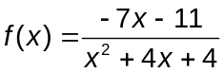
23. 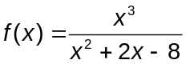
24. 

