Integer Darts
In this project, you will create an integer dart game. Part of the code has already been written in the “Integer Darts Template.tns” file. You will write the code to generate integer addition, subtraction, multiplication and division problems. You will also write the code to determine the score. Each correctly answered integer question will earn a dart. | Objectives:
Programming Objectives:
- Use variables to store values
- Use the randint() function to generate integers
- Use the print() function to display
- Use a while loop to repeat code.
- Use an if..elif statements to make decisions
Math Objectives:
- Add and subtract integers
- Multiply and divide integers.
- Use Pythagorean Theorem to find distance between two points (May be omitted. To skip, give students Template2 and stop coding after step 13.)
Math Course Connections: Middle School Mathematics
In this project, you will create an integer dart game. Part of the code has already been written in the “Integer Darts Template.tns” file. You will write the code to generate integer addition, subtraction, multiplication and division problems. You will also write the code to determine the score. Each correctly answered integer question will earn a dart.
Ask an integer addition, subtraction, multiplication or division problem | Correct answer earns a dart. | Another correct answer, another dart earned.
Incorrect answer. Correct answer displayed. Doesn’t earn a dart. | After 5 questions, the dart board appears. Player throws darts. | After all the darts are played, the final score is displayed.

- Obtain the “Integer Darts Template.tns” from your teacher. Part of the programming code has been coded for you.
Teacher Note:
Give students “Integer Darts Template2.tns” if skipping Pythagorean theorom. End project at step 13.
- Let’s examine the code template.  For each round, display the darts left, wait for the player to press “t” to toss  *You write code to create two random integers. Randomly determine an operation. Display the question. Check the answer. Add darts if the answer is correct.  Libraries needed for the project  Create the dart board.  Display earned darts each round |  | 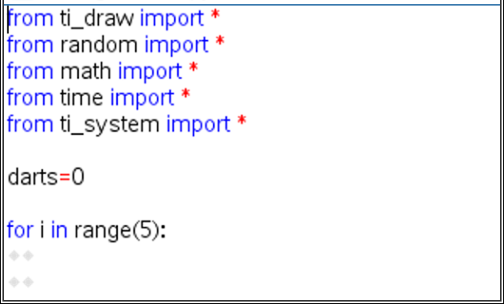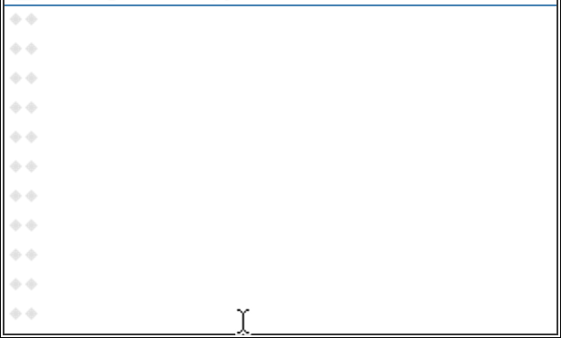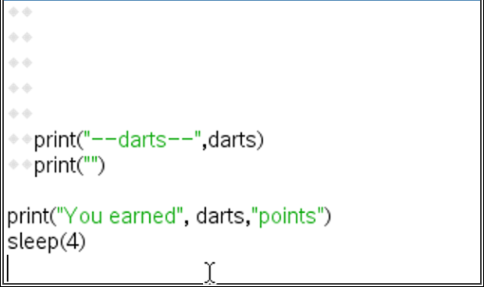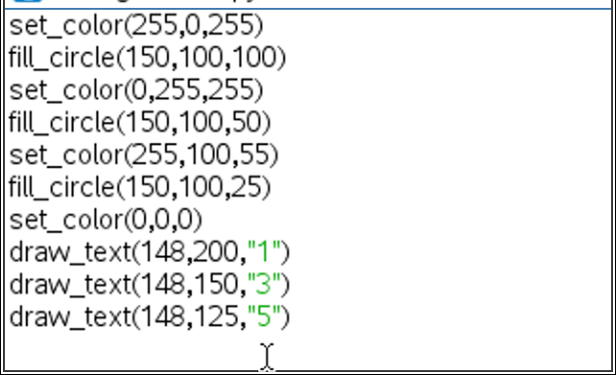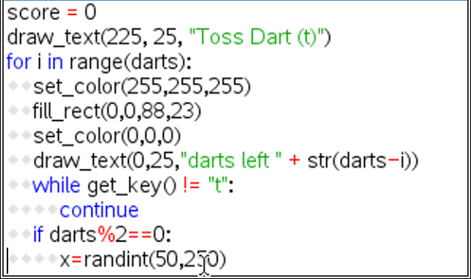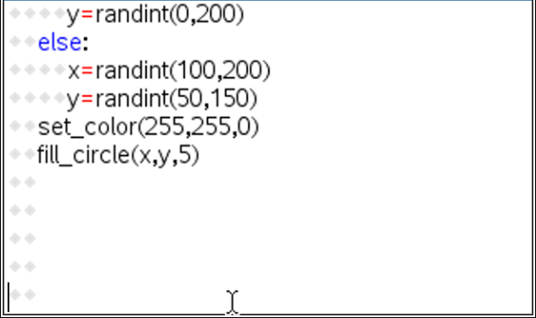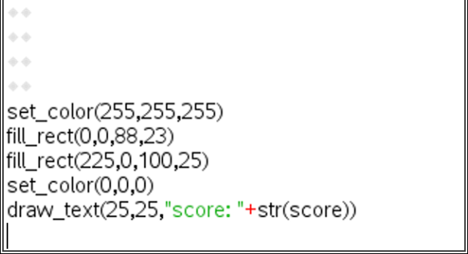  *You write the code to determine if the dart landed on the board. If it did, how many points did it earn?  Randomly generate dart location  Display final score
- Below are examples of all the types of equations your game will create.
a. -20 / -5 | b. 13 - -8 | c. -3 * -7 | d. -7 - 15 | e. 8 * -3
f. 8 * 3 | g. 9 + -8 | h. -48 / 6 | i. 42 / 6 | j. -1 + -18
k. 3 – 17 | l. -10 * 4 | m. -8 + 6 | n. -6 - -10 | o. 72 / -8
- Evaluate equation expression above without a calculator. Use your calculator to verify your answers.

- The first two lines of code will generate two random integers n1 and n2.  Initially, they will be any integer between -10 and 10.  Add the lines:  n1 = randint(-10,10)  n2 = randint(-10,10)  **randint -- You can type randint or you can find it in the menu  menu random randint |  | 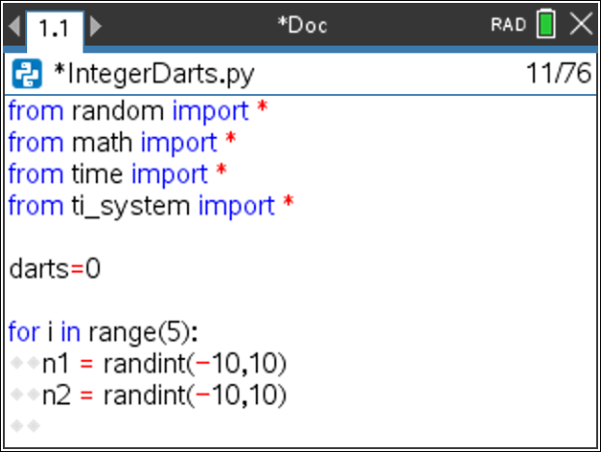
Teacher Note:
For differentiation enter different boundaries. For example n1=randint(-8, 12) generates integers from -8 to 12.
- Next, randomly select the operation. The function choice() lets you enter a list of possibilities. It then selects one item from the list. Notice the function has parenthesis (), the list starts and ends with square brackets [].  Add the line:  s = choice([“+”, “-“, “*”, “/”])  **choice -- You can type choice or you can find it in the menu  menu random choice |  | 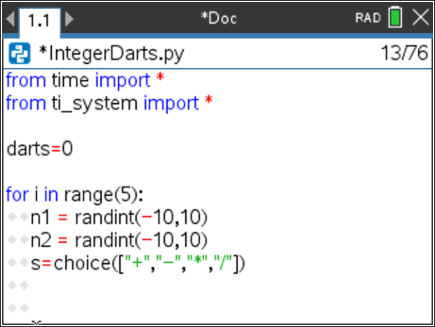
Teacher Notes:
For differentiation this list can be shortened. For example s = choice([“*’, “/”])
- If the choice is an addition or subtraction, we’ll make a wider range of integers possible. We’ll let n1 and n2 be anything from -20 to 20. This will require an if statement.  Python uses == to check IF two quantities are equivalent. By itself, the = sign assigns the variable on the left the value on the right. Notice how == and = are used in the statements below.  if s == “+” or s == “-”:  n1 = randint(-20,20)  n2 = randint(-20,20)  **if menu built-ins control if |  | 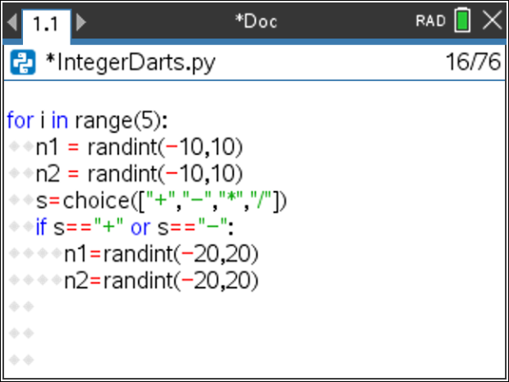
- If the sign was a division sign, you need to ensure you don’t divide by 0.  While n2 is a zero, you will generate a new integer value.  You only need to worry about 0 if the sign is “/”.  Therefore, the code will be  elif s == “/”:  while n2 == 0:  n2 = randint(-10,10)  **while menu built-ins control while  **elif menu built-ins control elif |  | 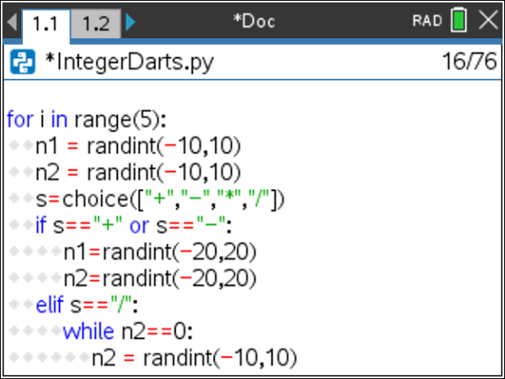
- If the sign was a division sign, we want to ensure the answer will be an integer.  For example, we don’t want questions like -12 / -7 or -8 / 3.  We want questions like -12 / -4 or 42 / -6 because they result in an integer.  Notice the n2=randint(-10,10) is indented from the while.  The n1 = n1*n2 line lines up below the w in the while.  n1 = n1*n2 |  | 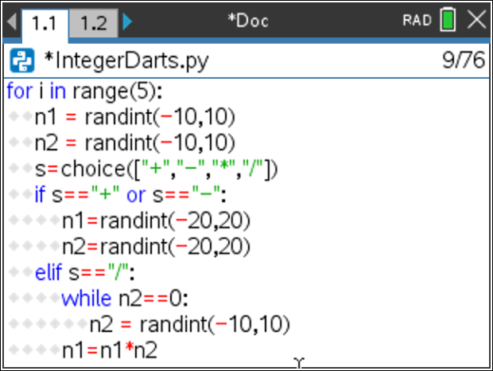
- Now to construct the question. We will concatenate, put together, the integers n1 and n2 with the string symbol. To put items together, they must all be of the same data type. You will use str(n1) and str(n2) to convert the integers to string.  prob = str(n1) + “ “ + s + “ “ + str(n2)  **str() menu built-ins type str |  | 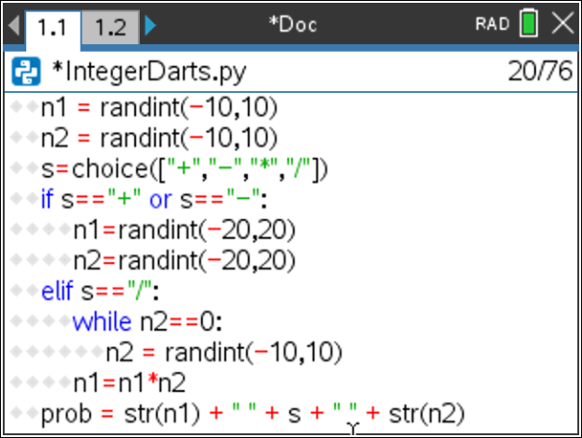
- You are now ready to ask the user for the answer. Python uses the function input to get information from the user and store it as a string. You will use int(input()) to get information and store it as an integer.  answer = int(input(prob + “= ”))  **int() menu built-ins type int  **input() menu built-ins i/0 input |  | 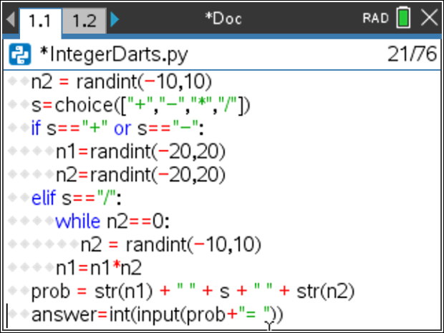
- If the user’s answer matches the evaluated problem, the user will earn a dart.  To add one to the darts total you could write darts = darts + 1. Python has a shortcut however, that is easier to type darts += 1. Print “correct”.  if answer == eval(prob):  darts += 1  print(“correct”)  **eval menu built-ins i/o eval |  | 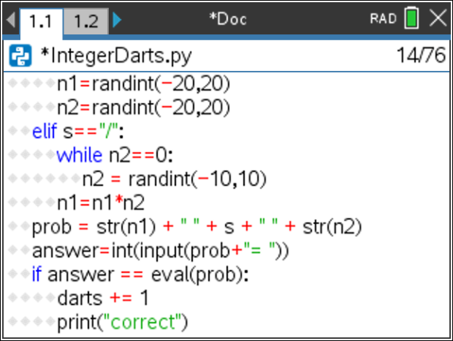
- If the answer isn’t true, the only option is false. Instead of using an elif like you did a few steps ago, use an else.  else:  print(“sorry, ”, eval(prob)) |  | 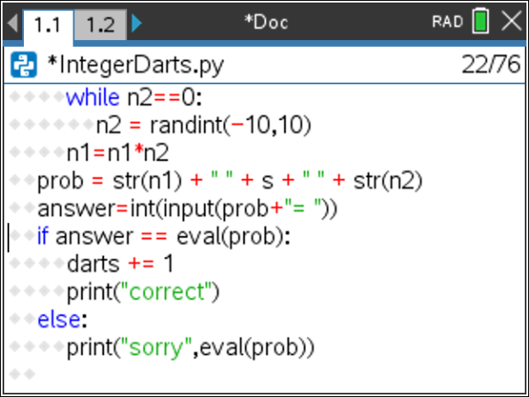
Teacher Notes:
If students were given Template2, their program is complete stop here.
Template1 is missing the Pythagorean Theorem (distance formula) code, continue.
- Now to code the scoring section.
The target is centered at (150,100).
If a dart lands at (200,13.4), it is barely inside the target. Find the radius for the largest region.
(You can use the scratchpad for calculations.)

- If a dart lands at (130, 54.2), It is barely inside the middle target. Find the radius for the middle region.
- If a dart lands at (140, 122.9). It is barely inside the smallest target. Find the radius for the smallest region.

- Fill in the blanks below with words or numbers.
To find the distance the dart lands from the center use ___________________
if the distance is less than or equal to _____
give 5 points because it is in the smallest circle
elif the distance is less than or equal to _____
give 3 points because it is in the middle circle
elif the distance is less than or equal to _____
give 1 point because it is in the largest circle
- Now to put the words called pseudo code from step 16 into Python syntax.  Scroll down to the next missing section of code. |  | 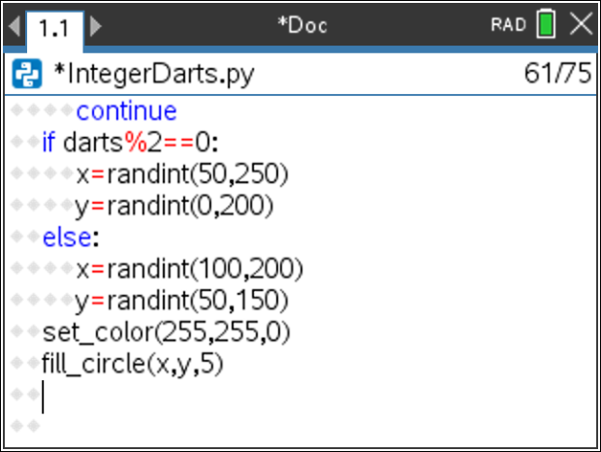
- To find the missing radius for each circle you used the Pythagorean Theorem:  leg1² + leg2² = hypotenuse²  (x – 150)² + (y – 100)² = radius²  $\sqrt{{\left(x-150\right)}^{2}+{\left(y-100\right)}^{2}}=radius$  The distance the dart lands from the center needs to be less than or equal to the radius of the circle.  Python uses **2 instead of ^2 to square numbers. The function sqrt() is used for square root.  Add  dist = sqrt((x-150)**2+(y-100)**2)  **sqrt menu math sqrt |  | 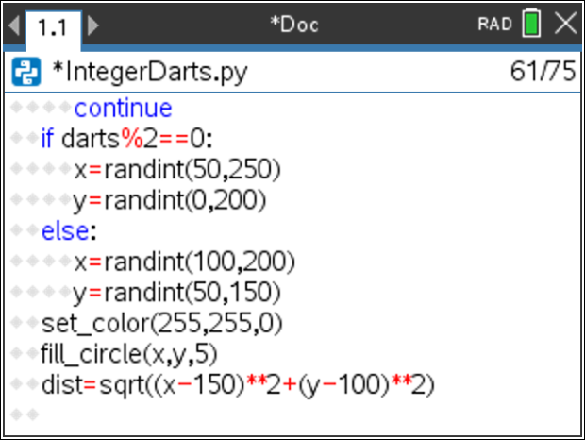
- Your pseudo code found above said:  if the distance is less than or equal to 25:  give 5 points because it is in the smallest circle  elif the distance is less than or equal to 50:  give 3 points because it is in the middle circle  elif the distance is less than or equal to 100:  give 1 point because it is in the largest circle  The dart has a width of 2.5 pixels. This gives 2.5 more pixels to the scoring region. Therefore, add the following:  if dist <= 27.5:  score += 5  elif dist <= 52.5:  score += 3  elif dist <= 102.5:  score += 1 |  | 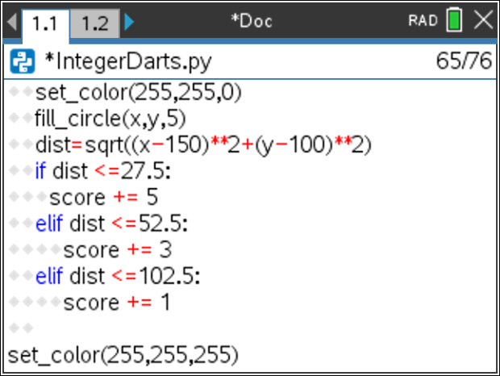
- Congratulations! You have typed all the code. Press [ctrl] [r] to execute the code. If you don’t have any errors, you should be able to play the game. If your code has errors, fix the errors, then play the game.
Teacher Notes:

from ti_draw import *
from random import *
from math import *
from time import *
from ti_system import *

darts=0

for i in range(5):
n1 = randint(-10,10)
n2 = randint(-10,10)
s=choice(["+","-","*","/"])
if s=="+" or s=="-":
n1=randint(-20,20)
n2=randint(-20,20)
elif s=="/":
while n2==0:
n2 = randint(-10,10)
n1=n1*n2
prob = str(n1) + " " + s + " " + str(n2)
answer=int(input(prob+"= "))
if answer == eval(prob):
darts += 1
print("correct")
else:
print("sorry",eval(prob))

print("-------")
print("darts",darts)
print("")

print("You earned", darts,"points")
sleep(4)

set_color(255,0,255)
fill_circle(150,100,100)
set_color(0,255,255)
fill_circle(150,100,50)
set_color(255,100,55)
fill_circle(150,100,25)
set_color(0,0,0)
draw_text(148,200,"1")
draw_text(148,150,"3")
draw_text(148,125,"5")

score = 0
draw_text(225, 25, "Toss Dart (t)")
for i in range(darts):
set_color(255,255,255)
fill_rect(0,0,88,23)
set_color(0,0,0)
draw_text(0,25,"darts left " + str(darts-i))
while get_key() != "t":
continue
if darts%2==0:
x=randint(50,250)
y=randint(0,200)
else:
x=randint(100,200)
y=randint(50,150)
set_color(255,255,0)
fill_circle(x,y,5)
dist=sqrt((x-150)**2+(y-100)**2)
if dist <=27.5:
score += 5
elif dist <=52.5:
score += 3
elif dist <=102.5:
score += 1

set_color(255,255,255)
fill_rect(0,0,88,23)
fill_rect(225,0,100,25)
set_color(0,0,0)
draw_text(25,25,"score: "+str(score))

