Gettin’ Trig-y with Python: Trigonometry Ratios
In this lesson, you will write a program that generates a random sine, cosine or tangent ratio. It will ask the user to enter a different trigonometric ratio based on the given triangle information. It will evaluate the user’s input. If the user’s input is incorrect, give the correct ratio.  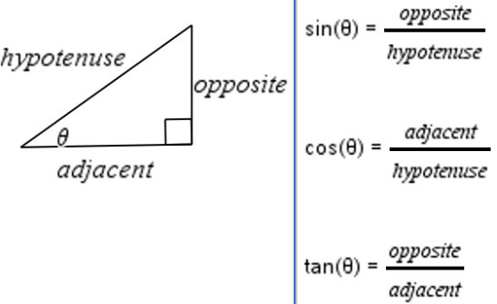 | Objectives:
Programming Objectives:
- Use the input function and a variable to collect and store data from a user
- Use the randint function to generate triangle side lengths
- Use the randint function to determine sine, cosine, or tangent prompts
- Use if..elif..else statements to make decisions
Math Objectives:
- Use the Pythagorean Theorem to find missing triangle side lengths
- Use right triangle trigonometry ratios to solve problems
For this project, you will write a program that generates a random sine, cosine or tangent ratio. It will ask the user to enter a different trigonometric ratio based on the given triangle information. It will evaluate the user’s input. If the user’s input is incorrect, it will give the correct ratio.

Problem 1 Prompt Problem 2 Prompt
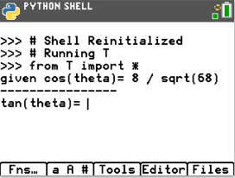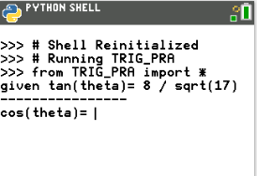

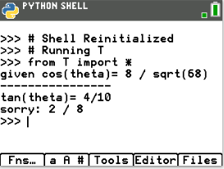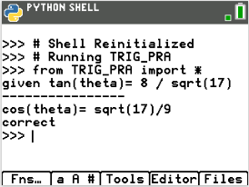
Incorrect answer entered, Correct answer was given.
gives the correct answer.

- Start a new Python project. Name the project TRIG_PRA.  To access the underscore, _, type [2nd] [ (-) ].  You do not have to put the underscore in the name of the file. You could name the file TRIGPRA  You are not allowed to use a space in the name of a project. Often, programmers will use an underscore to separate words variables and project names.  This project will utilize the randint function to generate random integers. This requires the random library. Select Random Simulation as the type. |  | 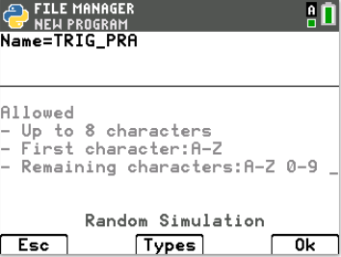
- Make sure the random library was imported.  If you forgot to select Random Simulation, you can go to  Fns> Modul> Random> from random import*  The comments, denoted by the # appear in light gray. These lines of code are optional. They do not affect how the program executes. Instead, they are notes to you, the programmer.  Comments are used to describe sections of code. This can be useful when debugging or modifying a program later. They help a programmer remember the purpose for different sections of code. These comments tell you the coder; this library is used for data sharing. |  | 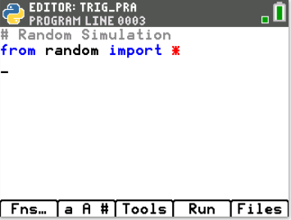
- Import the math library.  Fns> Modul> Math> from math import * |  | 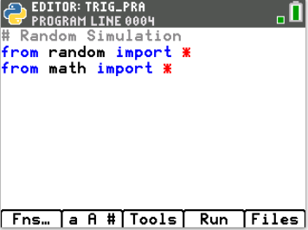
- The project will generate two integer sides for a right triangle.  It will calculate the missing side.  What is the name of the formula than can be used to find the missing side of a right triangle?  What is the formula that can be used to find a missing side of a triangle given two sides? |  | 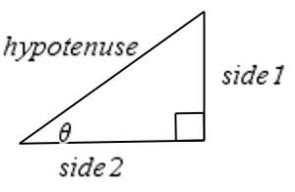
- Using the Pythagorean theorem, (side₁)² + (side₂)² = hypotenuse², you will create random right triangle side lengths.
To mix up the measurements, 1/3 of the time the sides will be integers, 1/3 of the time side1 and the hypotenuse will be integers and the remaining time side2 and the hypotenuse will be integers.
You will use an if..elif..else statement to make find the three options.

if randint(1,3) == 1:
#generate two integer side lengths
#calculate the hypotenuse
elif randint(1,2) == 1:
#generate opposite side and hypotenuse integers
#calculate the adjacent side
else:
#generate adjacent side and hypotenuse integers
#calculate the opposite side
- Add a comment to document this section of code.  [Tools] → C: Insert #comment below  or  [a A #] → # → [Paste]  #create sides  Add the if statement for the first option  Fns> Ctl> If..elif..else |  | 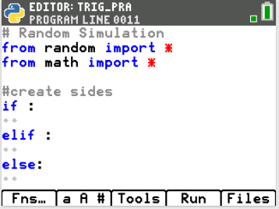
- The function randint(1,3) will generate numbers 1,2 and 3.  The function randint(1,2) will generate numbers 1 and 2.  Inside the first if statement, type  randint(1,3) == 1  Inside the elif statement type  randint(1,2) == 1  Fns> Modul> Random> randint |  | 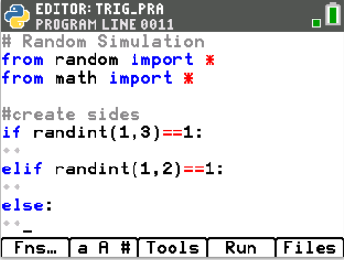
- Use randint to generate integer side lengths from 1 to 10.  In the if statement generate the opposite (op) and adjacent (adj).  In the elif statement generate the hypotenuse (h) and opposite (op).  The hypotenuse needs to be larger than the opposite side.  Therefore, start the hypotenuse options one more than op.  In the else statement generate the hypotenuse (h) and the adjacent (adj).  The hypotenuse needs to be larger than the adjacent side.  Therefore, start the hypotenuse options one more than adj.  **Tech Tip** the [Tools] menu has a copy line and paste line option.  It could be helpful to copy, paste and alter lines. |  | 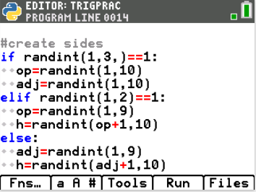
- Use the Pythagorean theorem,  (opposite)² + (side₂)² = hypotenuse²  to find the missing side length for each part of the if..elif..else.  To take the square root, type sqrt() or Fns> Modul> Math> Sqrt  To square each side you can multiple the side by itself, such as  adj*adj  or use **2 to square such as  adj**2 |  | 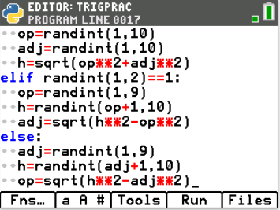
- Double check your equations.  Did you use:  h = sqrt(op**2 + adj**2)  op = sqrt(h**2 – adj**2)  adj = sqrt(h**2 – op**2) |  | 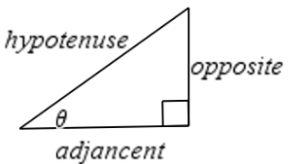
- Right now the values for the side lengths are stored as integers.  For display purposes we will need a string copy.  If the length is an integer, we will simply put str() around the value and save it under a different name.  For example, in the first if statement you found and stored the value of the adjacent side using the formula:  adj=randint(1,10)  To make a display string you will type  adj1=str(adj)  If the length is a number with a square root, it most likely is an irrational number. Instead of displaying the value as an evaluated decimal value, we will get a little fancy. We will put the words “sqrt(“ in front of the non-evaluated number.  For example, in the first if statement you found and stored the value of the hypotenuse using the formula:  h=sqrt(op**2+adj*2)  To make a display value you will type:  h1 = “sqrt(“ + str(op**2+adj**2) + “)”  if randint(1,3)==1:  op=randint(1,10)  adj=randint(1,10)  h=sqrt(op**2+adj*2)  op1=str(op)  adj1=str(adj)  h1="sqrt("+str(op**2+adj**2)+")"  elif randint(1,2)==1:  h=randint(1,10)  op=randint(1,10)  adj=sqrt(h**2-op**2)  h1=str(h)  op1=str(op)  adj1="sqrt("+str(h**2-op**2)+")"  else:  h=randint(1,10)  adj=randint(1,10)  op=sqrt(h**2-op**2)  h1=str(h)  adj1=str(adj)  op1="sqrt("+str(h**2-op**2)+")"  **Tech Tip** the [Tools] menu has a copy line and paste line option.  It could be helpful to copy, paste and alter lines |  | 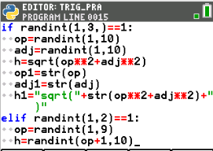  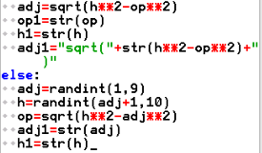  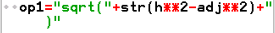
- Let’s check your code so far. In large projects such as this one, programmers execute the code often to check for errors.  Add three print lines to display the three display values.  Make sure the print lines are NOT INDENTED.  Fns> > I/O> print  print(adj1)  print(op1)  print(h1)  Execute the program multiple times. Run  Each time only one value should have sqrt() displayed. |  | Sample Runs:  The first time adj1 is a square root.  The second time op1 is a square root.
- Remove the three print lines.  This app should let you practice three different trig functions.  For example, it might give  the ratio for sin(θ) and ask the user to find the ratio for tan(θ)  or  the ratio for cos(θ) and ask the user to find the ratio for sin(θ)  There are three choices for the given function and three for the function  to find.  given = randint(1,3)  find = randint(1,3) |  | 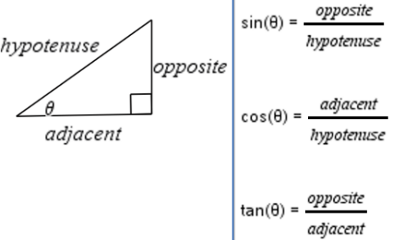  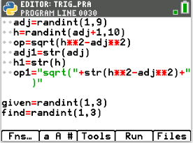
- It is highly likely (1/3) that the variable to find matches the given variable.  To fix this, add a while loop that will continually generate the find until while the find matches the given.  while find == given:  find=randint(1,3)  Fns > Ctl> while  Make sure to use == to check if they match. |  | 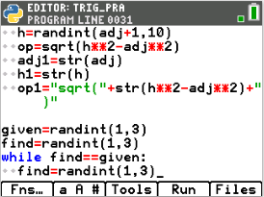
- If the given is a 1, display the ratio for sin(θ).  If the given is a 2, display the ratio for cos(θ).  If the given is a 3, display the ratio for tan(θ).  Outside the if statement print “-----------”  if given == 1:  print("Given: sin(theta) =",op1,"/",h1)  elif given == 2:  print("Given: cos(theta) =",adj1,"/",h1)  else:  print("Given: tan(theta) =",op1,"/",adj1)  print("-------") |  | 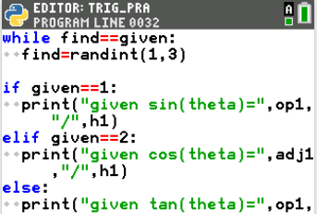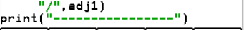
- A similar if..elif..else statement will print the ratio to find, retrieve the user’s result AND determine if the user is correct.  To start let’s display the question.  if find == 1:  ans=eval(input("sin(theta) = "))  elif find == 2:  ans=eval(input("cos(theta) = "))  else:  ans=eval(input("tan(theta) = ")) |  | 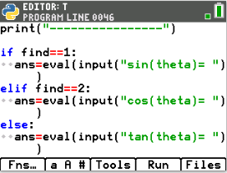
- Now, compare the entered answer to the correct answer.  For example, if find = 1, compare the answer to sin(θ).  We need to know if ans == op/h.  Because the answer is stored as a float (decimal), and op/h evaluates to a decimal, it is possible to have a round-off error when comparing. To fix this, we will check to see if the difference between the answer and op/h is less than 0.00001.  if abs(ans – op/h) <0.00001:  print(“correct”)  else:  print(“Sorry”,op1,”/”,h1) |  | 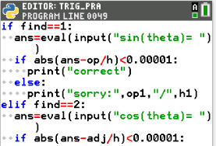  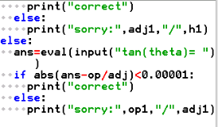
- Execute your program. Run  Sample 1  $\cos\left(theta\right)=\frac{8}{sqrt(68)}$ = $\frac{adjacent}{hypotenuse}$  opposite² + adjacent² = hypotenuse²  $opposite$² + 8² = sqrt(68)²  $4$ = opposite²  opposite= sqrt(4) = 2  $\tan\left(theta\right)=\frac{opposite}{adjacent}$ = $\frac{2}{8}$  Sample 2  $\tan\left(theta\right)=\frac{8}{sqrt(17)}$ = $\frac{opposite}{adjacent}$  opposite² + adjacent² = hypotenuse²  8² + sqrt(17)² = hypotenuse²  hypotenuse²= 64+17  hypotenuse = sqrt(81) = 9  $\cos\left(theta\right)=\frac{adjacent}{hypotenuse}$ = $\frac{sqrt(17)}{9}$ |  | Sample 1  Entered 4/10 incorrect answer  Sample 2
- Now that you have a trigonemtry practice app, can you answer 5 questions in a row correctly?

Can you get 10 in a row correct? Go on, Get Trig-y with it!

