Lesson Overview
In this activity, students investigate the concept of herd immunity and the role vaccines/interventions can play in helping to control the spread of a communicable disease. They will simulate the spread of a disease with a known transmission number in a community where a percent of the population is immune because they were vaccinated or because they had prior exposure to the disease. The process will help them identify the herd immunity threshold, the percent of the population that should be immune in order to stop the spread of the disease. Different diseases have different transmission numbers, and students will explore the effect of these different numbers on the herd immunity threshold. | Learning Goals
Students will be able to:
- Relate and interpret multiple representations of the same situation
- Use simulation to investigate probabilities
- Use and interpret percentages in contextual situations
- Identify common terms used in reporting the spread of a communicable disease
4

About the Lesson and Possible Course Connections:
The activity can be used whenever students have a background in elementary probability and reasoning with percentages. It would be very appropriate for a unit on quantitative reasoning or statistical literacy. Questions 6-8 in the extension provide an opportunity for students who have worked with functions to examine how several functions are related to each other and to interpret the behavior of the functions in terms of the context. These questions could be used earlier in the lesson if appropriate.

The lesson has three components, with each component at a higher level of abstraction. Part I consists of a physical simulation followed by a technology-based simulation; Part II involves an automated simulation using the program HERD.

CCSS Standards

Statistics and Probability Standards:
- 7.SP.A.1
- 7.SP.A.2
- 7.SP.C.6
- 7.SP.C.7
- HSS.IC.A.1
- HSS.IC.B.5
- HSS.CP.A.2
- HSS.MD.B.7
Mathematical Practice Standards

SMP.4

Lesson Materials
- Compatible TI Technologies:
TI-84 Plus*; TI-84 Plus Silver Edition*; TI-84 Plus C Silver Edition; TI-84 Plus CE
* with the latest operating system (2.55MP) featuring MathPrint TM functionality.
TI-Smartview CE software
- Herd Immunity_Teacher Notes.doc
- Herd Immunity_Teacher Notes.pdf
Background
During the recent pandemic, herd immunity was raised as a way to stop or control the spread of the coronavirus. Herd immunity is a form of indirect protection from an infectious disease that occurs when a sufficient percentage of a population has become immune to the infection. Immunity typically results after someone has been vaccinated or has had the disease and consequently developed a resistance to the disease. The more immune individuals in a community, the smaller the probability that non-immune individuals will come into contact with an infectious individual. Herd immunity is important for people who can’t get the vaccine for reasons such as location or health and those who are too ill to become naturally immune to the disease. Herd immunity depends on the contagiousness of the disease. Diseases that spread easily, such as measles, require a higher number of immune individuals in a community to reach herd immunity.

The following activity describes how simulation can be used to investigate the way in which herd immunity works. A picture can often provide a different way to make sense of a situation. Thus, the activity is based on “seeing” the spread of a disease using a scatterplot to represent a community and colors denoting those contacting the disease as well as representing the spread numerically.

Teacher note: The activity uses a time period of days for the duration of a contagious period for a disease. This varies with the disease and is often referred to in other terms, such as primary and secondary infectious people or in terms of generations of the disease in the transmission chain.

Facilitating the Lesson
Suppose a given percent of the population in a small community of 100 people is immune to a disease either by having been vaccinated or through prior exposure. Suppose also that a person newly infected with the disease typically will infect two people. Estimate how long will it take the spread of the disease to stop. What proportion of the community did not contact the disease before it stopped spreading? Describe how the number of newly infected people changes each day.

1) Open-Ended Approach:
Students can be given the information and asked to think about how they might use a simulation to approach the problem. After some individual think time, students should share their thoughts in groups of two or three. To prevent the task from being overwhelming or to deter students from just putting the two numbers together without much thought, they might be encouraged to try some simulations to investigate the situation. Students should be careful to think about the meaning of percentages and what cautions should be considered in working with them.

2) More-Structured Approach to Finding a Model:
The teacher might lead the class through the first part of the investigation as described below where each student or small group generates their own simulations, with frequent pauses to check that students understand what they are simulating, what the numbers and lists they generate mean, and how their results compare. It is important to recognize that samples drawn from the same population will vary, that the variability will have a certain regularity depending on the sample size, and this variability will show up when students compare their simulated results.
Teacher Tip: Typical student answers might be 90% or 2 to some power. The investigation below should make clear why these are not viable answers. Students should compare answers to their simulations, noting the variability that is inherent in the simulation process.

What to Expect: Example Student Approaches
Exploration 1
No Technology:
Materials needed: large chart, light grey, blue and pink sticky notes.
Suppose the class has 30 students, and 10% of them have had the disease and so are immune. Have the class stand. Give each student a number from one to thirty and have a chart with the numbers from 1 to 30 scattered on the chart. Students with numbers 1, 2, and 3 will represent the 10% who have been vaccinated or are immune because they have already had the disease and should cover their number with blue sticky notes, writing the number again on the sticky note and sit down. (The colors denote different stages of the spread and also coordinate visually with the other examples in the activity.) The remaining students with numbers 4 to 30 represent those students who are susceptible to contacting the disease, and they should cover their number with a light grey sticky note, again writing their number on the sticky note.
- Generate a random integer from 4 to 30. This student, say 20, is bringing the infection into the community and should replace the number 20 with a pink sticky note and sit down. This makes 4 people who are now or will be immune (pink or blue notes).
- Person 20 generates two random integers from 1 to 30 on his/her calculator, say 26 and 21. These two students replace their sticky note notes with pink ones, bringing to 6 the number of immune people for day 1, and sit down. (If the first two random integers generated represent already immune people (1,2, or 3), redo the simulation; this can happen by chance and a question at the end of the activity explores this possibility.)
- Students 21 and 26 both generate two random numbers, say 2, 18 and 15, 6 respectively. Student 2 is already sitting and has a blue sticky note and so does nothing. Students 6, 15 and 18 replace their notes with pink ones, sit down, and each generates two new random numbers representing those they infect, say 17, 5; 30, 22; 12, 29; respectively (Table 1) continuing the process.

Table 1 Spread of disease given that each newly infected person typically infects two new people and that 25% of the population was immune
 | Newly infected people | Infects random people | Immune/seated | Newly infected per day | Total number of Immune/seated
Day 0 |  | 20 | 1,2,3,20 | 1 | 4
Day 1 | 20 | 26, 21 | 1,2,3,20,21,26 | 2 | 6
Day 2 | 26 | 15, 6 | 1,2,3,6,15,20,21,26, | 3 | 8
 | 21 | 2, 18 | 1,2,3,6,15,18,20,21,26 |  | 9
Day 3 | 6 | 17, 5 | 1,2,3,5,6,15,17,18,20,21,26 | 6 | 11
 | 15 | 30, 22 | 1,2,3,5,6,15,17,18,20,21,22,26,30 |  | 13
 | 18 | 29,12 | 1,2,3,5,6,12,15,17,18,20,21,22,26,29,30 |  | 15
Day 4 | 5
 | 17
 | 22
 | 30
 | 12
 | 29

As more students are seated, the class should pay close attention to how many students do not yet have the disease and clearly record the number of those with the disease at the end of each “day”. The class should continue the simulation until everyone is either infected or was immune to begin with or the infected people are only spreading the disease to those who have been vaccinated or already have had the disease. Table 2 shows the results of carrying out the simulation above until that point, for a total of 19 newly infected people and 3 who were originally immune or 22/30 $≈$73 or 73%. This is called the herd immunity threshold. The answers to the questions above for this simulation are:
- An estimate for how long will it take the spread of the disease to stop is about six days.
- About 8 or 27% of the community did not contact the disease before it stopped spreading.
- The number of newly infected people grew until day four and then it dropped rapidly.

Table 2 Summarizing the simulation results for reaching herd immunity
Day | Newly infected each day | Originally immune | Total infected/ immune
0 | 1 | 3 | 4
1 | 2 | 3 | 6
2 | 3 | 3 | 9
3 | 6 | 3 | 15
4 | 6 | 3 | 21
5 | 1 | 3 | 22
6 | 0 | 3 | 22

As students move to larger populations, the use of technology can make the process more efficient and time saving. However, the hands-on experience will help ensure that students actually understand what the technology is doing.

With technology:  To “see” what is happening with the spread of a disease, create a set of ordered pairs to represent a population: math PROB, randInt( . Choose lower 1, upper 50 for n= 100 (Figure 1); enter; then store randint(1,50,100) to L1. | 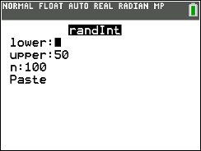  Figure 1 Selecting random integers

Repeat the commands and store to L2 (Figure 2). | 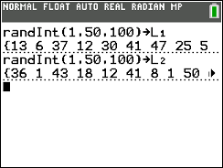  Figure 2 Creating ordered pairs to represent original population
To graph the ordered pairs, select statplot, activate Plot1 and set the parameters as in Figure 3. | 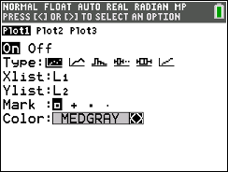  Figure 3 Choosing variables for scatter plot
Set the window as in Figure 4 and graph. | 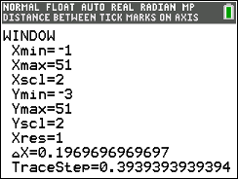  Figure 4 Setting up the graph window
The scatter plot represents the 100 people in a small community (Figure 5). | 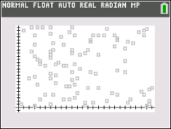  Figure 5 Scatter plot representing 100 people in community
Of those 100 people, 10% are immune, either because they have already had the disease or because they were vaccinated against it. Let the people in rows 1 to 10 represent these people and copy those values into L3 and L4 (Figure 6) | 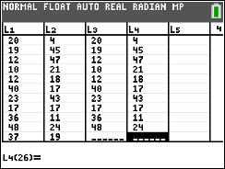  Figure 6 Identifying those immune
In statplot, activate Plot2 and add (L3, L4) to the plot using a different color, say magenta. The graph displays the population of the community with those infected/immune identified (Figure 7). | 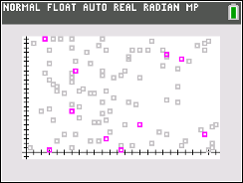  Figure 7 Community before onset of disease with 10% vaccinated
Randomly generate an integer from 11 to 100 (Figure 8). This number will identify a row in the spreadsheet and the corresponding ordered pair representing a new person in the community with the disease. | 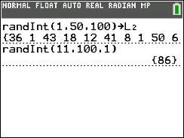  Figure 8 Identifying newly infected person in the community
Finding the coordinates to locate that person can be done by scrolling down the rows to the desired row number, row 86 in the example (Figure 9), or by calling up the values from row 86 for (L1, L2) on the home screen and storing them in (L5, L6). | 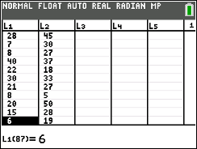  Figure 9 Identifying the row with coordinates of newly infected person
To do this, select L1(86) sto→ L5(1) and L2(86) sto→ L6(1) as shown in Figure 10. | 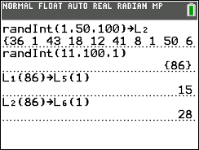  Figure 10 Identifying a newly infected person
To see the graph, go to statplot and activate Plot3 to display (L5, L6). Figure 11 shows the lists with the coordinates of the infected person, 86, at (15, 28). | 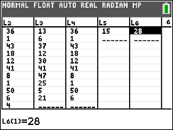  Figure 11 Table displaying coordinates of newly infected person
Figure 12 shows the graph updated with the infected person, 86, in black. | 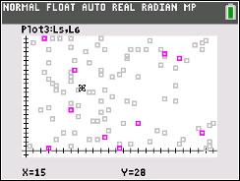  Figure 12 Graph of community showing the first newly infected person
Assume that each infected person on average infects two other people; that is, the transmission number is 2. This number typically depends on several variables such as the length of the infection period for the disease, the population density of the area, the age of the people in the area and sometimes other underlying medical conditions. To see which two people in the community are infected by person 86, arrow up to the random integer command (Figure 13) and press enter, to copy that command down to a new line. | 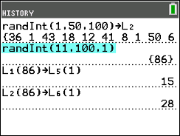  Figure 13 Spreading the infection
Use the arrow keys to change from generating one random integer to generate two random integers from 1 to 100 as shown in the 4th line of Figure 14.  Teacher tip: If students generate two numbers that both represent people originally immune, have them just start the simulation over. At the end of the activity, they might use the program Herd to investigate how likely this is to occur over many, many simulations. | 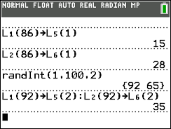  Figure 14 Identifying the coordinates of the two newly infected people
To find the ordered pairs for the two newly infected people, store L1(92) into the second row in L5, L5(2).  Use a colon to separate the commands and enter the command to store L2(92) to L6(2). Note the home screen shows only the coordinate in L6 (Figure 15). Checking the list will display both coordinates. | 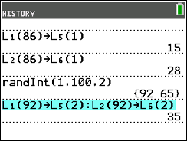  Figure 15 Repeating a command
To repeat the process for the second newly infected person in row 65, arrow up to highlight the last command (Figure 14). Enter pastes the command in the active line. Change the 92 to 65 and store the new coordinates in L5(3) and L6(3) and Enter twice (Figure 16) | 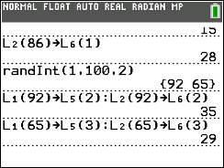  Figure 16 Storing coordinates for persons 92 and 65 into L5 and L6
The graph now displays the three people infected with the disease (Figure 17) after day 1. (Note that day 0 is the appearance of the first diseased person to enter the community.) | 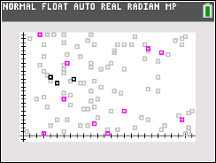  Figure 17 Newly infected people the first day
Neither of the two newly infected people was immune so they will each have the potential to infect two other people. Arrow up to capture the random integer command as shown in Figure 18. | 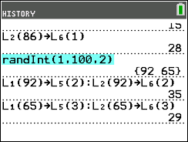  Figure 18 Those in contact with newly infected the second day
Then press enter and change the number of random integers to four (Figure 19) before executing the randint( command.  Note: Of the four people generated, only three are susceptible. Person in row 86 was already infected and cannot be reinfected, so on the second day of the spread of the disease, only three people were newly infected, making a total of six infected people at the end of day two. | 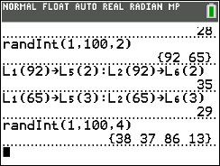  Figure 19 Generating more newly infected people

Teacher note:
- This part of the activity assumes that the contagious period for the disease is 1 day. The second part of the activity allows changing this assumption.
- Keeping track of those infected and not infected is necessary to determine how many new people are infected each day of the disease, that is how many random numbers need to be generated. Remember people numbered 1 to 10 are immune. Working in pairs, students might make a stem-and-leaf plot for each day as shown below. One person can generate the random numbers, and the other mark off the number for each newly infected person. The plot could look like the following given the random numbers generated after three days:

 | Day 0 | Day 1 | Day 2 | Day 3 | Day 4 | Day 5 | Day 6 | Day 7
0
1 |  |  | 3
2
3 |  |  | 7, 8
4
5
6 |  | 5
7
8 | 6
9 |  | 2
10
Total | 1 | 2 | 3

where 8| 6 is the person in row 86

In the simulation above, it took 16 days before those infected no longer had contact with those who were susceptible; that is, all of the random numbers generated were repeats of earlier numbers or of the original 10% that were immune. A graph of the community on the 16th day of the disease is displayed in Figure 19. The number of gray dots, 30 of the 100 people in the community, represent susceptible people who never contracted the disease. The community had achieved what is called herd immunity. The disease stopped spreading after 70% of the population was immune through vaccination or having had the disease (the original 10% plus the newly infected 60% from Table 3). In technical language, the herd immunity threshold of 70% had been reached. | 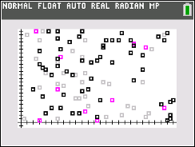  Figure 19 Status of the disease in the community when the disease stopped spreading.

Teacher tip: Because random samples are involved, the threshold will differ from student to student. Collecting everyone’s results and finding a mean threshold will provide a better approximation of the actual threshold, given the assumptions that each newly infected person typically infected two other people, the person was contagious for one day, and the starting population was 100.

Table 3 Summarizing the simulation results.
Day | Newly infected each day | Total infected
0 | 1 | 1
1 | 2 | 3
2 | 3 | 6
3 | 6 | 12
4 | 7 | 19
5 | 7 | 26
6 | 5 | 31
7 | 8 | 39
8 | 5 | 44
9 | 5 | 49
10 | 4 | 53
11 | 2 | 55
12 | 2 | 57
13 | 1 | 58
14 | 1 | 59
15 | 1 | 60
16 | 0 | 60

The answers to the original questions of interest for this simulation are:
- An estimate for how long will it take the spread of the disease to stop is about 15 days.
- About 30% of the community (considering the10% originally immune and 60% newly infected according to the simulation) did not contact the disease before it stopped spreading.
- The number of newly infected people peaked between days 4 and 7, then gradually dropped off.

Students might explore questions such as the following:
- How did the simulation results compare across the class?
- If people are typically ill and hospitalized for at least five days, what is the maximum capacity the hospital would need to accommodate all of those who got the disease? Explain your reasoning.
- How do you think the simulation would change if each newly infected person was contagious for two days, that is affected two people each day for two days? Explain your thinking.

Part Il. Exploring simulations with a program
Use the program HERD to answer each of the questions below. Enter the initial conditions after each prompt. For example, if the initial conditions on day 0 are similar to those in the example above where 10% of the community of 100 people has been vaccinated (or is immune because they have had the disease), and one newly infected person is in the community, enter S = 89; I = 1; T = 2; V = 10; and C = 1 (Figure 20). | 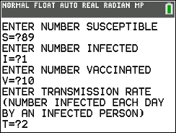  Figure 20 Enter conditions to run simulation
The total is 100, which is the number of people in the community. Pressing enter after designating C, will display a graph of the 100 people in the community on day 0, where the original 10 were vaccinated, 89 are uninfected and susceptible, 1 is newly contagious (Figure 21). | 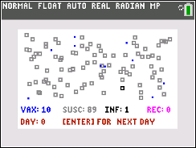  Figure 21 Community on day 0
Pressing enter will display the community for each succeeding day. The herd immunity threshold, the sum of the vaccinated and the number that have recovered has been reached when the number infected or the number of susceptible reaches 0 (Figure 22). | 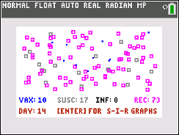  Figure 22 Herd Immunity Threshold of 83% reached
Teacher Tip:
- The program differs from the examples in Part I of the activity in that the user can choose the number of days an infected person is contagious.
- The program may run slowly so encourage students to be patient. Increasing the total number in the community may make the program even slower.
- Be aware that under some conditions, it is possible that the number of susceptible will become 0 before the number of infected does. In these cases, it may take several more days before everyone has recovered even though the disease has stopped spreading because there is no one left who has not already been infected or immune. This might be an important factor in the need for care.
- Pressing Enter after the herd immunity threshold has been reached will display the Susceptible, Immune and Recovered (SIR) graphs of the three functions with respect to time. Trace will display the function being graphed at the top of the screen. Questions 5 and 6 in the extension explore the behavior of these functions under different conditions. If students have not yet studied functions other than linear, they should omit that last step.

- Play with the program using different inputs for the conditions. Explain how the program relates to the simulation carried out by hand in the example above.

- Use HERD to create the table below for the conditions: 10% originally immune, one person newly infected and contagious for one day, 89 susceptible people, and each person infects two other people. How did the answers to the three questions from the example change?

Summarizing the simulation results.
Day | Newly infected each day | Number susceptible
0
1
2
3
4
5
6
7
8
9
10
…

- At one point in the COVID-19 pandemic, researchers conjectured that each person with COVID-19 infected four other people and that about 10% of the population was immune at the start because they had already contacted the virus.
- Think about your results for problem 1 above in a community of 100 where each person infected two other people. For the COVID-19 situation above make a conjecture about whether the percentage of the people in the community that would be infected before reaching the herd immunity threshold would increase or decrease and whether the number of days it would take to reach this point would increase or decrease. Explain your reasoning.
- Check your conjectures using the program HERD. Make a table similar to the one above to organize your results.
- How does the table change when each newly infected person infects two people compared to the table when each newly infected person infects four people?

- Suppose no one in the community of 100 people was vaccinated or immune to the disease.
- Set up the simulation to estimate the herd immunity threshold for a disease where each infected person infects two new people and a person is contagious for one day.
- Use the results to respond to the following: How long before the spread of the disease stops? What percent of the community never got the disease? Describe the change in the number of people affected each day.

- Does the size of the community affect the herd immunity threshold? Explain your thinking.

- Suppose 10% of a population of 100 people have been vaccinated.
- Make a conjecture about how the results will change if the number of people each person affects increases but the disease is still contagious for one day. Use the file to check your conjecture.
- Which do you think will have a greater effect on the Herd Immunity Threshold, infecting a larger number of people or being contagious for more days? Use the file to check your thinking.
- Compare your results with others in class.

- Explain what will happen to the herd immunity threshold if the transmission number is less than 1, equal to 1 or greater than 1. Give reasons to justify your thinking.

- Suppose the transmission number is 0.7, and the contagious period is 10 days. Make a conjecture about the number of days before the community reaches a herd immunity threshold. Use HERD to check your conjecture.

Formalizing the Vocabulary
Several formal terms are used by scientists in discussing the spread of a communicable disease, and studies show that these terms are often confused. Students might refer back to the results of their simulations and identify the numerical values for each of the terms below:
- Ro: the average number of secondary cases generated by a single primary case during its entire period of infectiousness in a fully susceptible population, a population in which no one is immune.
- R or Re: the average number of new infections caused by a single infected individual in a partially susceptible population, where some members of the population are immune through vaccination or prior exposure to the disease (sometimes called the effective reproduction number).
- Herd Immunity: the critical proportion of the population needed to be immune to stop the transmission of disease.
- Generation time: the time lag between infection in a primary case and a secondary case. In the examples above, “day” was used to keep the context simple, but a “day” could translate as a generation.

Validating the Models
Students should validate their models either by asking whether the models make sense in different scenarios related to the context or by finding other information to reflect against the model. The suggestions below might be useful in helping students think about whether their model was reasonable:
- Students should compare their results of their simulations to those others found. Note that the values might vary by several percentages. If the results are quite different, students should reexamine what they did.

- One formula for finding herd immunity threshold is HIT=1-1/Ro. (https://en.wikipedia.org/wiki/Basic_reproduction_number). In problem 3 above, Ro would be 2 and 5 for the respective cases.
- Use the formula to find the herd immunity threshold for both cases.
- How do your answers compare to the answers from your simulation? What might explain any differences?

- Many different formulas are used to find Ro because there are many variables involved in the actual spread of a disease.
- List some possible variables that could affect the spread of a disease.
- One formula is $Ro=$ $\frac{β}{γ}$ where $β$ is the transmission rate or reproduction number in some time period, and $γ$ is 1/average infectious period (Singh, 2017). If the Ro for measles is 12 to 18, and the average infectious period is 6 to 7 days, what is the reproduction number for measles?

Extension

- The information in the table below assumes that no one in the population has been vaccinated or is immune at the onset of the disease.
- Select at least two of the diseases and calculate the herd immune threshold.
- Research the disease and write a short paragraph describing why it is dangerous, where in the world the disease is most prevalent, where it has been relatively controlled and how this was achieved. Include any other interesting information you found.

Well known diseases (Note that these values vary considerably in different contexts)

Disease | Transmission | Infectious period
measles | 2.5 | 6-7 days*
flu | 0.9 | 1-3 days*
Common cold | 0.3 | 2-14 days***
Ebola | 0.2 | 2-21 days**
HIV | 0.4* | 21 days median*****
Hoof and Mouth Disease | 0.25 | 3-5 days ******
Malaria | 6 | 7-30 days****
Singh (2017)
* https://en.wikipedia.org/wiki/Basic_reproduction_number
**https://www.who.int/news-room/fact-sheets/detail/ebola-virus-disease
***https://www.cedars-sinai.org/blog/am-i-still-contagious.html
****https://www.cdc.gov/malaria/about/disease.html

- The headlines of an article asked: “A COVID-19 Vaccine May Be Only 50% Effective. Is That Good Enough?” How would you answer the question?
(Aubrey, A., September 12, 2020).

- A poll found that seven in 10 Americans said they would get vaccinated against the coronavirus if immunizations were free and available to everyone. Given the estimate that, as of October 2020, 10% of the population has had COVID-19, would this be enough to achieve “herd immunity”? Explain your thinking.

- Suppose that the transmission number is 2, an infected person is contagious for one day in a community of 100 people, and no one has been vaccinated or is immune at the onset of a disease.
  - Use the program HERD to generate at least 25 simulations of the herd immunity threshold and the number of days before the threshold is reached and create sampling distributions for each variable. Describe the two distributions.
  - Use the sampling distribution for the herd immunity threshold to estimate a confidence interval. Explain what this means in words that would be understood by the general public.*

- The transmission number for COVID-19 varied from 0.86 in Wyoming to 1.21 in Arizona according to data compiled as of December, 14, 2020 (Statista). COVID-19 is thought to be contagious anywhere from 10 days to up to 20 days (MIT Medical, December 17, 2020).
- Suppose 65% of the population were vaccinated. Would this be enough to achieve herd immunity if the contagious period is 10 days? Why or why not?
- If the contagious period is actually 20 days, would the 65% be enough to achieve herd immunity?
- If your answers to a) and b) are no, what percent would need to be vaccinated to achieve herd immunity in as short a time as possible.

- Suppose a person newly infected with a disease entered a community of 100 people. The transmission rate was 1, and the length of time a person was contagious was 2 days. Choosing Enter after the herd immunity threshold has been reached displays the SIR graphs of the three functions (days, susceptible), (days, infected) and (days, recovered). Take a picture of the graphs using Screen Capture so you can compare the results to other simulations.
- Use trace to help analyze the graphs. How can you find the herd immunity threshold from the graphs?
- Write three or four sentences describing the story in the graphs. Include when the spread is at its peak, the maximum number of people in the community who contacted the disease (the herd immunity threshold), the number of people who never contacted the disease, the number of days before herd immunity was reached, and what is conveyed by the points of intersection of the three curves.
- Set the number of days to 0 and change the number of days contagious to 4. Run the simulation and take a screen capture of the SIR graphs. How do the three graphs change from those in part b)? What would be different between the story in these graphs and the story you described in part b)?
- Set the number of days to 0, change the transmission number to two and return the number of days contagious to two. Repeat the simulation and capture the screen. Explain the effect that a larger transmission number has on the graphs.

- In a small group, experiment with other values for the transmission number and days contagious.
- In particular, make a conjecture about what the graphs of the three functions will look like for a transmission number of one and for a transmission number less than one. Use the program to check your conjectures.
- Write a short summary of the effect of a transmission number less than one and the number of days contagious on the graphs of the three functions.

- The program SIRMOD displays the theoretical models for the proportions of a population that are susceptible, infected and recovered (SIR model) from a disease under different conditions. Experiment with the conditions and see how well the theoretical model correlates with your conclusions in question 6 above.
*Requires a statistical background

Resources:
- The spread of disease – maths delivers, (April 2017). https://www.youtube.com/watch?v=buZjhRAAKH4
- Dinklage, F., Ehmann, A., Erdmann, E., Klack, M., Mast, M., Stahnke, J, Tröger, J. Vallentin, C., & Blickle, P. (November, 2020). Why is the risk of coronavirus transmission so high indoors?
https://www.zeit.de/wissen/gesundheit/2020-11/coronavirus-aerosols-infection-risk-hotspot-interiors

References
- Aubrey, A. (September 12, 2020). Morning Edition. Health News from NPR. https://www.npr.org/sections/health-shots/2020/09/12/911987987/a-covid-19-vaccine-may-be-only-50-effective-is-that-good-enough
- Collins, J., & Abdelal, N., ()Spread of disease. https://calculate.org.au/wp-content/uploads/sites/15/2018/10/spread-of-disease.pdf
- MIT Medical. Recovery from COVID-19: How long is someone contagious?
https://medical.mit.edu/covid-19-updates/2020/11/recovery-covid-19-how-long-someone-contagious
- Singh, B. (2017). Ro value and herd immunity. Indian Veterinary Research Institute, Barelly, UP, India
https://www.slideshare.net/singh_br1762/r0-value-herd-immunity
- Statista: Average number of people who become infected with COVID-19 on the US from contact with an infected person by state as of December 14, 2020.
https://www.statista.com/statistics/1119412/covid-19-transmission-rate-us-by-state/

