Introduction
Imagine you are standing in the batter’s box waiting for the pitch from someone who throws a fastball at 150 km per hour. The pitcher’s mound is 18.4 meters from home plate. In the time it takes for the ball to get from the pitcher’s hand to the plate, you must decide whether to swing the bat, where to swing the bat, or whether you need to dive out of the way to avoid getting hit by the ball! How much time do you have to decide? How long is your reaction time?

Objectives  - Use the CBR 2 to measure reaction time  - Compile and analyze single-variable data using a boxplot, histogram, and five-number summary  - Use the reaction time to calculate the drop distance |  | 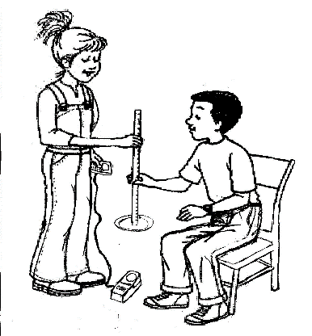
You'll Need

- TI 84 Plus CE, with Vernier EasyData™ App
- CBR 2™ motion sensor unit with mini-USB connecting cable
- Paper plate or 4”x6” index card
- Meter stick
- Thumb tack

Using the CBR 2™ motion sensor and Vernier EasyData™ App  Connect the handheld with the CBR 2 using the USB cable. EasyData will immediately open, and the CBR 2 will begin collecting distance data every time it clicks. In the EasyData app, the tabs at the bottom indicate the menus that can be accessed by pressing the keys directly below. For example, to go to File to select New, press o. To change the Setup, press p. To Start, press q. To see the Graph, press r. To Quit the app, press s. |  | 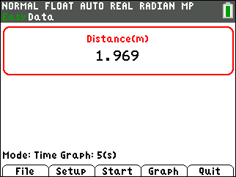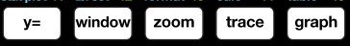
Collecting the Data  1. The default time in EasyData is 5 seconds. To change the amount of collection time to 2 seconds, press p to change the and select Time Graph. |  | 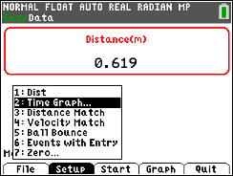
2. the settings by pressing q and enter the values shown or the ones provided by your teacher. When the changes are done, press s to the settings. |  | 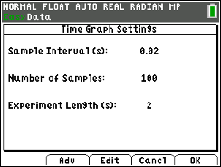
3. Tack a paper plate or note card to one end of a meter stick.
4. Place the CBR 2 on the floor. Have one partner hold the meter stick so that the plate or note card is approximately one meter from the CBR 2. Make sure the plate/note card is directly over the CBR 2 sensor.
5. The other partner should be ready to catch the meter stick with his/her finger and thumb when the stick is released.
6. The partner holding the meter stick should select (Press q) when ready to start collecting data. The partner assigned to catch the stick should watch the stick and catch it as quickly as possible after it starts to fall. Remember that the CBR 2 will collect data for two seconds, so the person releasing can slightly vary the release time from trial to trial. Do not let your partner know when you will drop the meter stick! When the graph is displayed, press the right arrow key ~ to the last data point before the graph drops off. The x-coordinate at the top is the Start Time. Record in the data table. |  | 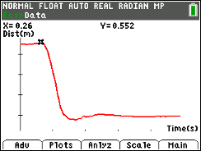  In this graph, Start Time = 0.26 sec.
7. Then continue moving through the data until the graph levels off again. The x-coordinate displayed is the End Time. Record in the data table. In the example to the right, the reaction time is the difference between the End Time and the Start Time: 0.62 ‒ 0.26 = 0.36 sec. |  | 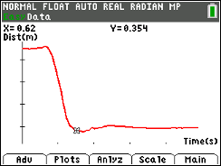  In the above graph, End Time = 0.62 s.
8. After recording your times in the data table, go to the Main Menu by pressing s to start again. Select by pressing q. Select to overwrite the latest run when you see the message shown at the right, and the CBR2 will immediately start collecting data. You and your group members will each need to do 10 trials or as directed by your teacher. |  | 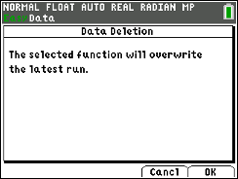
9. When your group has their average reaction time, your teacher will give instructions on compiling the data from the entire class.
Looking at the Results
1. Enter your data and calculate the average reaction time for each one in your group.
 | Student #1 |  |  | Student #2 |  |  | Student #3
Trial | Start  Time | End  Time | Reaction  Time | Start  Time | End  Time | Reaction  Time | Start  Time | End  Time | Reaction  Time
1
2
3
4
5
6
7
8
9
10
 |  | Avg. |  |  | Avg. |  |  | Avg.

2. Enter the five-number summary and the mean of the class data:

minX (minimum time)
Q₁ (first quartile)
Med (median value) |  | Mean
Q₃ (third quartile)
maxX (maximum time)

Sketch the boxplot and draw a vertical line at the value of the mean. | 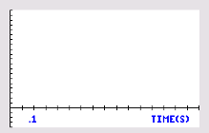
3. Notice where the mean is relative to the median. What does this indicate about the distribution of the reaction times of your class?
4. Calculate the IQR or InterQuartile Range (Q₃ ‒ Q₁). ________________ Based on what you can see in the graph and the IQR, comment on the spread (variability) of the reaction times of your class.
5. What outliers are identified in the boxplot? Explain what this means.
6. If the minimum and the maximum were to be connected to the box of the boxplot, would the resulting whiskers be the same length? What do the comparative lengths of the whiskers tell you about the class data?
7. Enter the reaction times of the girls in the class into L2 and the reaction times of the boys into L3. Setup Plot1 as a boxplot for the girls data and Plot 2 as a boxplot for the boys data. Comment on how the reaction time of the girls compares with those of the boys. Include mean, median, spread, shape, and outliers in your response.
8. As support for your previous response, sketch the boxplots and provide the mean and the five-number summaries of each group
 | Girls | Boys
Min
Q1
Med
Q3
Max
Mean

9. Going back to the baseball game scenario in the Introduction...with the pitch coming at you at 150 km per hour. If the ball is released 18.3 meters from home plate, how much time do you have to make your decision about what to do?
Going Further
- More on variability: Your analysis above included looking at the IQR. Calculate the Mean Absolute Deviation (MAD) of the class data. What does it tell you about the reaction times of your classmates?

- What factors can change a person’s reaction time? List at least three.

- Pick one of the above factors and describe specifically how you would collect data to study the effect of that factor on reaction time—especially how you would pick participants in your study and what procedure you would follow to gather the data.

- Just a small amount of alcohol in your bloodstream can slow your reaction time by about 30%. If you are driving a car at 50 miles per hour, approximately what distance is added to your ability to stop?

