Lesson Overview
Statements often occur in the media making claims about trends or issues/problems that are (or should be) of general interest. This activity follows up one such statement by finding and examining the data underlying the claim that women’s income is catching up to men’s income. The bigger picture has many facets that are ignored in this investigation but could be followed up in later investigations (the nature of the jobs, when women work as opposed to having children, the level of education required for a job, etc.). Collecting the actual data can be problematic as incomes are given in a variety of ways, for example: weekly incomes vs yearly incomes; for full time workers over the age of 15 vs full time workers over the age of 25; in current dollars vs dollars adjusted for inflation to some common year. The data used here are for full time workers over the age of 15 adjusted to 2018 dollars | Learning Goals
Students will be able to:
1. Model a contextual situation mathematically and use the model to make a prediction
2. Represent two quantitative variables on a scatter plot, and describe how the variables are related.
3. Find and interpret linear equations to model relationships between two quantitative variables;
4. Use proportional relationships to solve real-world and mathematical problems
About the Lesson and Possible Course Connections:
The activity can be used with middle grades students familiar with percentages and ratios (typically by grades 6,7 and beyond), possibly as an end of unit investigation. The students should be familiar with using tables or scatterplots to identify trends and patterns. Students in grades 8 and above might plot the data and fit some kind of model (by hand or least squares regression) depending on their mathematical background. Both of these situations involve extrapolating from the data to what might happen in the future, which assumes that conditions will remain relatively the same. This might not be the case given some recent efforts calling attention to the problem, and students should think about the “best case” and “worst case” scenarios in making their predictions. See the extension notes at the end of the activity for one example of what this might look like.
CCSS Standards

Algebra Standards:

• A-CED.A.2

Interpreting Data Standards:
• S-ID.B.6, S-ID.C.7
Statistics and Probability Standards:
• 8-SP.A.1, 8-SP.A.2, 8-SP.A.3
Ratios and Proportional Standards:
• 7.RP.A.1, 7.RP.A.3
Mathematical Practice Standards
• SMP.4

Lesson Materials
- Compatible TI Technologies:
TI-Nspire CX Handhelds, TI-Nspire Apps for iPad®, TI-Nspire Software
- Modeling Median Income_Student.pdf
- Modeling Median Income_Student.doc
- Modeling Income.tns
- Modeling Median Income_Teacher Notes
Background
More and more attention is being given to the earnings of men and women and how they compare. In some headline cases, men and women have not been given the same pay for the same work-some examples may be: movie stars (Amy Adams, Meryl Streep), women’s US Soccer team, and the technology industry. Across the whole US employment picture, studies clearly suggest a disparity in the earnings of men and women and offer a variety of reasons for the difference. Over time, both men’s and women’s salaries have been increasing. This activity investigates whether they have been increasing at the same rate or whether women’s salaries are “catching up”. Students can approach investigating this in a variety of ways, from percentages to regression lines depending on their mathematical backgrounds. One key element of the investigation is to have students write up their decision, whether they agree or disagree with the claim, and to provide evidence in their writing based on the mathematical analysis they did of the data.
Median Income for men and women full time workers age 15 and over

Median Income in 2018 dollars
Year | Men | Women |  | Year | Men | Women
1960 | 39941 | 24234 |  | 2000 | 54471 | 40156
1965 | 44656 | 26760 |  | 2001 | 54418 | 41537
1970 | 51888 | 30805 |  | 2002 | 55189 | 42275
1975 | 54291 | 31933 |  | 2003 | 55659 | 42049
1980 | 54152 | 32578 |  | 2004 | 54365 | 41631
1985 | 53997 | 34869 |  | 2005 | 53345 | 41063
1986 | 55395 | 35603 |  | 2006 | 53762 | 40594
1987 | 55016 | 35858 |  | 2007 | 54769 | 42616
1988. | 54551 | 36030 |  | 2008 | 54210 | 41791
1989 | 53590 | 36802 |  | 2009 | 55290 | 42562
1990 | 51720 | 37040 |  | 2010 | 55344 | 42575
1991 | 53047 | 37058 |  | 2011 | 53934 | 41532
1992 | 53125 | 37605 |  | 2012 | 54126 | 41408
1993 | 52179 | 37318 |  | 2013 | 54021 | 42278
1994 | 51863 | 37325 |  | 2014 | 53493 | 42067
1995 | 51696 | 36926 |  | 2015 | 54280 | 43183
1996 | 51391 | 37907 |  | 2016 | 54036 | 43482
1997 | 52698 | 39082 |  | 2017 | 53459 | 43658
1998 | 54574 | 39932 |  | 2018 | 55291 | 45097
1999 | 55018 | 39786
Hegewisch, A., Phil, M. Tesfaselassie, A. (9/11/2019).The Gender Wage Gap: 2018; Earnings Differences by Gender, Race, and Ethnicity https://iwpr.org/publications/annual-gender-wage-gap-2018/
Teacher Tip: Students should open the .tns file containing the data. If they enter the data by hand, they are likely to make errors, but it is an option. Younger students might work with a subset, for example the years from 2000 to 2018. Students can think about different ways to look at the relationship between men’s and women’s income over time.

Facilitating the Lesson
Start by discussing whether men and women make the same amount of money. Is there any problem with men earning more than women for the same job? (With a few prompts, students are likely to recall women’s professional soccer team; some female movie stars; some article they heard about in the technology world). Present the class with the data – either projected or paper copies (See Appendix). Begin the discussion by asking students:
- What does it mean to have the data in 2018 dollars? Why would this be important?
- Ask them to think about how much some older person in their family made when they started working. How does that compare to the median income in the table for that year? What would explain any difference?

Pose the task: The newspaper headlines proclaimed: “Women’s Income Catching up to Men’s”.
- While many factors could enter into such headlines, just using the data below, do you think the headlines are correct?
- If the headlines seem to be correct, predict when the median women’s income will be the same as men’s median income

There are several ways this lesson can be implemented in the classroom:
1) Open-Ended Approach:
First, ask the students to think alone for a few minutes and then write down how they would start the task. Then, put them in pairs or threes for further discussion.
Student Instructions: In your groups,
- Exchange your ideas.
- Decide as a group how you will begin to analyze the data. Give each member of the group a job to do that will help you in the work.
- Decide whether your approach seems reasonable for the data. Explain why you think the model you found is appropriate. What are the drawbacks, if any, to your model?

2) More-Structured Approach to Finding a Model:
Ask the class as individuals to write down their answers to the first three questions below.
1. What do you notice from the table? (Both men’s and women’s median income increased; women didn’t earn much in 1960; the years start increasing by 5s and then increase by 1s.)
2. What do you wonder about? (Are the differences in income getting smaller?)
3. What are some strategies you might use to compare the incomes?

After individual thinking time, put students in groups and have them discuss their answers. Have a brief discussion of ideas that you noticed from their discussions that seemed interesting, but primarily posed as questions a group might want to follow up on. After a short discussion, have them work as a group to answer the question. Remind them that they will be expected to defend their reasoning. The two questions below might be useful in pushing their thinking:
- Will a graph help?
- Can you create a formula?
Some groups will graph the data as plots over time or graph men’s income against women’s income. Others may create fractions of women’s income divided by men’s income or the difference between men’s and women’s incomes divided by men’s income. Some might just look at the last several years and note that the difference is getting smaller (from about $12,000 to about $10,000) and conclude the answer is yes. Push these students to find a mathematical way to use the data to make a prediction.
 | What to Expect: Example Student Solutions
Student answers will vary.
Some groups will graph the data as plots over time or graph men’s income against women’s income. Others may create fractions from women’s income divided by men’s income or the difference between men’s and women’s incomes divided by men’s income. Some might just look at the last several years and note that the difference is getting smaller (from about $12,000 to about $10,000) and conclude the answer is yes. Push these students to find a mathematical way to use the data to make a prediction.
There are different ways to think about the question. Class discussion should surface these with enough detail that all students can see how the different ways of approaching the problem might work.
 | Points to make:  • The data from 1960 to about 1985seem to suggest a different trend than the data from 1985 on (Figure 1). | 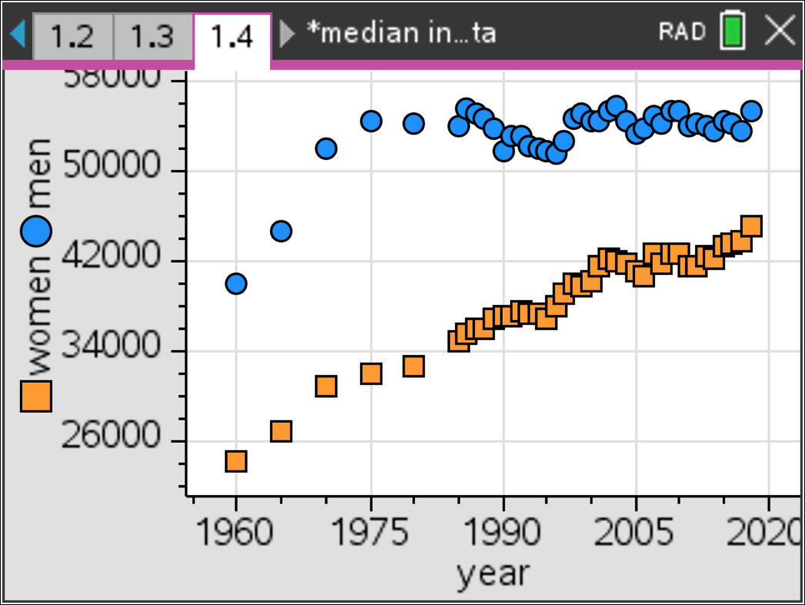  Figure 1 Year vs median income for men and women from 1960 to 2018

It makes sense to look at the data just from 1985 to 2018 (Figure 2). | 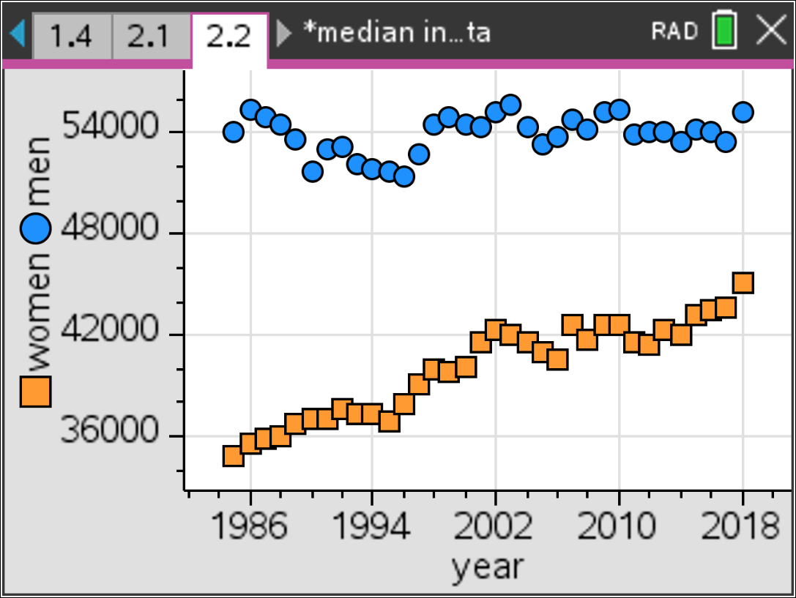  Figure 2 Year vs median income for men and women from 1985 to 2018
Students may draw in a line using Menu, Analyze, Add Moveable Line and drag the line to capture the relationship between time and the incomes. In fitting lines to scatterplots, ask students to interpret the slope. Be sure they respond in terms of estimated rate of change in earnings from each year. If students have experience with curve fitting and regression, they can use the linear regression feature to plot the least squares line. Figure 3 shows the results of using the least squares linear regression line, but fitting a line by hand should be approximately the same. (Note that the regression equation for men’s income is y=32.48 -11084.) | 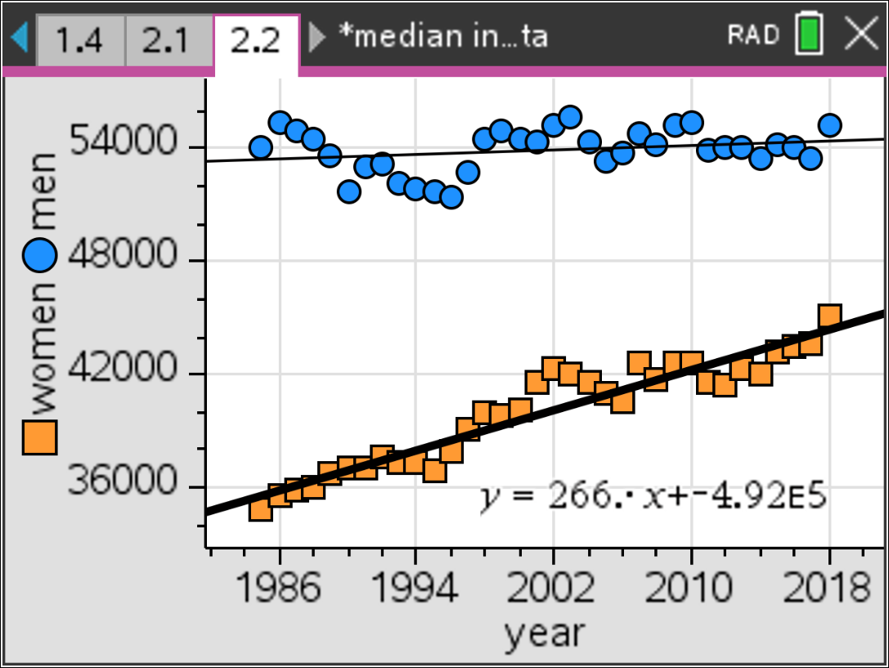  Figure 3 Regression lines for the median income of men and women over time
By changing the window, students can make an estimate for the year when the incomes of men and women will be equal (Figure 4), assuming the current trends continue. | 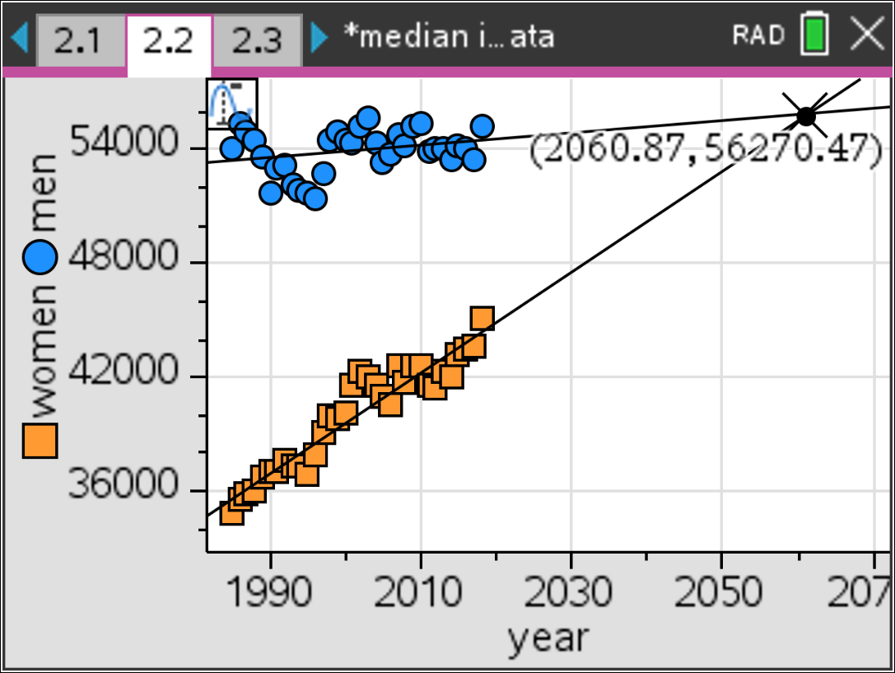  Figure 4 Projected year for equal incomes

Students might use Lists & Spreadsheets to calculate the ratio of women’s income to men’s income, graph the ratios over time  (Figure 5). | 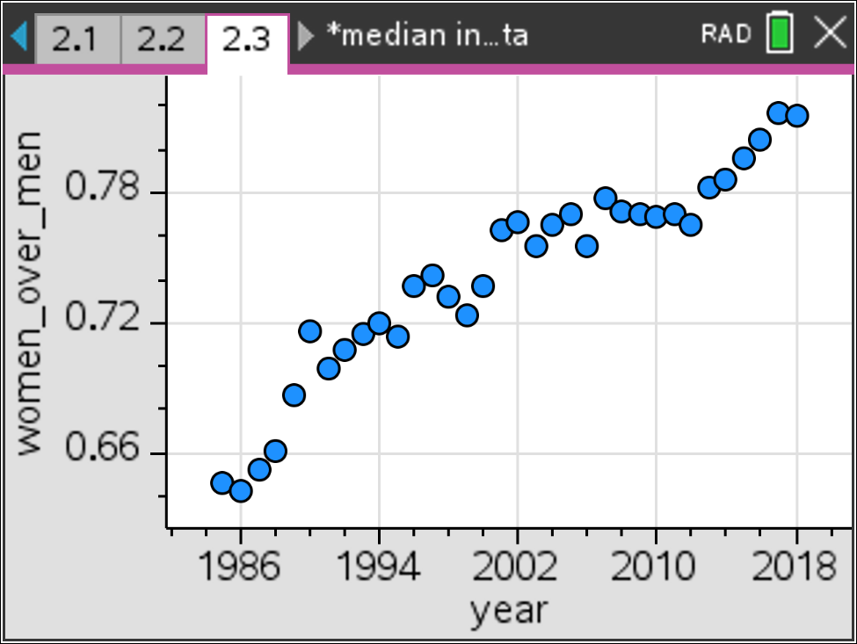  Figure 5 Ratio of women’s income to men’s income over the years
Students can then fit a linear model to the relationship (Figure 6). | 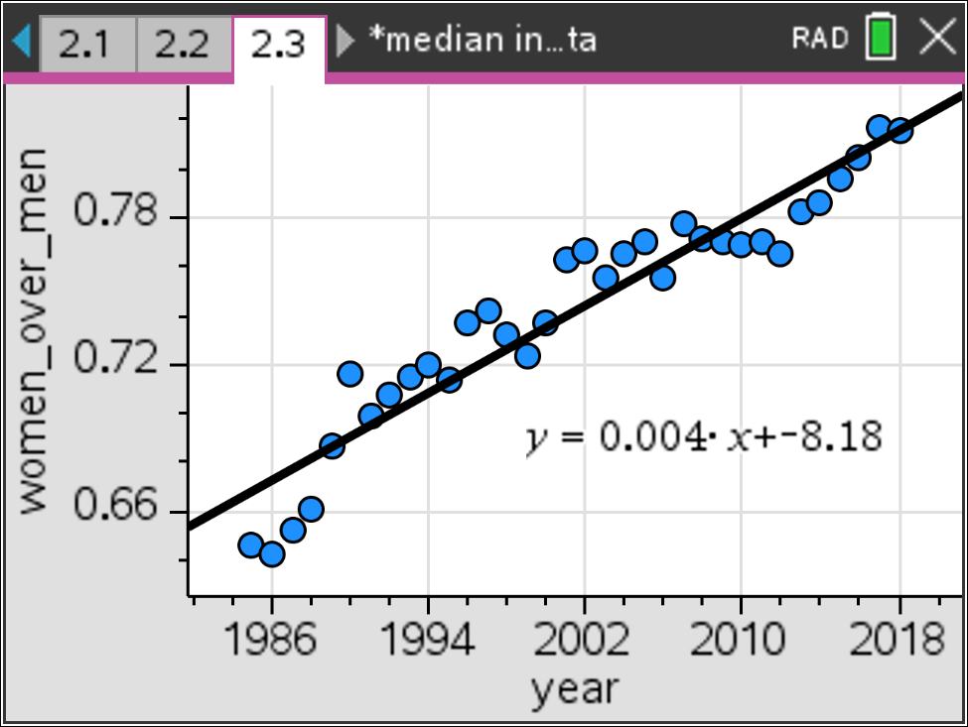  Figure 6 Regression line for the ratio of women’s to men’s income over time
The incomes will be equal when the fraction of women to men is 1 (Figure 7). | 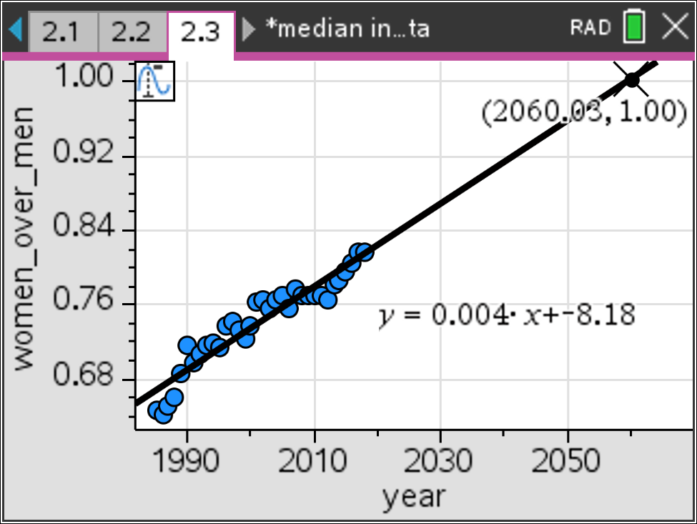  Figure 7 Projected year when the ratio of women’s to men’s income is 1

A similar approach is to find the difference between men’s and women’s income divided by men’s income, look at a graph (Figure 8) of the difference divided by men vs. year | 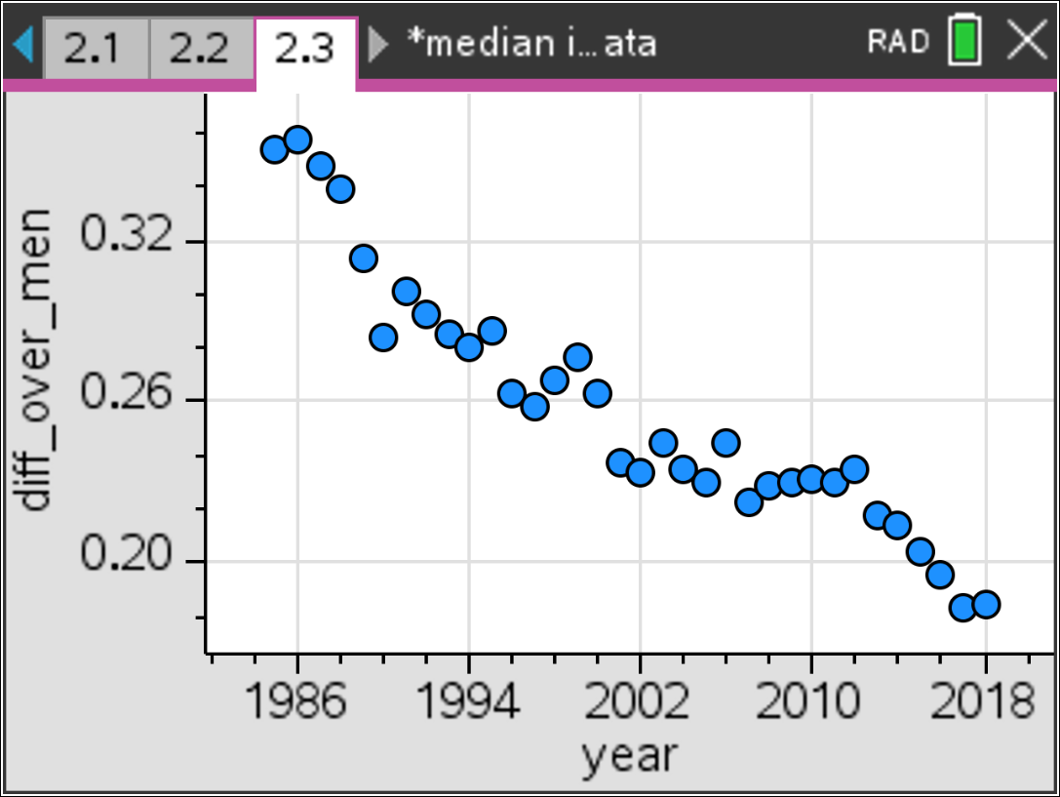  Figure 8 Ratio of the difference between men’s and women’s income to men’s income
Then plot a linear model for the relationship (Figure 9). | 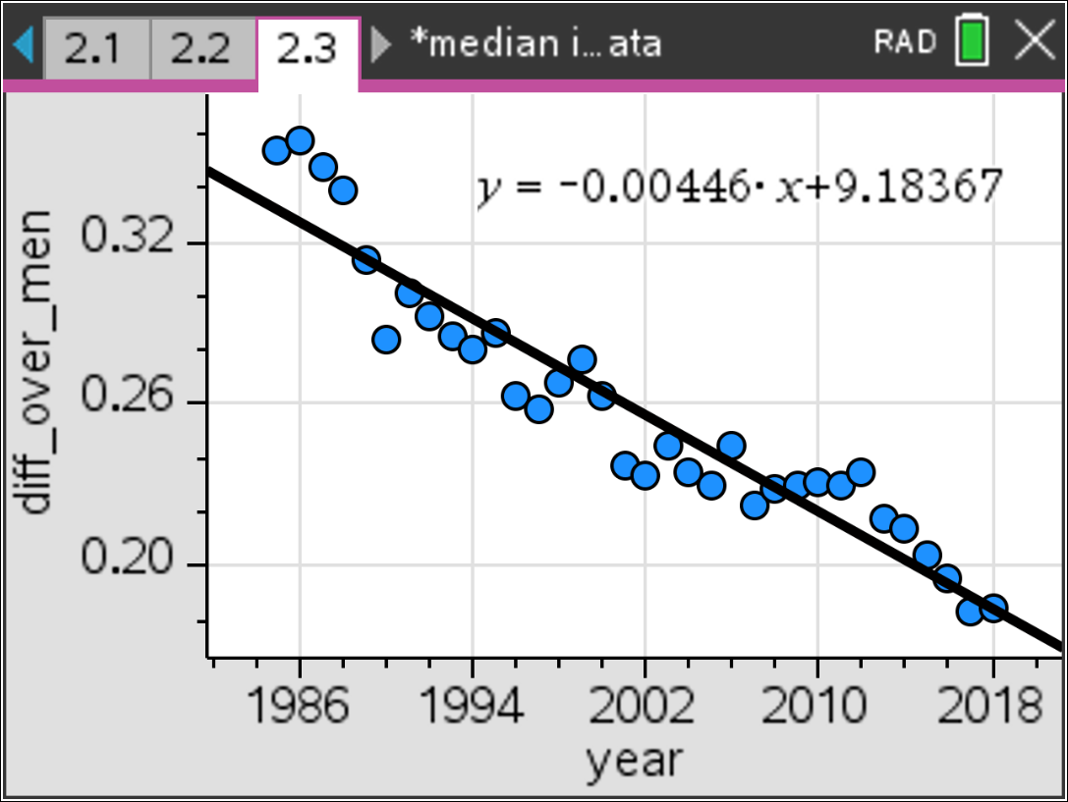  Figure 9 Regression line for the ratio of the difference between men’s and women’s income to men’s income
In this case, the incomes will be equal when the difference between  men’s and women’s income is 0 (Figure 10). | 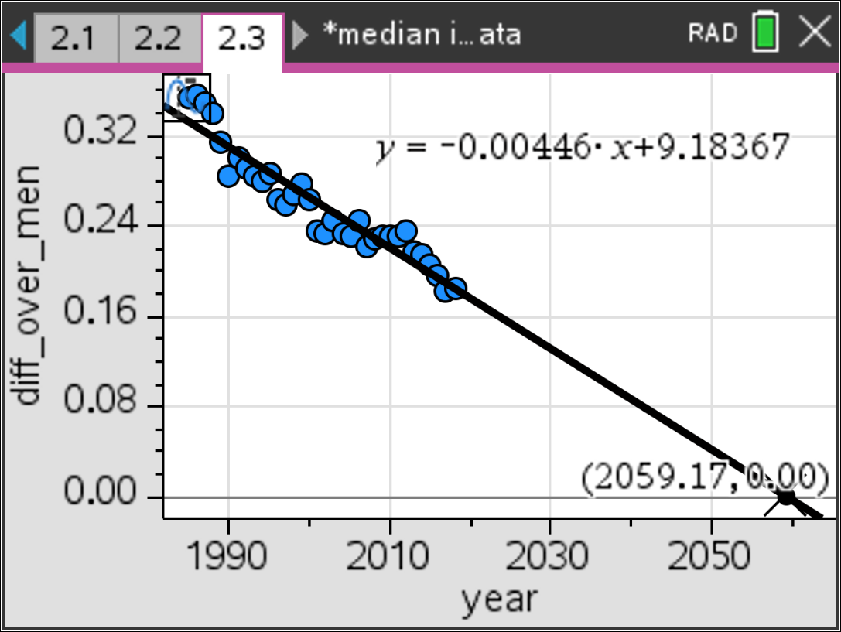  Figure 10 Projected year when the ratio of women’s to men’s income is 0
Teacher note: Some students may concentrate only on the income ignoring the time. Boxplots of men’s and women’s incomes show the amount of money for men and women but will not show how the variable time is related to the income. Scatter plot of men's vs. women's also ignores the impact of time and is not useful for answering the question. Again, there are many possible approaches, which provide good opportunities for sharing and discussion.

Validating the Models
Students should validate their models either by asking whether the models make sense in different scenarios related to the context or by finding other information to reflect against the model. The suggestions below might be useful in helping students think about whether their model was reasonable:
- How can you tell if your line is a good fit for the relationship?
- How do your predictions for the relationship between men’s and women’s incomes match your classmates? What might explain any differences?
- Search for predictions about when men and women’s income will be equal. How well do these predictions match yours? What might explain any differences?

Extensions

Modeling involves more than fitting curves to (x,y) data points. Thinking about what the data represent in their context is critically important!
- Predicting beyond the data depends on whether the assumptions used to formulate the model remain the same. Look at the graph below.
a) Share with your classmates what you notice. What you wonder?
- Describe the story in the graph.

(Note that the graph suggests that if the change continues at the slower rate seen since 2001, women will not reach pay equity with men until 2106.)
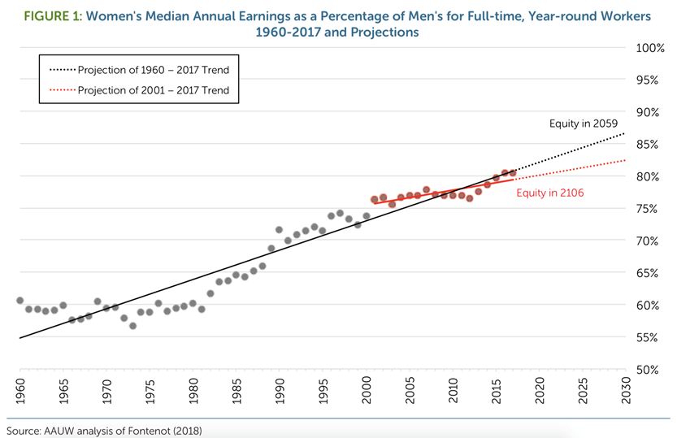
Miller, K. & Vagins, D. (2018). The Simple Truth about the Gender Pay Gap pg.5
https://www.aauw.org/app/uploads/2020/02/AAUW-2018-SimpleTruth-nsa.pdf

- Write four sentences describing the information in the graph below.

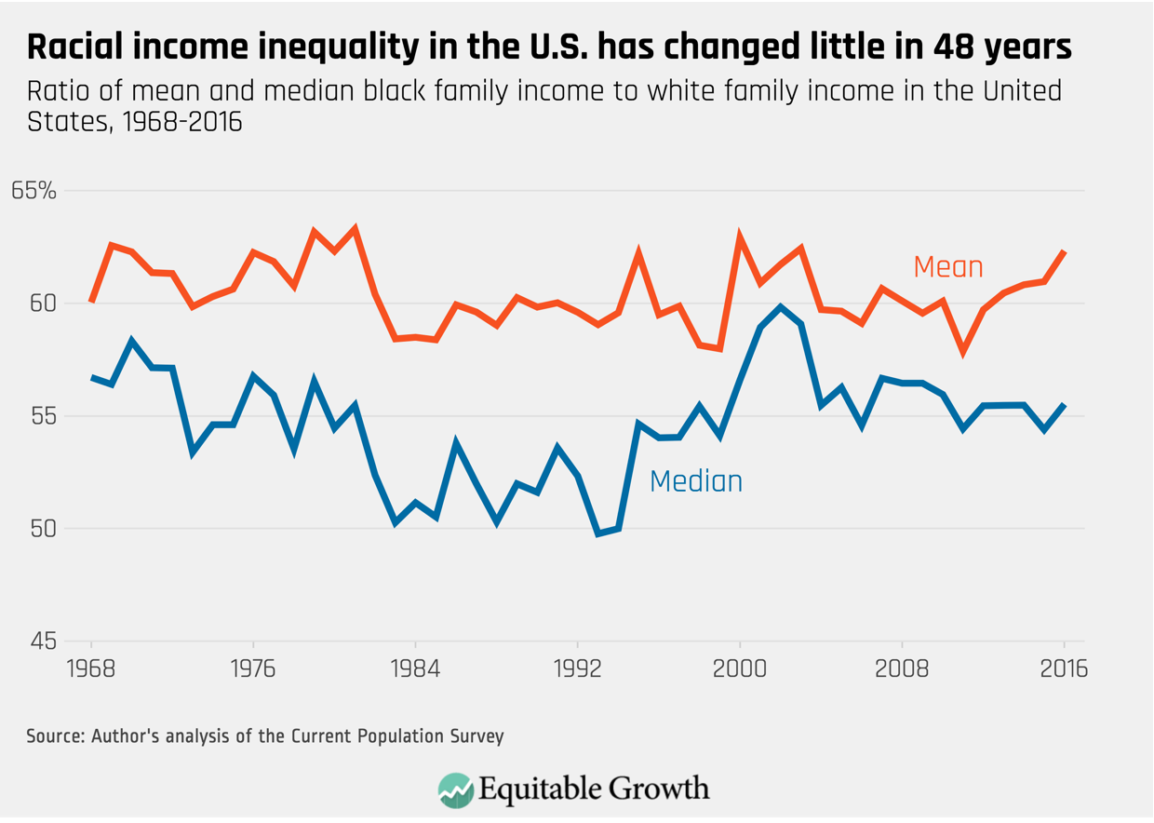
Manduca, R. (2018). How rising U.S. income inequality exacerbates racial economic disparities
https://equitablegrowth.org/how-rising-u-s-income-inequality-exacerbates-racial-economic-disparities/
- Look for data on median income for different races and ethnicities for gender, age, race, educational attainment, and occupation. Investigate what the gender gap looks like across the states, or median annual earnings by race, ethnicity and gender.

Possible sources to investigate for relevant data:
- https://www.pewsocialtrends.org/2018/07/12/income-inequality-in-the-u-s-is-rising-most-rapidly-among-asians/
- The simple truth about the gender pay gap. Fall 2018. AAUW https://files.eric.ed.gov/fulltext/ED596219.pdf
- Amadeo, K. (12/16/19). Income inequality in America. https://www.thebalance.com/income-inequality-in-america-3306190

Resources:
The simple truth about the gender pay gap. Fall 2018. AAUW https://files.eric.ed.gov/fulltext/ED596219.pdf

Manduca, R. (2018). How rising U.S. income inequality exacerbates racial economic disparities https://equitablegrowth.org/how-rising-u-s-income-inequality-exacerbates-racial-economic-disparities/
Hegewisch, A., Phil, M. Tesfaselassie, A. (9/11/2019).The Gender Wage Gap: 2018; Earnings Differences by Gender, Race, and Ethnicity
https://iwpr.org/publications/annual-gender-wage-gap-2018/

