In this activity, students are able to apply their knowledge of finding a derivative and using implicit differentiation as they are introduced to the topic of related rates. In several problems, students will have two variables, which are both changing with time. With each problem, one variable’s rate of change at a given instant will be known and the student will need to find the second variable’s rate of change at that same instant. | 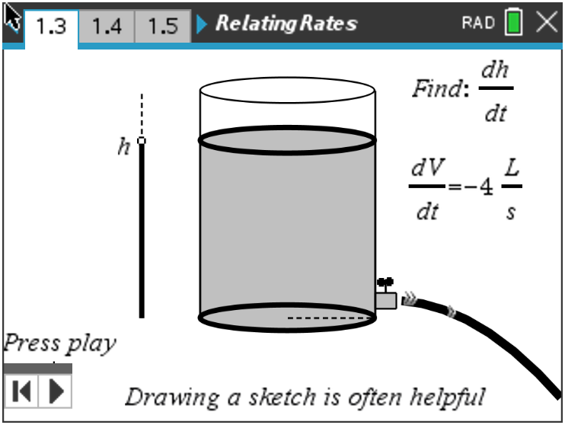
Let’s do a couple practice problems to better understand the process when dealing with related rates.
Open the file RelatingRates.tns to help guide you through this activity and provide useful visuals.

Move to page 1.2.
Problem 1 – Example & Explanation

Water is draining from a cylindrical tank at 4 liters/seconds. If the radius of the tank is 2 centimeters, find how fast the surface is dropping. Move to page 1.3 to see a helpful visual of the tank draining.
Step 1: Assign variables, list given information, and determine the unknown(s).
  - Variables:

  - Given information:

  - Unknown(s):

Move to page 1.4.
Step 2: Write a formula relating given(s) and unknown(s) for a cylindrical tank.

Move to page 1.5.
Step 3: Differentiate both sides of the equation from Step 2 with respect to t to find the related rates.
- Explain if this problem can or cannot be solved using the Product Rule.

Move to page 1.6.
- Use implicit differentiation to differentiate the equation. Show your work.

Move to page 1.7.
Step 4: Evaluate—substitute and answer the question being asked!
- Find how fast the surface is dropping when the radius is 2 cm.

Move to page 2.1.
Problem 2 – Additional Example & Explanation

Two cars leave at the same time, one traveling east at 15 units/hour and the other traveling north at 8 units/hour. Find at what rate the distance between them is increasing when the car going east is 30 units from the starting point. Move to page 2.2 to see a helpful visual of this situation.
Step 1: Assign variables, list given information, and determine the goal.

Move to page 2.3.
Step 2: Find the equation that relates what is known and what you want to find.

Move to page 2.4.
Step 3: Implicitly differentiate both sides of the equation from Step 2 with respect to t to find the related rates.

Step 4: Substitute to evaluate.
- Show these key steps.

Move to page 2.5.
- Find at what rate the distance between them is increasing when the car going east is 30 units from the starting point.

Move to page 3.1.
Problem 3 – Practice/Extension
Move to page 3.2.
1. A spherical bubble is being blown up. The volume is increasing at the rate of 9 mm³ per second. Find at what rate the radius is increasing when the radius is 3 mm. Move to page 3.3 for a helpful visual.

Move to page 3.4.
2. A point moves along the curve y = –0.5x² + 8 in such a way that the y value is decreasing at the rate of 2 units per second. Find at what rate x is changing when x = 4.

Move to page 3.5.
3. A particle moves on the curve such that = 6. Find the instantaneous rate of change of x with respect to t when x = 2. Move to page 3.6 for a helpful visual.

Move to page 3.7.
4. Two trains leave the station at the same time with one train traveling south at 20 mph and the other traveling west at 33 mph. Find how fast the distance between the trains is changing after 3 hours.

Move to page 3.8.
5. A cylindrical tumbler with a radius of 3 cm has its height increasing at a rate of 2.5 cm/sec. Find the
rate of change of the volume of the cylinder when the height is 12.56 cm. Move to page 3.9 for a
helpful visual.

Further IB Application

Move to page 3.10.

A balloon is submerged in liquid nitrogen. The balloon’s diameter contracts when it is cooled. The diameter of the sphere is decreasing at a rate of 4 cm/s.

(a) Find an expression for the surface area in terms of the radius (r).

(b) Find how fast the surface area is changing when the radius is 10 centimeters.

