Activity Overview
In this activity you will match your motion to a given graph of distance versus time and to a graph of velocity versus time. You will apply the mathematical concepts of slope and y-intercept to a real-world situation.
Materials
- TI-84 Plus CE calculator with the Vernier EasyData® app or TI-SmartView™ CE emulator software
- CBR™ 2 motion sensor
- USB CBR 2-to-calculator cable
Note: To plug the CBR 2 into the computer, a mini-standard USB adaptor is needed.

Part 1—Step-by-step Setup and Distance Match
To utilize the built-in, easy-to-use Distance Match feature, first Connect the CBR 2 to the TI-84 Plus CE with the USB cable. If the EasyData app does not open, press Œ, and select EasyData. The distance displayed is the distance from the CBR 2 to the closest object.  In the EasyData app, the tabs at the bottom of the screen indicate the menus that can be accessed by pressing the calculator keys directly below the tabs.  - Hold the CBR 2 so that it points toward a smooth surface like a wall or door. Move forward and backward to observe the reading changes.  - How far are you from the wall? _________  Record all the digits that are given, as well as the units. | 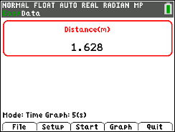

- To set up the Distance Match, press p for Setup. Select Distance Match.  Mode: Distance Match will be displayed in the lower part of the screen.  - Press the q key for Start.  If an “overwriting the latest run” message appears, press s for OK.  - Read the Graph Match information provided and then press q for Next.  A graph should be displayed.  - Before walking, draw your Distance Match graph on the graph to the right.  - Describe the motion necessary to match the distance versus time graph displayed on your calculator. |  | 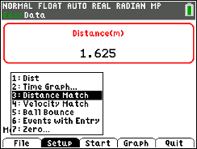  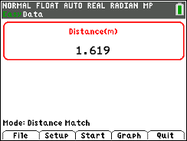  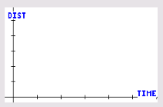
- Record your observations about the graph by answering the following questions:
a. What is the y-intercept?

b. What does the y-intercept represent physically?

c. At approximately what distance from the wall should the motion detector be located to match the initial position in the motion graph?

d. The slope is the change of position with respect to time or the velocity of the walker. Between what times does the graph depict the slowest motion? Between what times does the graph depict the fastest motion?

e. Is there a time when the walker should stand still? If so, when is that time?

- Press q to start the data collection. Point the CBR 2 at a wall, and move back and forth until your graph matches the Distance Match graph as closely as possible.
If you are not pleased with your first attempt, press q for Retry. You may want to review the information that you wrote about the graph to assist you.
- Describe the parts of your graph that were difficult to match and any adjustments, based on your graph of your walk, made to make a better match in the next attempt.
Now, look at the graph shown at the right.  - Describe how you would need to walk in order to match that graph with your motion. Be sure to include information about the y-intercept, distance from the motion sensor at various times, velocity, and direction. For what times does the graph depict the slowest motion? The fastest motion?  - The thicker graph shown at the right was created by a walker. Contrast the graph of distance versus time that should have been created with what actually happened. Write at least two observations. |  | 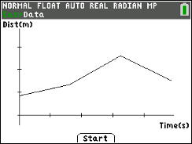  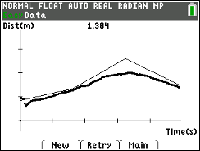
Part 2—Extend and Explore
- Press p for New to display a new Distance Match.

- Consider how to walk to match the graph.

- Press q to start the data collection, and walk to match the graph.

- If you are not pleased with your first attempt, press q for Retry.

- Discuss your new match with a classmate.
Part 3 – Velocity Match  - To set up the Velocity Match, return to the Main menu (if necessary).  - Press p for Setup. Select Velocity Match.  Mode: Velocity Match will be displayed in the lower part of the screen. | 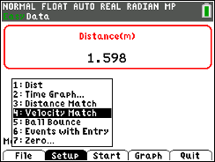  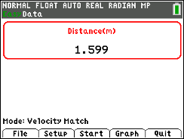
- Press the q key for Start. If an “overwriting the latest run” message appears, press s for OK.  - Read the Graph Match information provided, and then press q for Next.  - Draw your Velocity Match graph on the graph to the right.  - Before walking, describe the motion necessary to match the velocity versus time graph displayed on your calculator. | 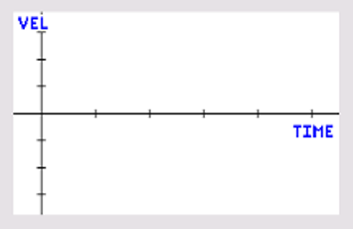
- Press the q key for Start.

- To try again with the same graph, select Retry and then select Start.

- Describe the parts of the graph that were difficult to match and any adjustments made to make a better match in the next attempt.

- Select other Velocity Match graphs to match. For each Velocity Match graph, first describe the motion necessary to match the graph displayed on your calculator.

Challenge:  An example of a velocity versus time graph is shown at the right. How should a person move to match this graph? | 