Open the TI-Nspire document Proportions_in_Stories.tns.  In this activity, you will determine whether real-life stories describe proportional or non-proportional relationships by creating and examining tables of data and the related equations and graphs that represent each story. | 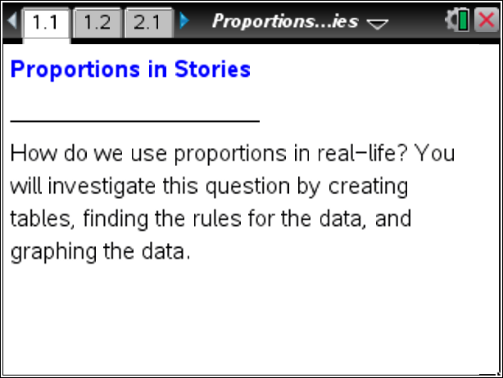

Move to page 1.2.

1. You plan to participate in a fund-raising event to collect money for research to fight cancer. Your parents will donate $20 for each mile you walk or run.

- Using the table below, record the total amount of money you can raise depending on how many miles you will walk or run. Show how you determined the amount of the donation by recording the process you used to calculate the amount in the column labeled “Process.”

Miles (x) | Process | Money (y)
0
1
2
3
4
x

- Input the money into the table on Page 1.2. Describe how the scatter plot is a representation of the table.

- Determine an equation that could be used to calculate the amount of money you can raise if you were to walk x miles. Make a prediction about the graph of this equation.

2. Move the cursor to the y = ? box at the top of Page 1.2 and input the equation.
- Does your equation represent the data you entered? Explain your reasoning.

- In what way is the $20 per mile donation represented in the data table? How is it represented in the equation? How is it represented in the graph of the equation?

- Does this situation represent a proportional relationship? Why or why not?

Move to page 2.1.

3. Your school plans to buy new computers at $525 per computer. The total number of computers that can be purchased depends on the amount of money in the budget allocated for the computers. Using the table on Page 2.1, record the cost of computers depending on the number of computers.
- Determine an equation that could be used to budget x computers. Input the equation on Page 2.1.

- Does your equation represent the data you entered? Explain your reasoning.

- In what way is the price of a computer represented in the data table? How is it represented in the equation? How is it represented in the graph of the equation?

- Does this situation represent a proportional relationship? Why or why not?

Move to page 3.1.

4. You are planning a birthday party at a bowling alley. The shoe rental is $5, and each game costs $2.50. Record the cost per person for a different number of games in the table on Page 3.1.
- Determine an equation that could be used to calculate the cost per person for x games. Input the equation on Page 3.1.

- Does your equation represent the data you entered? Explain your reasoning.

- In what way is the cost per game represented in the data table? How is it represented in the equation? How is it represented in the graph of the equation?

- In what way is the shoe rental price represented in the data table? How is it represented in the equation? How is it represented in the graph of the equation?

- Does this situation represent a proportional relationship? Why or why not?

5. Compare and contrast the data tables, graphs, and equations for the three stories you explored.
- What is similar and what is different for the three tables?

- What is similar and what is different for the three graphs?

- What is similar and what is different for the three equations?

6. Describe the properties of data in a table that represent a proportional relationship.

7. Describe the properties of a graph that represents a proportional relationship.

8. Describe the properties of an equation that represents a proportional relationship.

