Problem 1 – Defining and Plotting Absolute Value
The absolute value function can be defined as .
Explore this definition by using the absolute value function on the graphing calculator.  Press ». Move to the NUM menu and select abs(. | 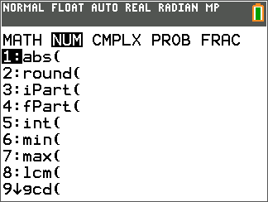
1. Use the abs command on the Home screen to complete the following.
a. |10.5| = _____ b. |–15| = _____ c. |–3.14| = _____
d. |–12| = _____ e. |8| = _____ f. |2.71| = _____

2. What happens to the absolute value of numbers that are negative (to the left of zero on a number line)? How does this relate to the definition stated above?

To view a plot of the absolute value function, enter 10 random numbers (positive and negative) into L1 using the stat editor.  To access the editor press … Í.  Note: If there is data already in L1, clear it by moving the cursor to the top of L1 and pressing ‘ Í.) |  | 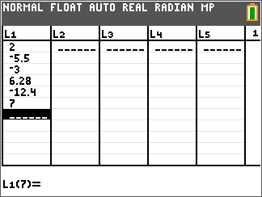
Now, move the cursor on top of L2, press Í and let the values of L2 be equal to abs(L1) to compute the absolute values of the data you entered. To enter L1, press y À.  The screen to the right just shows a sampling of six L1 values you may use. |  | 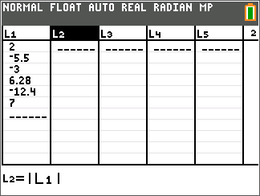
To graph the scatter plot of the data, press y o [stat plot] and select Plot1. Match the screen to the right.  Press q and select ZoomStat. |  | 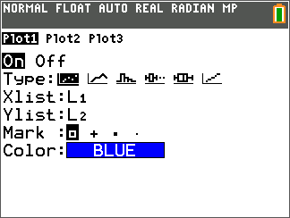

3. L1 represents the x-values and L2 represents the y-values. What trend do you notice about the y-values for the negative x-values? Describe the shape of the graph to the left of x = 0.

4. Describe the shape of the graph of y = |x|. Enter new numbers into the list, press q, and select ZoomStat to check the shape you described.

Problem 2 – Exploring Functions with Absolute Value
Now you will explore how changing parts of an absolute value function affects its graph using the transformation graphing application.
Before you begin, turn off Plot 1 by pressing y o [stat plot] selecting Plot1 and choosing the Off Option.
Start the transformational graphing application by pressing Œ and selecting Transfrm.
Press o and enter A∗abs(X+D)+C next to Y1. Then press q and select Zstandard.  To enter the letter A, press ƒ ». The letters D and C are entered in a similar manner by using ƒ followed by the corresponding button to your desired letter. |  |  |  |  | 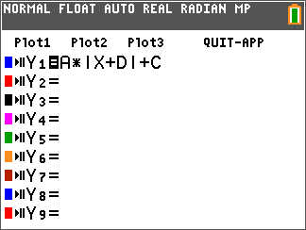
To change the window setting shown at the right, press p } (up arrow).  To change the values of the constants, use the } and † arrow keys to select the desired variable and then use the | and ~ arrow keys to change the value. |  |  |  |  | 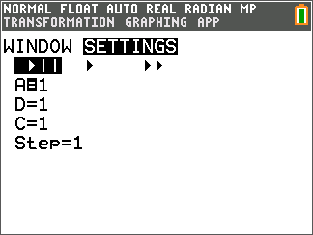  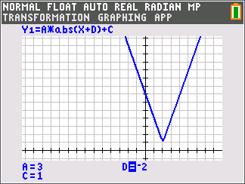
5. What happens to the graph when a is negative? When a is positive?

6. In general, what effect does a have on the graph?

7. a. What happens to the graph when d is positive? When d is negative?

b. What happens to the graph when c is positive? When c is negative?

c. For this general function y = |x + d| + c, what are the coordinates of the vertex?

Problem 3 – Matching Equations to Graphs
Choose the correct equation from the options below for each graph shown.

a. y = |x – 6| + 3  c. y = |x – 3| + 6 |  | b. y = –|x + 3| – 6  d. y = –|x + 6| + 3
8. | 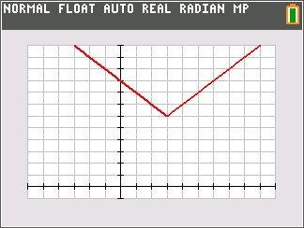 |  | 9. | 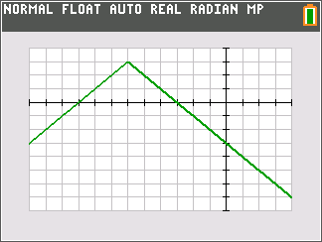
10. | 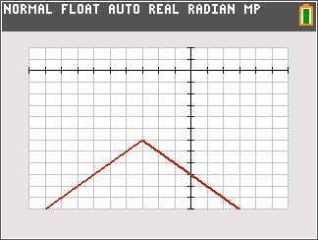 |  | 11. | 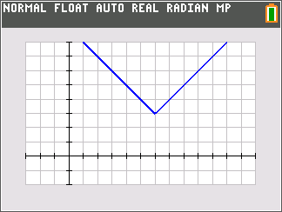
Extension – General Absolute Value Function
12. Using the Transformation Graphing App, explore the graph of Y1=A∗abs(BX+D)+C. What does the graph look like when a is zero? What about when b is zero? Explain why.

13. List any other observations. For example, how is the slope related to a and b? Is the vertex always (–d, c)?

