Part 1 – The First Constraint
In this problem, you will build a model of a real-life situation by writing linear inequalities to represent the constraints on the situation. You will see how the set of solutions changes as each constraint is added.
The owner of a birdhouse business can make a birdhouse in 90 minutes. He can work at most 40 hours a week making birdhouses. Write an inequality to represent the number of birdhouses he can make in one week, x, given this constraint.

We can use the calculator to view the solution set to this inequality in two different ways. The first is with the Lists feature. Press … Í to open the List Editor. Clear any data from L1 and L2. |  | 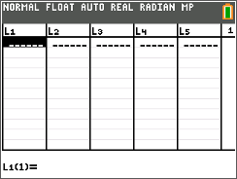
Enter a range of values of x in L1. These values represent different numbers of birdhouses that the owner could make in a week.  Arrow up to the top of L2 and type your inequality. Replace x with L1.  To type L1, press y d.  Inequality symbols are found in the Test menu (y[test]). |  | 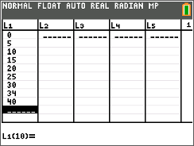
A value of 1 in L2 means that the inequality is true for the value of x in that row. A value of 0 means that the inequality is false for the value of x in that row. Each x value in L1 with a value of 1 in L2 is a solution to the inequality.
1. Can the owner make 10 birdhouses in one week? 20? 30?

Another way to view the solutions to this inequality is by graphing. First, adjust the window settings as shown. | 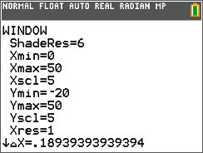
Press Œ to open the Applications menu and choose Inequalz to open the Inequality Graphing application.  Press any key to begin. | 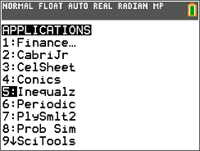
To graph an inequality with the variable x, move to the text X= in the upper left corner of the screen and press Í. This changes all the equations from the form Y= to X=.  Solve your inequality for x and enter it in X1. Round any decimals to the nearest hundredth. To change the = to the correct inequality symbol, select the X1= and press Í to bring up the relation formatting window. | 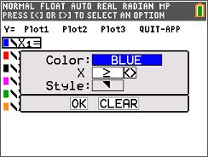
Press s to view the graph. All of the points in the shaded area represent solutions to the inequality.
Part 2 – Another Constraint
The owner decides to hire an expert carpenter to help make the birdhouses. The expert carpenter can make a birdhouse in 75 minutes. However, the owner can only afford to pay the expert for 20 hours of work per week.
Write an inequality to represent the number of birdhouses the expert can make in a week, y, given this constraint.
Press … Í to open the List Editor. Clear any data from L3 and L4.  Enter a range of values of y in L3. These values represent different numbers of birdhouses that the expert carpenter could make in a week. | 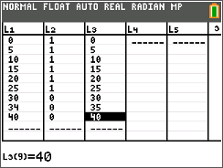
Arrow up to the top of L4 and type your inequality. Replace y with L3.  To type L3, press y f.  Inequality symbols are found in the Test menu (y[test]). | 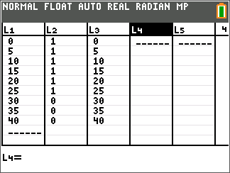
A value of 1 in L4 means that the inequality is true for the value of y in that row. A value of 0 means that the inequality is false for the value of y in that row. Each y value in L3 with a value of 1 in L4 is a solution to the inequality.
2. Can the expert make 10 birdhouses in one week? 20? 30?

Look for the rows that have a 1 in L2 and a 1 in L4. The x- and y-pairs from these rows are solutions to both inequalities.
For example, if L1 = 10, and L3 = 10, and there is a 1 in L2 and a 1 in L4, the ordered pair (10, 10) is a solution to the system.
In fact, any combination of an x-value that is a solution to the first inequality and a y-value that is a solution to the second inequality is a solution to this system, even if the two values are not in the same row. So (10, 15) and (20, 10) are also solutions.
3. What does the solution (10, 15) represent in this situation?

4. List as many solutions to the system as you can.

Another way to view the solutions to this system is to graph the two inequalities together. Press o to return to the Inequality Grapher.  To graph an inequality with the variable y, move to the text Y= in the upper left corner of the screen and press Í. This changes all the equations from the form X= to Y=.  The screen should like the one to the right. | 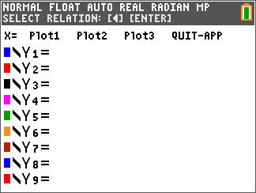
Solve your inequality for y and enter it in Y1. Remember to change the = to the correct inequality symbol.
Press s to view the graph. The points where the two areas overlap are solutions to the both inequalities, and hence solutions to the system.

Use the arrow keys to move the cursor to the intersection of the two shaded areas.
5. List several points that are within this area.

6. Compare your answer to Question 5 with your answer to Question 4.

Part 3 – A Final Constraint
A store would like to place an order for 50 birdhouses a week. Can the owner and the expert working together fill the order?
Write an inequality to represent the number of birdhouses the owner would have to make each week (x) and the expert would have to make each week (y) to fill this order.
Press … Í to open the List Editor. Clear any data from L5.  Arrow up to the top of L5 and type your inequality. Replace x with L1 and y with L3. | 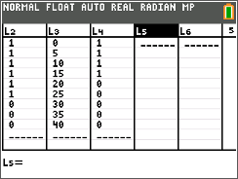
A value of 1 in L5 means that the inequality is true for the values of x and y in that row. A value of 0 means that the inequality is false for the values of x and y in that row. Each (x, y) pair with a value of 1 in L5 is a solution to the inequality.
7. List several solutions to this inequality.

Look for rows that have a 1 in L2, a 1 in L4, and a 1 in L5. The x and y pairs from these rows are solutions to all three inequalities, in other words, solutions to the system.
8. Are there any such rows that are solutions? List as many solutions to the system as you can.

9. What does your answer to question 8 mean in this situation?

To view the solutions to this system, graph all three inequalities together. Press to return to the Inequality Graphing App.  Solve your inequality for y and enter it in Y2. (You could also solve the inequality for x and enter it into X2 with the same result.) | 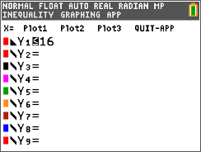
Press s to view the graph. All of the points in the horizontally striped area are solutions to the first inequality. All the points in the vertically striped area are solutions to the second inequality. All the points in the diagonally striped area are solutions to the third inequality.
10. Is there an area where all three of these overlap?

11. What does this mean about the solutions to this system?

Challenge
12. Use the Points of Interest – Trace feature of the Inequality Graphing App to find the maximum number of birdhouses that the owner and the expert can make in a week. (Press ƒ [f3] to access this feature and use the arrow keys to move between the points of interest on the graph.)

