Problem 1 – Stretching a Parabola
The equation y = x² is the basic equation for a quadratic. The parabola is the foundation for all other quadratic graphs!
This equation is also the simplest version of the standard form equation: y = ax² + bx + c. There is also a vertex form equation: y = a(x – h)² + k.
To get the Transformation Graphing application started, press Œ and select Transfrm.  Now press o and enter ax² in Y1. | 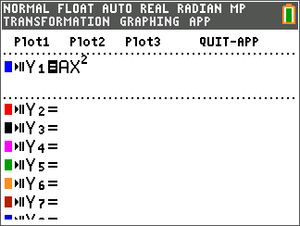
Press q and select 6:Zstandard to get the graph displayed in a normal window. Notice that the variable A is listed to the left along with the equation. To change the value of A, press the left | and right ~ arrow keys or type in the number you want to use for A and press Í.  Experiment with different values for A and notice the changes they result in for the graph of the parabola. Use your observations to answer the questions below. | 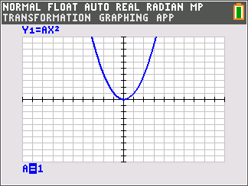
1. What effect does the A variable have on the graph of the equation?

2. When the coefficient of x² becomes negative, what happens to the graph?

3. Is the coefficient of x² positive or negative for the equation of the graph to the right? | 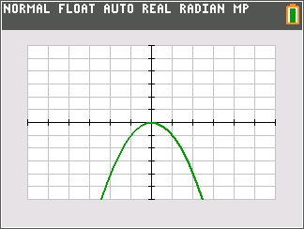
4. What is a possible coefficient of x² in the graph to the right? Is it 5 or 0.5? | 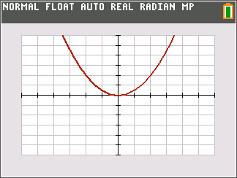
Problem 2 – Translating a Parabola
Press o and enter a(x – b)² + c in Y1. | 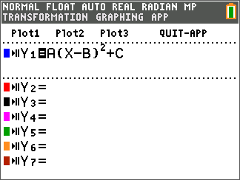
Press q and select 6:Zstandard to get the graph displayed in a normal window. Notice that the variables A, B, and C are listed to the left along with the equation.  To select the variable whose value you want to change, highlight is using the up and down arrow keys and then modify the value as was done in Problem 1.  Experiment with different values for A, B, and C. Notice the changes they result in for the graph of the parabola. Use your observations to answer the questions below. | 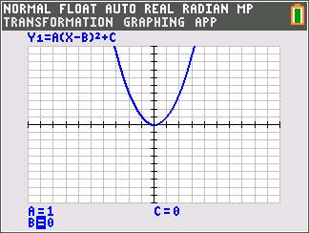
5. What effects do the variables, A, B, and C have on the graph of the equation?

6. What does (B, C) represent?

7. What is the vertex of the graph to the right? | 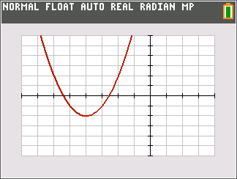
8. What is the vertex of the function f(x) = (x – 3)² + 1?

9. Which of the following functions has (have) a vertex at (–1, 1)?
a(x) = 2(x – 1)² + 1
b(x) = –1(x + 1)² – 1
c(x) = –3(x + 1)² + 1
10. Write an equation with a vertex of (–2, 3). Check your work by graphing.

11. Write a second equation with a vertex of (–2, 3), if possible. If it is not possible, explain why.

Before moving on to the next problem, quit the Transformation Graphing app. Press Œ, select Transfrm, and select 2:Quit Transfrm Graphing.

Problem 3 – Finding Zeros of a Quadratic Graphically
Find the zeros for the equation y = 4 – x² by following the steps below.  Step 1: Enter the equation into the o screen and  press s.  Step 2: Press y [calc] and select 2:Zero. | 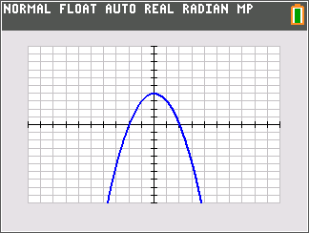
Step 3: Move the cursor to the left of the zero and  press Í.  Step 4: Move the cursor to the right of the zero and  press Í.  Step 5: Move the cursor to your guess of the zero and  press Í. | 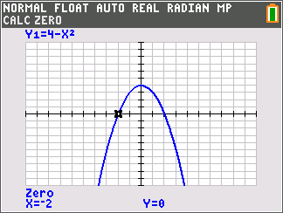
12. What is (are) the zero(s) of the function y = 4 – x²?

13. What is (are) the zero(s) of the function y = x² – 3x – 4?

14. What is (are) the zero(s) of the function y = –x² + 2x + 8?

Problem 4 – Connecting Zeros to the Equation
Find the zeros for the following functions. Be sure to observe how the factored form of the function could be used to find the zeros.
15. y = (x – 1)(x + 3)

16. y = (x – 3)(x – 2)

17. y = (x + 2)²

18. For the factored form equation y = a(x – p)(x – q), what do p and q represent?

19. What are the zeros of the function y = (x – 4)(x + 2)?

