Problem 1 – Discovering the Area of a Regular Polygon Given the Length of Each Side.
In this activity, we will investigate the area of a regular polygon given the length of one side.
1. What is the area of a regular polygon in terms of the apothem and the perimeter?

2. What is the measure of ∠ABC in the regular polygon below?
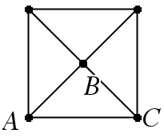
3. What is the measure of ∠ABC in a regular polygon with 5 sides? (Where A and C are consecutive vertices of the polygon and B is the center of the polygon.)

4. What is the measure of ∠ABC in the regular polygon with n sides? (Where A and C are consecutive vertices of the polygon and B is the center of the polygon.)

We will investigate a regular polygon with 3 sides (an equilateral triangle), its center, a vertex of the polygon, and the apothem. Remember, that we are discovering a formula for the area of a regular polygon in terms of the number of sides n and the length of a side s.
5. What is the perimeter of the regular polygon with n sides and sides of length s?

We know the perimeter in terms of the number of sides and the length of a side of a regular polygon. We need to find the length of the apothem in terms of the number of sides and the length of a side. To do this we will use some Trigonometry. Let’s look at the case for n = 3. For Questions 6–9, use the triangle given below.
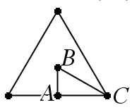
6. What is the measure of ∠B in the equilateral triangle?

7. What is the length of 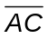 if each side is length s in the equilateral triangle?

8. What is the length of the apothem AB in terms of s? (Hint: Use trigonometry.)

9. What is the area of a regular polygon with 3 sides of length s?

We will now derive the formula for a regular polygon with n = 4. For Questions 10–13, use the figure below.
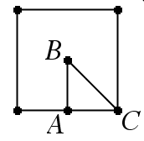
10. What is the measure of ∠B in the square?

11. What is the length of if each side is length s in the square?

12. What is the length of the apothem AB in terms of s?

13. What is the area of a regular polygon with 4 sides of length s?

Next, we will try to find a general formula for the area of a regular polygon with n sides. Now let’s look at a regular pentagon. Try to see if you can find the pattern. Use the figure below for Questions 14–17.
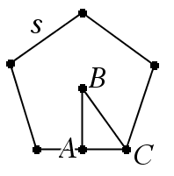
14. What is the measure of ∠B in the regular pentagon?

15. What is the length of if each side has length s?

16. What is the length of the apothem AB in terms of s?

17. What is the area of a regular polygon with 5 sides of length s?

Lastly, we will discover the formula for a regular polygon with n sides each of length s.
18. What is the measure of ∠B in the regular polygon with n sides? Assume that B is the center of the polygon and ∠B is formed with the apothem and a vertex of the regular polygon.

19. What is the length of if each side of the regular polygon with n sides is length s? Assume that AB is the apothem where ∠B is the center of the regular polygon and A is on a side of the regular polygon and that C is a vertex of the polygon.

20. What is the length of the apothem AB in terms of s for a regular polygon with n sides?

21. What is the area of a regular polygon with n sides each of length s?

Problem 2 – Applications of the Area of a Regular Polygon
You will now be asked several questions applying the formula you derived in Problem 1. Round your answers to two decimal places.
22. Find the area of the regular polygon given below with sides of length 2 centimeters?
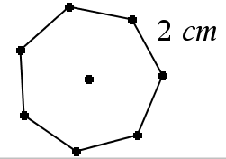
23. Find the area of a regular 25-gon with side length 9 centimeters.

24. Find the area of a regular dodecagon with sides of length 3 inches.

Problem 3 – Real-World Applications of the Area of Regular Polygons
25. A stop sign is a regular polygon with each side a length of approximately 12.5 inches. Find the approximate area of a stop sign.

26. A yield sign is a regular polygon. What is the area of a yield sign if each side is of length 90 cm?

27. The Pentagon Building in Arlington, VA is where the defense department is located. Each side is 921 feet long. What is the area of land that the Pentagon building occupies (including the courtyard in the center)?

28. The Sigil of Ameth is an emblem given to Queen Elizabeth I in the 16th Century by John Dee. The Sigil of Ameth contains a regular heptagon. If each side of the heptagon is 7 cm, then what is the area?

