Math Objectives  - Students will practice and discuss applications of finding the area bounded by a curve and the x-axis.  - Students will apply this information to finding the area bounded by two curves.  - Students will try to make a connection with how to understand these topics in both IB Mathematics and AP Calculus and on their final assessments.  Vocabulary  - Riemann Sums • Underestimate • Overestimate  - Definite Integrals • Bounded Areas • Concavity  About the Lesson  - This lesson involves comparing the Riemann Sum area estimates with the exact bounded area of a curve and the x-axis.  - This lesson is aligned with the curriculum of IB Mathematics Applications and Interpretations SL/HL and IB Mathematics Approaches and Analysis SL/HL  - This falls under the IB Mathematics Core Content Topic 5 Calculus:  5.5a Introduction to integration as anti-differentiation of functions and its link between definite integrals and area  5.5c Definite integrals using technology and the area of a region  enclosed by y = f(x) and the x-axis.  5.8 Approximating areas using the trapezoid rule (IB AI only)  5.11a/b Definite integrals and area between curves (IB AA only)  - As a result, students will:  - Apply this information to real world situations  TI-Nspire™ Navigator™  - Transfer a File.  - Use Class Capture to examine patterns that emerge.  - Use Live Presenter to demonstrate.  - Use Teacher Edition computer software to review student documents.  - Use Quick Poll to assess students’ understanding.  Activity Materials  - Compatible TI Technologies: TI-Nspire™ CX Handhelds,  TI-Nspire™ Apps for iPad®, TI-Nspire™ Software | 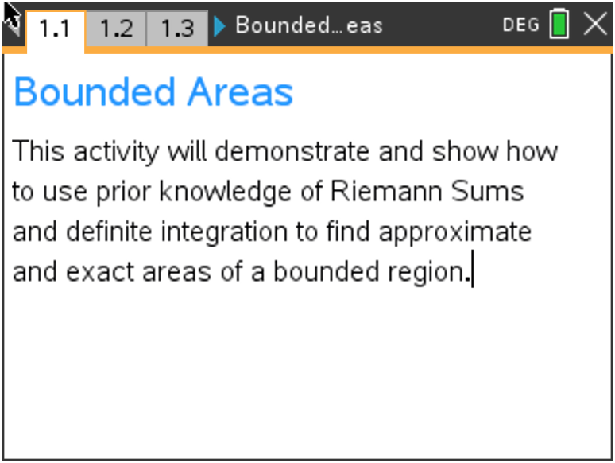  Tech Tips:  - This activity includes screen captures taken from the TI-Nspire CX handheld. It is also appropriate for use with the TI-Nspire family of products including TI-Nspire software and TI-Nspire App. Slight variations to these directions may be required if using other technologies besides the handheld.  - Watch for additional Tech Tips throughout the activity for the specific technology you are using.  - Access free tutorials at http://education.ti.com/calculators/pd/US/Online-Learning/Tutorials  Lesson Files:  Student Activity  Bounded_Areas_Student-Nspire.pdf  Bounded_Areas_Student-Nspire.doc  TI-Nspire document  Bounded_Areas.tns
Teacher Tip: Students should have worked with Riemann Sums and
Definite Integrals prior to this activity.

Move to page 1.2  On this page, the function $f\left(x\right)= x^{2}+2$ is being discussed. You will use the subsequent pages to refresh your skills on left-hand rectangle, right-hand rectangle, midpoint rectangle, and trapezoidal Riemann Sums given the bounded area between $f(x)$, the x-axis, and the vertical lines x = 1 and x = 3. For the remainder of this activity, we will call this bounded area $A(x)$. |  | 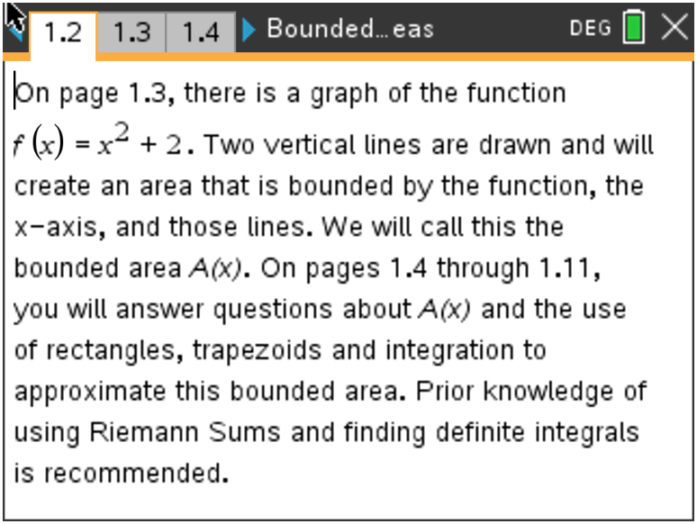
Move to page 1.3  This is a visual of the bounded area, $A(x)$. |  | 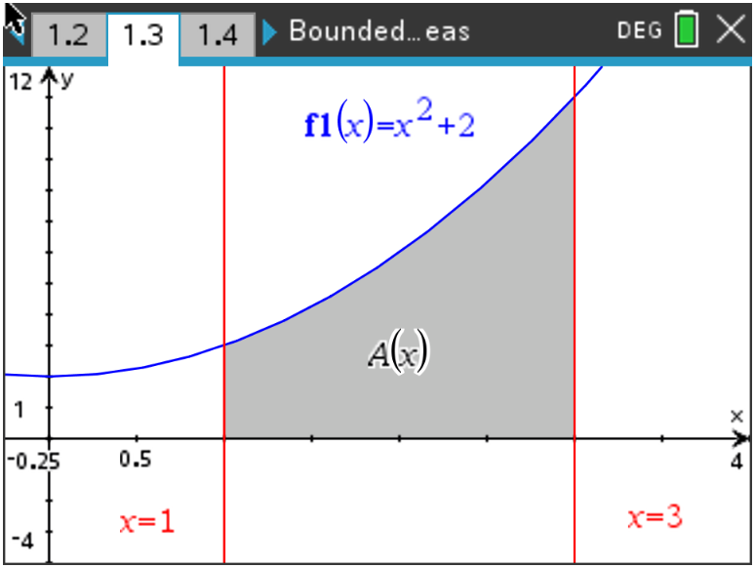
Move to page 1.4  1. Using the four left-endpoint rectangles provided on this page, find their sum total area between the curve and the x-axis. State if this is an underestimate or overestimate of the bounded area A(x).  Explain your reasoning.  Sample Answer: Sum Total Area- 10.75, this is an underestimate due to the graph increasing, making the left sum an underestimate of the actual bounded area between the x-axis, f(x), x = 1, and x = 3. |  | 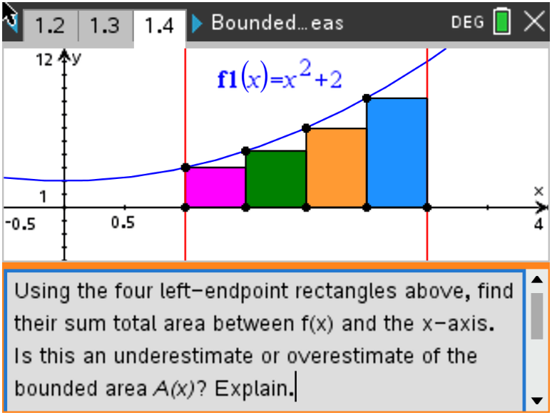
Teacher Tip: When finding the area of each rectangle, remember that the base is the x width of each rectangle (0.5) and the height is f(left endpoint x-value).

Move to page 1.5  2. Using the four right-endpoint rectangles provided on this page, find their sum total area between the curve and the x-axis. State if this is an underestimate or overestimate of the bounded area $A(x)$.  Explain your reasoning.  Sample Answer: Sum Total Area- 14.75, this is an overestimate due to the graph increasing, making the right sum an overestimate of the actual bounded area between the x-axis, f(x), x = 1, and x = 3. |  | 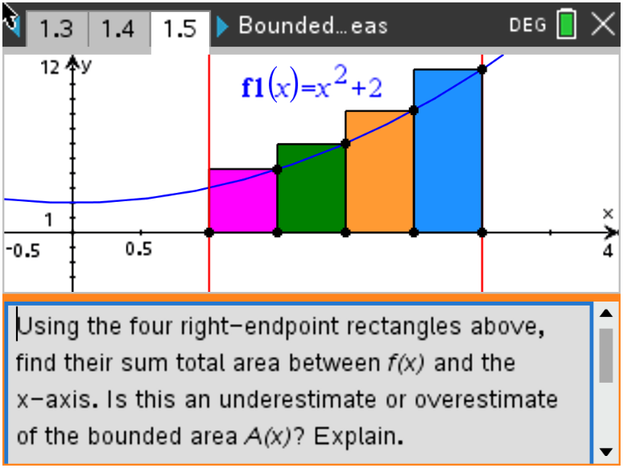
Move to page 1.6.  3. Using the four midpoint rectangles provided on this page, find  their sum total area between the curve and the x-axis. State if  this is an underestimate or overestimate of the bounded area  $A(x)$. Explain your reasoning. |  | 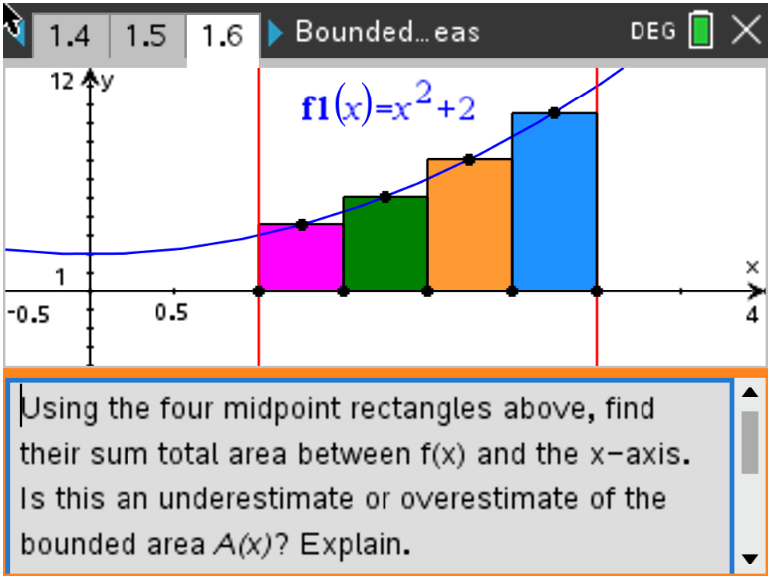
Sample Answer: Sum Total Area- 12.625, this is an underestimate due to the graph being concave up, making the midpoint sum an underestimate of the actual bounded area between the x-axis, f(x), x = 1, and x = 3.

Move to page 1.7.  4. Using the four trapezoids provided on this page, find their sum total area between the curve and the  x-axis. State if this is an underestimate or overestimate of the bounded area $A(x)$. Explain your  reasoning.  Sample Answer: Sum Total Area- 12.75, this is an overestimate due to the graph being concave up, making the trapezoidal sum an overestimate of the actual bounded area between the x-axis, f(x), x = 1, and x = 3. |  | 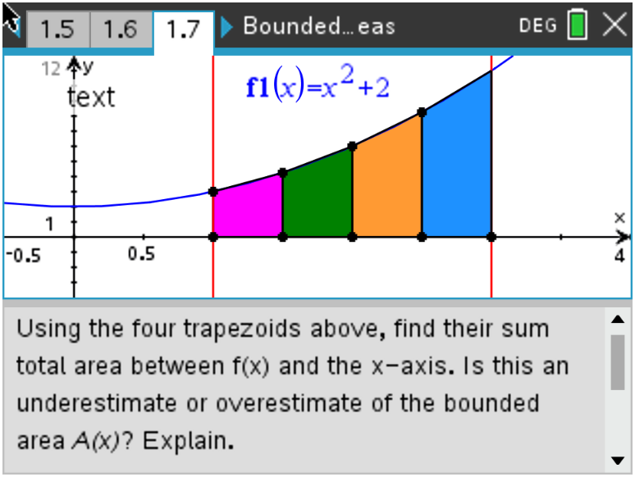
Teacher Tip: Using the Area of a trapezoid formula,
A = 0.5(b₁+ b₂)h, the height in this case is the x width of each trapezoid (0.5) and the bases are f(left endpoint x-value) and f(right endpoint x-value).

Move to page 1.8.  5. Looking back on the last four questions, pages 1.4 - 1.7, state  which you think is the most accurate for the area, $A(x)$. Explain  your reasoning.  Sample Answer: Since students have not yet found the exact area, answers may vary. The differences are:  Left Sum: 12.67 – 10.75 = 1.92 under  Right Sum: 12.67 – 14.75 = -2.08 over  Midpoint Sum: 12.67 – 12.63 = 0.04 under  Trapezoidal Sum: 12.67 – 12.75 = -0.08 over  It seems that the Midpoint Sum in this case is the closest. |  | 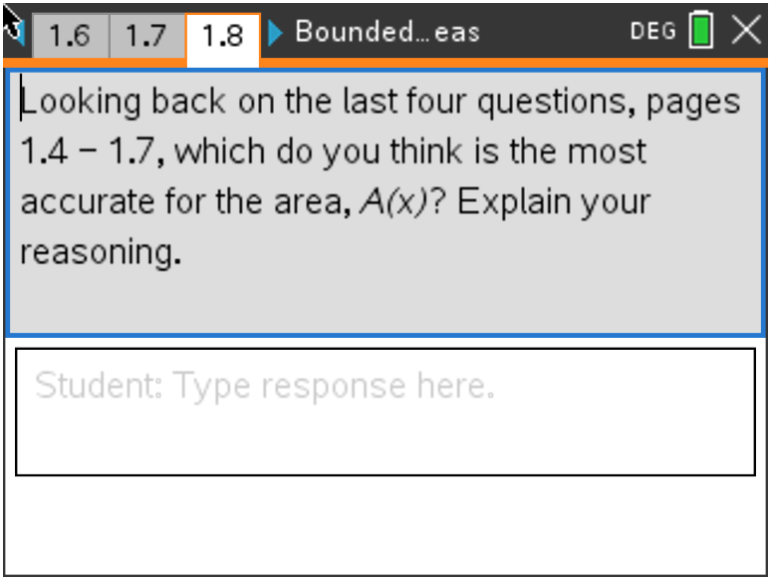
Move to page 1.9.  6. With your classmates, explain how we can use integration to  find the exact bounded area.  Sample Answer: You can find the definite integral of f(x) using the boundaries x = 1 and x = 3. This will find the exact area between the curve and the x-axis between 1 and 3.  Move to page 1.10.  7. On page 1.11, use your handheld to find the exact area on the  graph page and on the calculator page. Explain why the  answers are or are not the same.  Answer:  Graph (Top): Menu > 6 Analyze Graph > 7 Integral, then move your dotted line to x = 1 and press the center of your touchpad. Move your dotted line to x = 3 and press the center of your touchpad. The shaded region is the area.  Calculator (Bottom): Menu > 4 Calculus > 3 Integral, then fill in the boundaries with 1 and 3, the expression with f(x), with respect to x.  Area of the bounded region (definite integral) = 12.67 |  | 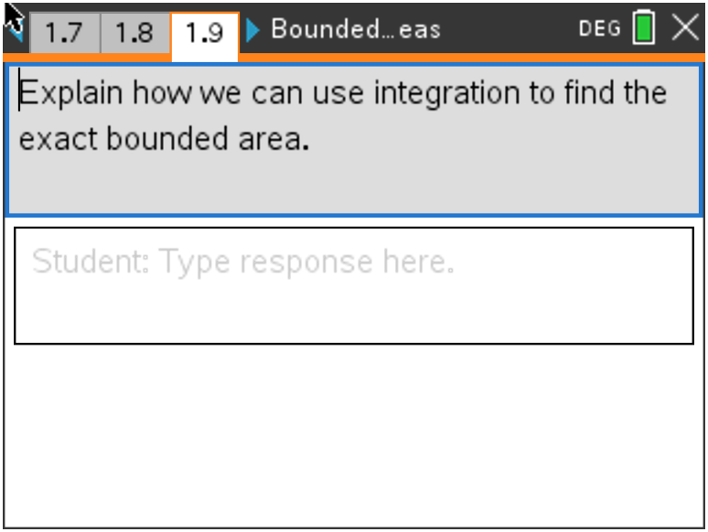  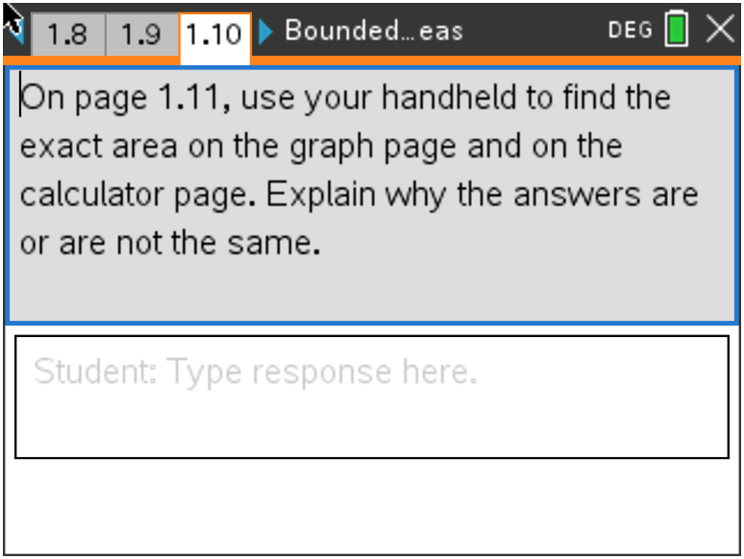  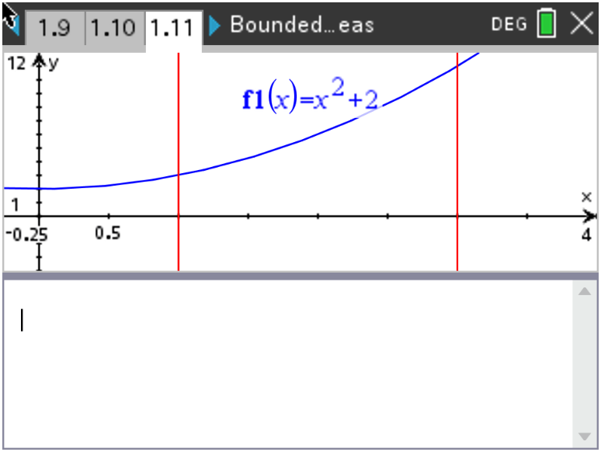
Extension

Move to page 1.12.
Discuss with one another what would happen if:

8. The function was $f\left(x\right)= {-x}^{2}+2$ instead;

Sample Answer: Students should discuss that if the boundaries are kept the same (x = 1 and x = 3) that some of the area will be above the x-axis and some below. They should also discuss that the function is now deceasing which may affect which sums are overestimates and underestimates.

9. The number of rectangles/trapezoids was doubled;

Sample Answer: Students should discuss that if the number of rectangles or trapezoids went from 4 to 8, the sum total areas will be more precise and closer to the actual area of the bounded region.

10. The function was $f\left(x\right)= {-x}^{2}-2$;

Sample Answer: Students should discuss that this function is a reflection over the x-axis and will give the identical areas as the original function, just the opposite of each answer.

11. The x-axis and vertical lines were no longer the boundaries, but a second function,
$g\left(x\right)= {-x}^{2}+4$, was. Describe how you would find this area.

Sample Answer: This would be a great opportunity to have the students discuss that the definite integration that they have been using was actually finding the area between two curves. The first was the given function, the second was the line y = 0 (the x-axis). They could then discuss the subtraction of the two functions as part of the integral expression set up and the points of intersection as the boundaries.

Application  A couple building a house want to make a statement with their front door. They are considering multiple  shapes for the entrance. They find the standard rectangular doorway to be boring. One shape that piqued their interest was an arch. The door is the shaded region modeled by the function  $f\left(x\right)=\frac{1}{3}(8-x)(x-2)$, bounded by the x-axis and $f\left(x\right)$.  (a) Write down an integral for the shaded region.  Answer: $\int_{2}^{8}{\frac{1}{3}(8-x)(x-2)} dx$  (b) Find the area of this shaded region.  Answer: Area = 12 | 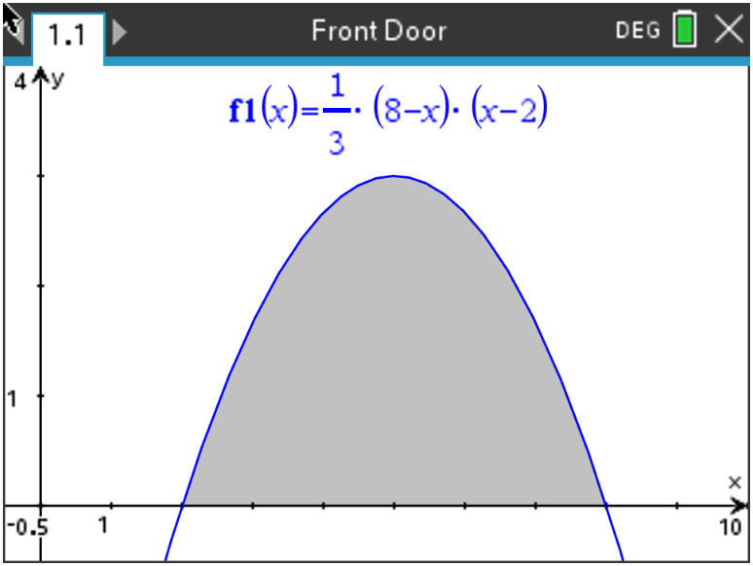
The couple have always been fascinated by triangles. Below is the rendering of how a triangular entrance would look. The three vertices are given as P(0, 2.5), Q(5, 4), and R(c, 0). | 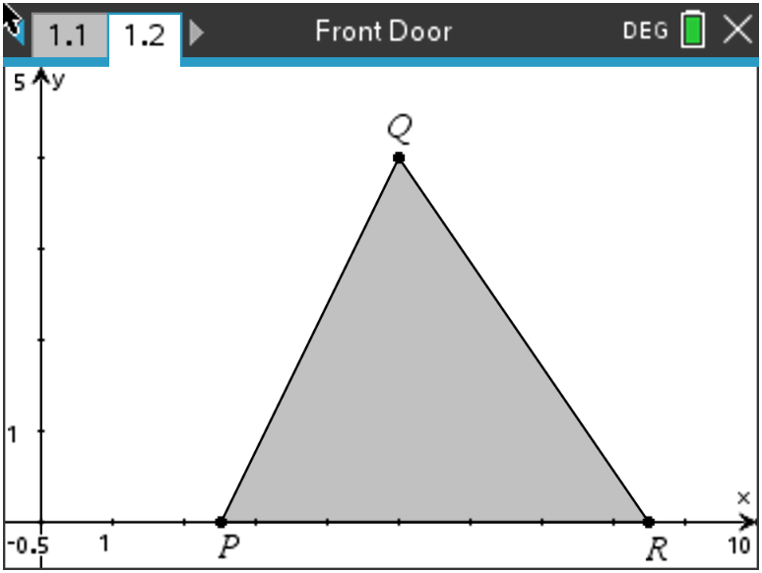
(c) Find the value of c, the x-coordinate of R, such that the area of the triangle is equal to the area of the region found in part (b).

Answer: 12 = 0.5 (c – 2.5)(4)
c = 8.5
Wrap Up
Upon completion of the discussion, the teacher should ensure that students are able to understand:
- How to compare Riemann Sums and explain overestimates and underestimates.
- How to find and compare definite integrals to Riemann Sum estimates.
- How to apply bounded areas to the real world.

TI-Nspire Navigator
Name of Feature: Quick Poll
A Quick Poll can be given at several points during this lesson. It can be useful to save the results and show a Class Analysis.
A sample question:
Briefly explain how limits can be used to approximate a more exact answer when using Riemann Sums.

**Note: This activity has been developed independently by Texas Instruments and aligned with the IB Mathematics curriculum, but is not endorsed by IB™. IB is a registered trademark owned by the International Baccalaureate Organization.

