Lesson Overview
In this activity, students investigate where to locate a food truck in Washington DC to maximize the number of potential customers. Possible sites are eleven points of interest, chosen either because of tourist attractions in the area or because of the density of businesses and office buildings in the area. Students examine data such as population density, the average daily foot traffic, the number of permanent residents in the area and balance that with the cost of parking a truck in a given location, the distance from the storage site to possible locations and the cost of two different storage sites. | Learning Goals
Students will be able to:
1. Recognize the value of using data to make informed decisions
2. Identify strategies for standardizing values of variables representing different units and different magnitudes
3. Understand that different graphical representations can reveal different information about the context
4. Identify strategies for using multiple variables in analyzing situations

About the Lesson and Possible Course Connections:
This activity is designed to involve students in considering a variety of data that can be used to make a decision. Analyzing the data can involve graphs, fractions, proportional reasoning, linear equations, and basic notions of probability. The fourth example of student work illustrates an application of z-scores for students who are familiar with statistics. Because the question can be approached from many different angles, the activity would be appropriate as an individual or group project for students at different levels and could easily be tied to a social studies or economics lesson.
CCSS Standards

Ratio and Proportional Relationship Standards
- 6.RP.A.3.D
- 7.RP.A.1

Statistics and Probability Standards
- 6.SP.B.5.
- HSS.ID.A.1
- HSS. ID.B.5

Expressions and Equations Standards
- 7.EE.B.4

Algebra Standards
- HSA.CED.A.2
- HSA.CED.A.3
Mathematical Practice Standards

SMP.4

Lesson Materials
Compatible TI Technologies:
TI-84 Plus*; TI-84 Plus Silver Edition*; TI-84 Plus C Silver Edition; TI-84 Plus CE
* with the latest operating system (2.55MP) featuring MathPrint TM functionality
TI-Smartview CE software
- Food Truck_Teacher Notes.doc
- Food Truck_Teacher Notes.pdf
- Food Truck_Student Data Sheet.doc
- Food Truck_Student Data Sheet.pdf
- Food Truck Data.8xp (displays as FTDLS on the calculator)
Background
Washington DC is the capital city of the United States making it a popular tourist destination and home to government offices and many other businesses that thrive from being in the US capital. DC is also a beautiful city with parks and plazas inviting people to stop and rest and perhaps eat, taking advantage of one of the many food trucks throughout the city that cater to a wide variety of tastes. Suppose a prospective food truck operator (Truckr) is considering 11 sites in the city for a new food truck (Figure 1):
- DuPont Circle (1), popular residential neighborhood with unique shops, restaurants and museums, near Embassy Row, home to many foreign embassies
- Federal Triangle (3), L’Enfant Plaza (5), Farragut Square (2), areas near major office centers
- Foggy Bottom (4), home of many federal offices including the state department and near Georgetown University and the Kennedy Center
- Tourist attractions such as the Mall (6), near the African America Museum; the Wharf (10) at the waterfront; Navy Yard (8), near National Stadium, home of the Washington Nationals baseball team; and Woodley Park Zoo (11)
- Metro Center (7), the hub of the Metrorail system in downtown DC, close to shopping and some tourist attractions
- Union Station (9), the railroad station
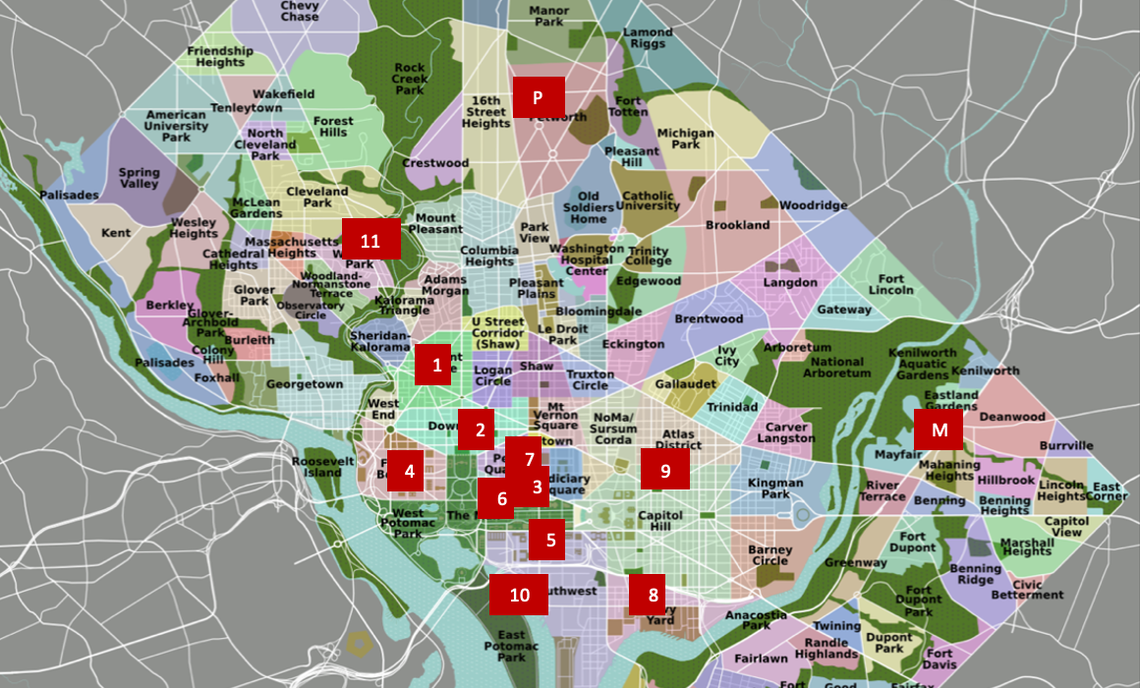
Figure 1 Potential food truck sites

The Truckr will need to have a commissary, an established commercial kitchen where food Truckrs and food service providers go to prepare and store food, park their vehicles and store their equipment overnight. The commissary rates at the two being considered are: Mayfair, M, $490 a month; Petworth, P, $125 per week. The Truckr will also have to pay to park the truck at the site during hours when food is being sold. This can be done in three ways, depending on the site:
- Lottery $25 per month to enter; $150 a month fee and approximately 180 spaces allocated in the lottery each month with typically about 450 food trucks that could take part in the lottery
- Street parking metered, $2.50 an hour; one site offers three hours for $2.
- Lot parking $250 month average

Data collected that might have some bearing on the number of potential customers and the cost involved in choosing a site include the following (84 CE List Name):
- Population (POP)
- Population density (DENS)
- Foot traffic (average number of visitors and workers) during weekdays and weekends (WVPD)
- Median Income (INCM)
- Number other food trucks typically at site (FTRKS)
- Monthly cost to park* (PCOST)
- Number of hotels within 0.25 miles, around two blocks (HTLS)
- Distance to two commissaries, one located in Petworth and the other in Mayfair (DMF, DPW)
- Number of metro fares per weekday and per weekend day at closest stop (MFPWD, MFPSS)
*Note that those sites with a monthly fee of $175 are lottery sites.

The Food Truck Data.8xp program file contains these data for the 11 sites, and the data can also be found on the student data worksheet at the end of the activity. The Truckr believes that the most profit will occur when the number of possible customers is maximized and the cost is minimized. Use the data to decide which of the 11 sites the Truckr should choose to park the truck and whether to house the truck at Petworth or Mayfair.

Note: Some costs are constant for every truck (license, cost of inspections, etc.), and
the type of food offered and the price of a meal are other factors the potential Truckr has to consider. These are not part of this investigation, but students might pursue them as an extension to the activity.

Teacher Tip: This activity involves many and very different variables, similar to an investigative task in data science. Students may choose some of the variables as relevant and not others; they may want to investigate other possible variables. Some will find creative ways to arrive at what they think would be an optimal site to locate a food truck. The examples below are only suggestions that highlight possible avenues for thinking about the task.
At the end of the investigation, students might make a poster defending their choice for locating a food truck to be shared with the class. The posters should attend to the assumptions made, clarity of the message, use of visual representations, creativity and method of analysis. The posters could be critiqued by another team and revised as part of the process. Sharing the final products with the class can be accompanied by a class discussion about the differences and similarities across the posters, highlighting ideas and the way they are portrayed that seem particularly useful or relevant in making an informed decision.

Facilitating the Lesson
- Open-Ended Approach:

Students can be given the data and asked to think about how they might approach the problem. After some individual think time, students should share their thoughts in groups of two or three. To prevent the task from being overwhelming, students might be encouraged to make a list of the factors they think would be important in choosing a site. They might also think about ways to organize, combine and graph the data. The only constraint is that they should be able to justify their reasoning in a convincing fashion.
2) More-Structured Approach to Finding a Model:
The teacher might lead the class through the following exploration.

Suppose the Truckr investigates possible sites for locating a food truck during the week, when people are at work and tourists are exploring the city. While the number of potential customers is the goal, the Truck also has to consider the expenses associated with parking the truck at a site and the location of the commissary to facilitate traveling back and forth each day and the potential cost for each commissary.
What to Expect: Example Student Approaches
With technology:  Example 1: Graphs can provide some insight into both the potential number of customers and the costs associated with parking and storing the truck. The program, FTDLS, will load the data for the variables with regard to each site into named lists as given above (Figure 2). The sites are denoted by a number from 1 to 11 as indicated in Figure 1. (Note: To access the named lists use 2nd list (stat) NAMES.) | 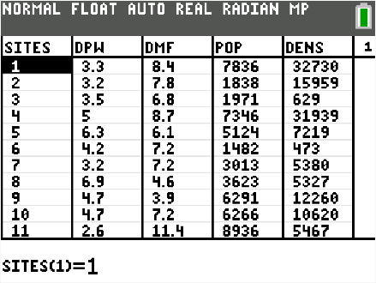  Figure 2 Data for potential food truck sites
Use statplot to plot the sites with population density (SITES, DENS); number of workers/visitors (SITES,WVPD); and the number of people using the metro stop nearest each site on a week day (SITES, MFPWD). Trace will identify any ordered pair in the plot, for example, (1, 18573) gives the average number of metro fares per day for DuPont Circle (Figure 3). Arrowing up or down displays the variables for a given site.  From this perspective, three sites - Farragut Square, Union Station and Dupont Circle - have the largest number of potential customers during a week day. | 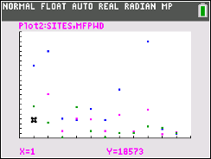  Figure 3 Potential number of customers considering population, population density, number of workers/visitors and weekday metro fairs
There are three costs of concern to the Truckr:  - The cost to park the truck at a site.  - The cost to house the truck at the commissary.  - The cost of a daily round trip between the commissary and the site.  One way to find the total costs associated with driving to and from a commissary is to estimate the cost of gas for driving a round trip to each site. The assumptions here are that the truck gets 10 miles per gallon and gas costs $4 per gallon. Figure 4 displays the calculation for inserting a column for the daily cost of commuting to and from Mayfair (CTOM). Note: Storing the formula for a calculation can be done by enclosing the formula in quotations. This will allow students to refer back to the calculations to know what they computed and make adjustments as necessary. | 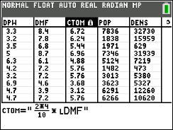  Figure 4 Computing daily cost of commute to and from each site
Suppose the Truckr wants to compute the total cost of operations on a monthly basis. Accounting for 30 round-trips per month, the daily parking rate and adding in the monthly fee for each commissary gives an estimate of the total cost for each commissary per month, TOTMF and TOTPW (Figure 5), | 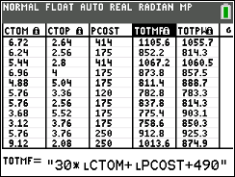  Figure 5 Travel cost +parking + commissary fee for  Mayfair
Figure 6 displays the total monthly costs associated with each commissary. The least cost for the Petworth Commissary is the Mall followed by Farragut Square; Union Station has the smallest costs for the Mayfair Commissary followed by the Navy Yard. Maximizing the potential number of customers and minimizing the costs associated with each site would suggest choosing Union Station. However, Union Station is a lottery site as are Navy Yard, Farragut Square, and the Metro Center. Parking is allowed only with a lottery permit; there are about 180 spots and as many as 450 trucks eligible for the sites. This means about a 40% chance of getting a permit, where each of the lottery sites is assigned at random for those winning the lottery. Students should consider these factors when deciding on where to locate a food truck. | 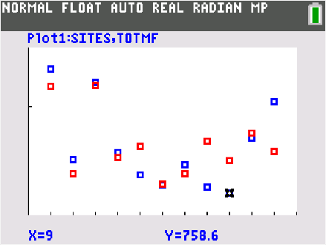  Figure 6 Monthly cost of travel and commissary fee for Petworth and Mayfair
Example 2  The example above did not use all of the given information. One way to use more information is to rank each category from 1 as the most desirable to 11, the least desirable (Figure 7). Ranking can easily be done by hand using the data sheet. Students can enter the sum of the ranks for each site into a new list, which produces an overall view of how the sites ranked across the variables. (Student rankings might differ slightly depending on how students handle ties, etc.) | 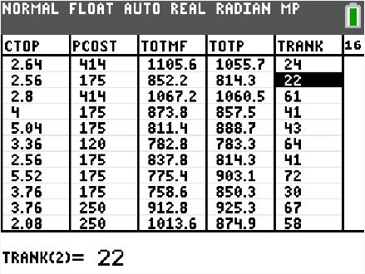  Figure 7 The sum of each rank for the categories related to potential customers for Farragut Square
Figure 8 illustrates the total sum of the ranks for all of the categories related to potential customers with Farragut Square top ranked (smallest sum) most often followed by Dupont Circle and Union Station. Note that summing the ranks assigns equal value to each of the variables. | 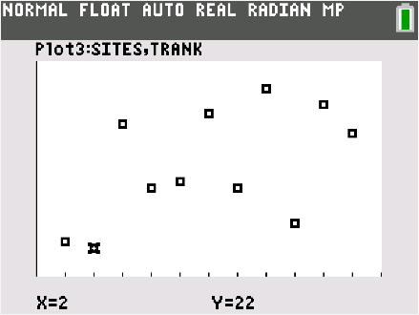  Figure 8 Sum of rankings for variables related to potential customers by site
Including ranks for the total cost of operations out of either commissary, Farragut Square ranks best regardless of commissary. Union Station and Dupont Circle rank second using Petworth, and Union Station ranks second followed by Dupont Circle using Mayfair. Any decision should also consider the cost of renting space at each of the commissaries. | 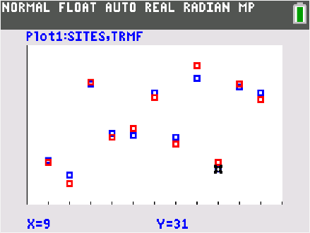  Figure 9 Rankings by site including distance to Mayfair and Petworth
Questions for students to consider:
- The number of food trucks allowed or typically present at a site is one of the variables. As a potential food Truckr, would you like this number to be high or low? Explain your reasoning.
- Were any of the rankings “outliers” for a site (e.g., one category with a high ranking and all the others low or vice versa)? Would this affect your analysis? Explain why or why not.
- What is “lost” by using rankings instead of the actual data values? What is gained?

Example 3  Because the variables in each category have very different units and magnitudes (e.g., dollars, number of people), finding a common method to standardize them so they can be compared is important. Ranking as described in Example 2 is one way to consider the variables without the impact of units and magnitude. Another way to do this is to rescale each of the values for a given variable in terms of the “best”; for example, the site with the largest permanent population is the Zoo with 8,936 people living nearby. Dividing each of the populations by 8936 gives the proportion of the population at each site with respect to the population near the Zoo; for example population divided by maximum population (Figure 10). The formula for RPOP is stored by wrapping the equation in quotations. The maximum of a list can be computed using the max( operation under 2nd > Lists> Math. | 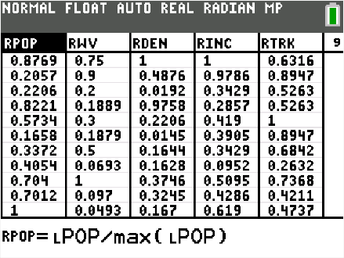  Figure 10 Scaling variables in a category with respect to the optimal value for that variable
A scatterplot of the scaled values for the variables population density, number of metro fares per weekday, and number of visitors/workers shows the distribution of the rescaled values. Tracing selects a site and one of the variables, for example, (Farragut Square, Workers/visitors) in Figure 11. The scaled values for density and metro fares will be directly above and/or below the highlighted point. Dupont Circle, Farragut Square and Union Station have relatively high scaled values compared to the “best” for these three variables. Farragut Square is either first or second with respect to most of the variables related to the potential number of customers.  Note: Conclusions drawn from this will vary depending on which variables are used to compare across sites. | 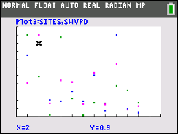  Figure 11 Farragut Square position with respect to scaled values for population density & number of metro fares and visitors/workers
The total monthly cost for each site by commissary can be computed and compared to the scaled categories for potential customers (Figure 12). | Figure 12 Total costs including monthly parking and commissary fees
Displaying these data indicates how the sites compare on total cost for parking, travel, and commissary fees (Figure 13). | 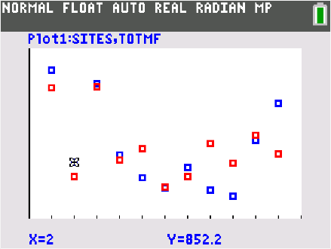  Figure 13 Highlighting monthly cost for Farragut Square and Mayfair

To compare some of the other scaled variables, students might make a second plot to compare hotel rank, weekday metro fares, and number of other food trucks as in Figure 14. From Figures 11, 13, and 14, Farragut Square and Union Station emerge as strong candidates with respect to potential customers and total cost. As noted above, Farragut Square and Union Station are both lottery sites: parking is allowed only with a lottery permit, and the chances of getting a permit could be a factor in choosing a site to locate a food truck. | 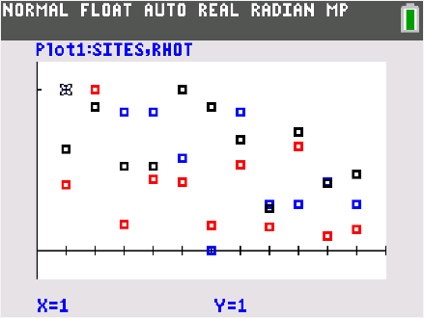  Figure 14 comparing hotel rank, weekday metro fairs, and number of other trucks
In addition to or in place of graphing, students might look at the scaled values in the spreadsheet to see which sites are closest to the top in the most categories. A table might be useful to organize the information. The table below shows that Farragut Square has the most categories ranked first and second and that it is close to Petworth, followed by Dupont Circle. Note that Union Station would move up if the number of third place rankings were included.

Table 1 Scaled ranks in terms of the “best” for each variable
Site | Total number of first/second rank | Closest to Mayfair | Close to Petworth
Dupont Circle | 4 |  | √
Farragut Sq | 6 |  | √
Federal Triangle | 2
Foggy Bottom | 2
L’Enfant Plaza | 1
Mall | 0
Metro Center | 2 |  | √
Navy Yard | 0 | √
Union Station | 2 | √
Wharf | 1
Zoo | 1 |  | √
Example 4  Another method for standardizing variables with different units and magnitudes is to express the average value (mean) of the variable in terms of the typical variability, the standard deviation, from the mean. This is called a z-score. Transforming all of the data values for each category using the formula $=\frac{value-mean(values)}{stdev(values)}$ in the list for a given category will give values that are unitless and can be combined without worrying about magnitude (Figure 15). Note the commands for mean and standard deviation are under list MATH. | 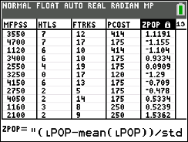  Figure 15 Transforming the data into z-scores
Once the variables are transformed, they can be combined by adding them and displaying the results in scatterplot of (SITES, ZSUM) as in Figure 16. From this perspective, Farragut Square and Dupont Circle are farthest above the average in terms of z-scores. Union Station is third by some distance. Note that finding the sum of the z-scores by adding the values suggests each variable is equally important. | 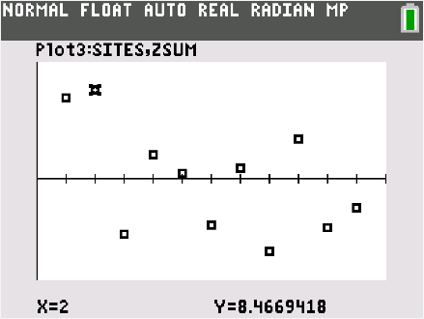  Figure 16 Summing z-scores for each variable related to potential customers
Teacher Note: Some of the variables that seem more important could be “weighted” using coefficients that essentially give more weight to some of the variables than to others. See the activity Judging a Poster Contest (https://education.ti.com/en/timathnspired/us/mathematical-modeling/ratings) for suggestions on different ways to deal with ranked data.
Finally, students should include the costs and distance to the commissaries in making their choice. For example, Figure 17 shows a scatterplot of total cost and the sum of the z-scores of potential customers for using the commissary at Petworth. Looking for low total cost and high sum of z-scores for potential customers, again, Farragut Square, Union Station, and Dupont Circle are of interest. Note that Dupont Circle is the most expensive of those three. | 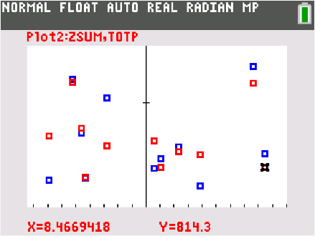  Figure 17 Scatterplot of z-scores for variables involving potential customers and costs for Petworth
Validating the Models
Students should validate their models either by asking whether the models make sense in different scenarios related to the context or by finding other information to reflect against the model. The suggestions below might be useful in helping students think about whether their model was reasonable:
- How did your results compare to those who used other strategies to analyze the information? If your results were clearly different, is your argument flawed in some way?
- Would your argument convince someone else (such as a potential funder) that you have made a good decision? If not, what else might be needed? (You might share your decisions and reasons for making those decisions with your family or other adults and see what they think about your reasoning.)
Extension

- Interview the owner of a local food truck. Ask the Truckr how they chose the location they did, and what are its advantages and disadvantages.
- Some data suggests that age might be an important variable in those who choose to eat at a food truck. Survey a sample of high school students, young adults, parents, and grandparents to see if this might be the case.
- What other data might be useful in making an informed decision about where to locate a food truck? Why would it be useful? Search to see if you can find the information you identified.
- Consider how the time of year might affect your choice of location for a food truck. Do you think the site you choose would be the optimal site year around? Why or why not?
- Identify a location in your community you think would be optimal for a food truck. Collect the data needed to support your choice.

- Distance is often measured in time- the length of time it will take to get from one location to another. Particularly in big cities, the time will vary depending on the day. The website below gives the distance and the time between locations at the time you do the search. Make a conjecture about the time of day when traveling between Dupont Circle and Petworth that will take the least amount of time and the longest time. Check the website to verify your conjecture.
https://www.google.com/search?client=safari&rls=en&q=distance+from+Dupont+Circle+in+DC+to+Petworth+DC&ie=UTF-8&oe=UTF-8
- Read one of the following and report what you found interesting to the class. Did the article suggest anything useful that might affect your choice of location in the activity?
  - Mobile Cuisine: Food Truck Fun Facts at https://mobile-cuisine.com/did-you-know/food-truck-fun-facts/

Foodie. (May 17, 2018). Impressive Facts on the Food Truck Industry https://www.food.ee/blog/12-impressive-facts-on-the-food-truck-industry/

How successful food trucks choose the best locations. Restaurant Engine. https://restaurantengine.com/food-trucks-choose-best-locations/

Summary Table for data related to food trucks in Washington DC. Note that the data are estimates, typically based on information collected prior to 2020.
 | Sites | Distance Petworth (miles) | Distance Mayfair (miles) | Pop | Density (pop per sq mile) | Income (med) | Workers- visitors/ week day | # Metro fares week day (avg) | #Metro fares weekend day (avg) | # Hotels within 2.5 blocks | Food trucks | Truck Parking costs per month*
1 | Dupont Circle | 3.3 | 8.4 | 7836 | 32730 | 105000 | 75000 | 18573 | 3550 | 7 | 12 | $440 ($2.30/hr, 6 hrs day for 30 days)
2 | Farragut Square | 3.2 | 7.8 | 1838 | 15959 | 102705 | 90000 | 45514 | 4700 | 7 | 17 | *$175
3 | Federal Triangle | 3.5 | 6.8 | 1971 | 629 | 36000 | 20000 | 7381 | 1120 | 6 | 10 | $440 ($2.30/hr, 6 hrs day for 30 days)
4 | Foggy Bottom | 5 | 8.7 | 7346 | 31939 | 30000 | 18890 | 20121 | 3400 | 6 | 10 | **$175
5 | L’Enfant Plaza | 6.3 | 6.1 | 5124 | 7219 | 44000 | 30000 | 19343 | 2550 | 4 | 19 | **$175
6 | Mall | 4.2 | 7.2 | 1482 | 473 | 41000 | 18789 | 7149 | 3250 | 0 | 17 | $120 ($2/3 hr, for 6 hrs a day)
7 | Metro Center | 3.2 | 7.2 | 3013 | 5380 | 36000 | 50000 | 24330 | 4150 | 6 | 13 | *$175
8 | Navy Yard | 6.9 | 4.6 | 3623 | 5327 | 10000 | 6930 | 6843 | 2750 | 2 | 5 | *$175
9 | Union Station | 4.7 | 3.9 | 6291 | 12260 | 53500 | 100000 | 29371 | 4050 | 2 | 14 | *$175
10 | The Wharf | 4.7 | 7.2 | 6266 | 10620 | 45000 | 9698 | 4008 | 1160 | 3 | 8 | **$250
11 | Woodley Park Zoo | 2.6 | 11.4 | 8936 | 5467 | 65000 | 4931 | 5861 | 2100 | 2 | 9 | **$250
*Lottery $25 per month to enter; $150 a month fee
** Assume lot parking, $250 month avg.
Street parking metered, $2.30 an hour with exception of the Mall, $2.00/3 hrs.

Metro data collected Feb 2016 AND https://www.wmata.com/initiatives/ridership-portal/Rail-Data-Portal.cfm
http://vn4.cs.fiu.edu/cgi-bin/gnis.cgi?Lat=38.92470845896335&Long=-77.05070299938015&vid= pop, density, med income
https://silo.tips/download/washington-dc-s-lottery-rotation-system-for-food-trucks-a-step-in-the-right-dire
https://www.census.gov/geographies/reference-files/2010/geo/state-local-geo-guides-2010/districtofcolumbia.html

