Example of Geometric Sequence  The height that a ball rebounds to after repeated bounces is an example of a geometric sequence. The top of the ball appears to be about 4.0, 2.8, 2.0, and 1.4 units. If the ratios of consecutive terms of a sequence are the same, then it is a geometric sequence. The common ratio r for these values is about 0.7. | 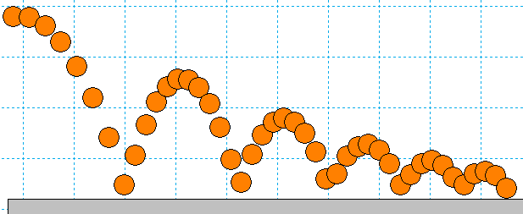
Problem 1 – Changing the Common Ratio
Explore what happens when the common ratio changes.  Start the Transfrm App. Press o and for Y1, enter 4∗A^(X–1).  Change your settings by pressing p and arrow right to go to SETTINGS. Set A = 0.7 and Step = 0.1.  Graph the function by pressing q and selecting ZStandard. Change the value of the common ratio (A).  1. Discuss why you think the r-value is called the common ratio.  2. With a classmate observe what happens when you change the common ratio from positive to negative. Explain why this happens.  3. If each output from this function was a term in a geometric sequence, describe what would happen if you added all the terms of this sequence. Explain what common ratio conditions that would be needed so that the sum will diverge, (get larger, and not converge to some number). Use the table functions on the handheld as an aid. |  | 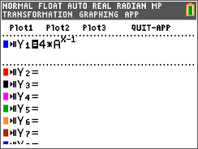  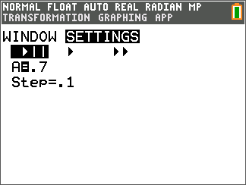
4. When the common ratio is larger than 1, explain what happens to the graph and values of y.

5. Discuss with a classmate the r-values that could model the heights of a ball bounce. Share your
results with the class.

Problem 2 – Changing the Initial Value and the Common Ratio
Press o and change Y₁ to B∗A^(X–1).  Change the p SETTINGS so that A=0.7, B=4 and Step=0.1.  6. Explain your observations of what happens when $b$ changes. Describe, in the context of a real world problem, what $b$ is also known as.  7. Discuss with a classmate which variable seems to have a more  profound effect on the sequence. Share your results with the  class.  Further Discussion  If time permits, Discuss how the bouncing ball data was  generated in the picture at the beginning, making connections to the modeling of real world quadratic data, quadratic transformations, and gravity. Finally, discuss how the bouncing ball connects to geometric sequences. |  | 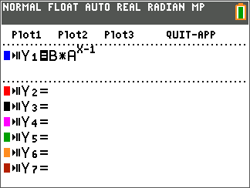
Extension – Deriving and Applying the Partial Sum Formula
The sum of a finite geometric series can be useful for calculating funds in your bank account, the depreciation of a car, or the population growth of a city.
e.g. $S_{6}=4+8+16+32+64+128$
In this example, the common ratio is 2, the first term is 4, and there are 6 terms.
The general formula:
$S_{n}= a_{1}+ a_{2}+ a_{3}+…+ a_{n-1}+ a_{n}$
Because $a_{n}=r∙a_{n-1}$, substituting gives
$$S_{n}= a_{1}+r∙a_{1}+ r^{2}∙a_{1}+ r^{3}∙a_{1}+…+ r^{n-2}∙a_{1}+ r^{n-1}∙ a_{1}$$
$$r∙S_{n}=r∙ a_{1}+ r^{2} ∙ a_{1}+r^{2} ∙ a_{1}+…+ r^{n-1} ∙ a_{1}+ r^{n} ∙ a_{1}$$
Subtract the previous two lines.
$S_{n}-r ∙ S_{n}= a_{1}- r^{n} ∙ a_{1}$
$S_{n}\left(1 -r\right)= a_{1}(1 - r^{n})$
So, $S_{n}= a_{1} ∙ \frac{1 - r^{n}}{1 - r}$

Use the formula to find the sum of the following finite geometric series.
8. Find $S_{5}$ for $a_{n}=6{\left(\frac{1}{3}\right)}^{n-1}$.

9. =

10. Find $S_{25}$ for $a_{n}=2{\left(1.01\right)}^{n-1}$.

11. =

Further IB Extension
Mac was trying out a new cheesecake recipe. Once completed, he will be serving it to his family. Loving
the are of math, he decides to cut the slices using the cheesecake’s volume. Each slice will represent a
term in a geometric sequence, with the smallest being cut first.
The second smallest slice has a volume of $80 {cm}^{3}$. The fourth smallest slice has a volume of $1280 {cm}^{3}$.
- Find the common ratio. [2 marks]

- Find the volume of the smallest slice. [2 marks]

- The cheesecake has a total volume of $27,300 {cm}^{3}$, find how many family members get to try
Mac’s delicious cheesecake.
[2 marks]

