Part 1 – Sequences and Scatter Plots
Press … Í and enter the data shown at the right into L1 and L2.  - L2 shows a finite sequence with six terms.  - L1 shows the term numbers. | 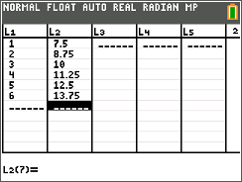
Find the differences between consecutive terms of the sequence in L2 and record them in L3.  - For the first difference, in the first row of L3, subtract the second term of L2 from the first by typing L2(2)–L2(1). Do this for the next four rows: L2(3)–L2(2), L2(4)–L2(3), etc. | 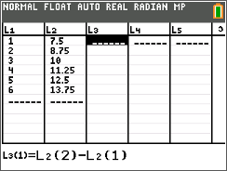
Now enter the data shown at the right into L4.  - L4 shows a finite sequence with six terms.  - L1 shows the term numbers for this sequence.  Find the consecutive differences for L4 sequence and record them in L5. | 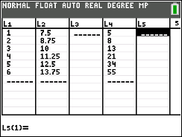
Graph the sequences in L2 and L4.  Press y o [stat plot] and select Plot1. Change the settings to those shown at the right. | 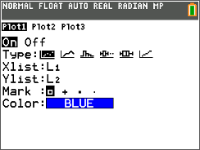
Press y o [stat plot] and select Plot2. Change the settings to those shown at the right.  Press q and select 9:ZoomStat. | 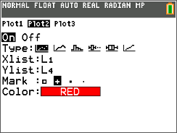
1. For each sequence, write the differences between the consecutive terms and give a description of the scatter plot.
a. Sequence L2

b. Sequence L4

c. Study the graphs and the differences you found in L3 and L5. Make a conjecture.

Clear the data from L2, L3, L4, and L5. Leave the natural numbers in L1.  - Enter the two new sequences shown at the right into L2 and L4.  - Recalculate the differences between consecutive terms and record them in L3 and L5.  Press q and select 9:ZoomStat. | 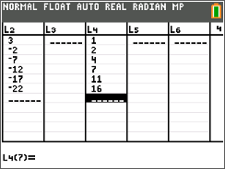
2. For each sequence, write the differences between the consecutive terms and give a description of the scatter plot.
a. Sequence L2

b. Sequence L4

c. With a classmate, discuss how your observations affect your conjecture about the scatter plot of a sequence and the differences between the consecutive terms. Share your discussion with the class.

Part 2 – Explicit Formulas and Sums
An arithmetic sequence is formed by adding a fixed number, called a common difference $(d)$, to each previous term (this number can be positive or negative).
The explicit formula for the nth term in an arithmetic sequence is
$u_{n}= u_{1}+ \left(n-1\right)∙d,$
- $u_{n}$ is any term of a sequence
- $n$ is the term number
- $u_{1}$ is the first term
- $d$ is the common difference
You can use this formula to calculate any term in an arithmetic sequence.
Generate a sequence in L₂ to display the first 30 terms of  $u_{n}=7.5+ \left(n-1\right)∙1.25$.  - Clear the data from L2, L3, L4, and L5. Leave the natural numbers in L1.  - Arrow to the top of L2 and type and press y … [list]. Arrow over to the OPS menu and select seq(.  - Enter 7.5 + (N–1)·1.25. Press Í and input the information on the right, pressing Í after each entry. Once in the List Editor, Press Í again.  Note: N is selected by using the ƒ key. | 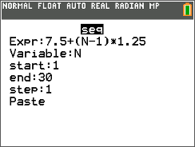
3. Simplify the formula $u_{n}=7.5+ \left(n-1\right)∙1.25$ by distributing and combining like terms. Use this formula in the sequence command to generate 30 terms of this sequence in L3.
Explain what you notice about the terms in L2 and L3.

Part 3 – Practice Finding the Sum of a Series
The expression consisting of summing the terms in a sequence is called a series. To find the finite sum of the first $n$ terms of an arithmetic sequence algebraically, you will use the formula: $S_{n}= \frac{n}{2}\left(2u_{1}+ \left(n-1\right)∙d\right) or S_{n}= \frac{n}{2}\left(u_{1}+ u_{n}\right)$  To check your sum, you can use the handheld and on the home screen enter sum(L2).  The Sum command can be found by pressing y … [list], moving to the MATH menu and selecting sum(. | 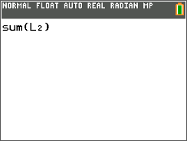
4. Find the sum of the first 30 terms of this sequence in L₂ algebraically. Check your result using the sum command.

5. Now, let’s look at another sequence. Find the sum of the first 80 terms of the sequence below, using the Lists feature and the sum() command.
62, 67, 72, 77, 82…
a. Find the explicit formula for this sequence in simplified form.

b. Find the sum of the first 80 terms.

Further IB Extension
The Clemson Tigers football team play in the multilevel Memorial stadium. The closer you are to the field, the higher the ticket prices. The ticket prices for the first 4 rows of a Tigers football game are as follows:
Row 1: $120 per ticket; Row 2: $117 per ticket; Row 3: $114 per ticket
These ticket prices continue in an arithmetic pattern.

(a) Find the common difference between each consecutive row price. [1 mark]

(b) Calculate the price of a ticket in row 20. [2 marks]

(c) Find the total cost of buying 2 tickets in each of the first 20 rows. [3 marks]

