Topic 4: Statistics and Probability | Probability and Tree Diagrams
- If Amanda gets up on time, the probability that she walks to school is 0.90. If Amanda gets up late, there is a 0.25 probability that she gets a ride with her father. The tree diagram below represents the probabilities of these scenarios. Amanda wakes up on time at a probability of 0.7.

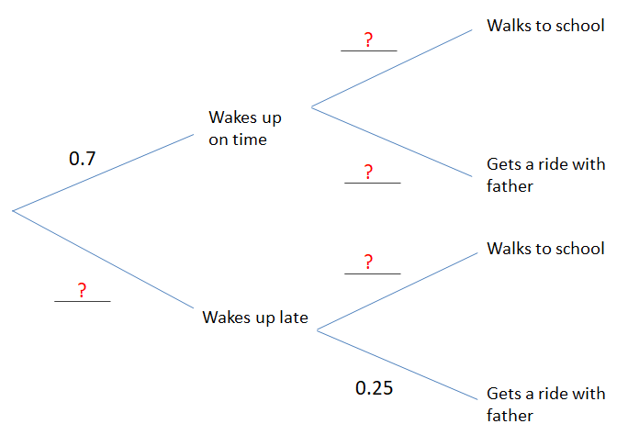
- Complete the tree diagram  - Find the probability she walks to school |  | (3 marks)  (3 marks)

Mark scheme:
(a)
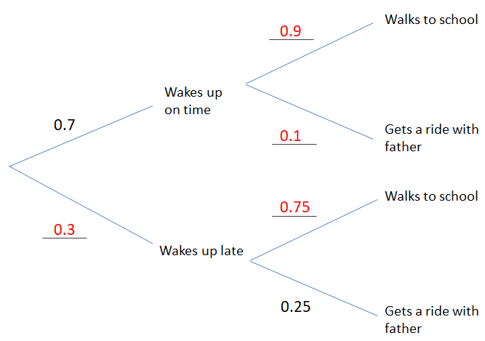
(A1)(A1)(A1) for each correct pair
- $\left(0.7\right)\left(0.9\right)+(0.3)(0.75)$  $$=0.855$$ | (A1)(M1)  (A1)

