Fraction Tic Tac Toe
In this project, you will create a fraction tic tac toe game. The tic tac toe board and scoring code have already been written for you in the “TicTacTo.8xv” file. You will write the code to generate fraction addition, subtraction, multiplication and division problems. You will also write the code to request the user’s answer. The user must answer the question correctly to earn a new spot on the board. The computer always earns a new spot, so math carefully! | Objectives:
Programming Objectives:
- Use variables to store values
- Use the randint() function to generate integers
- Use the print() function to display
- Use a while loop to repeat code.
Math Objectives:
- Add and subtract fractions with unlike denominators.
- Multiply and divide fractions.
- Add, subtract, multiple, and divide fractions with positive and negative values.
Math Course Connections: Middle School Mathematics
In this project, you will create a fraction tic tac toe game. The tic tac toe board and scoring code have already been written for you in the “TicTacTo.8xv” file. You will write the code to generate fraction addition, subtraction, multiplication and division problems. You will also write the code to request the user’s answer. The user must answer the question correctly to earn a new spot on the board. The computer always earns a new spot, so math carefully!
User given fraction problem | If answered correctly, earns an “x” | Computer plays “o”. Next question.
 |  | .……
User enters incorrect answer. Lose a turn. Computer gets to place “o”. | User answers correctly, gets to choose a location on the board. | …….Game continues until someone …….wins or spaces are filled.

- Obtain the “TicTacTo.8xv” from your teacher. Part of the programming code has been coded for you.
- Let’s examine the code template.  Checks tic tac toe board for a winner  Determine and display current board  Code checks if answer is correct  *You write code to create 2 new fractions using the function above. Generate a question, show the question, get the user’s answer  *You write code to create one fraction  Libraries needed for the project |  | 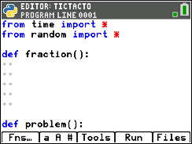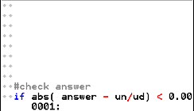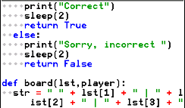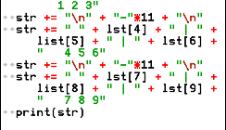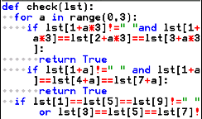  (Continues on the next page)  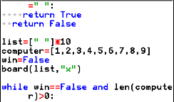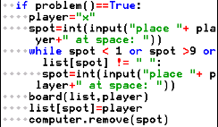  Loop generates multiple rounds of player and computer play  Create the initial tic tac toe board  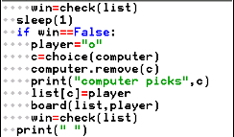  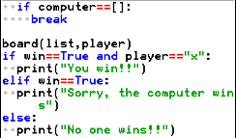  Display the winner
- The first step to create your fraction tic tac toe game is to create a fraction.  To create positive numerator values from 1 to 10, you would write the code  n = randint(1,10). To create the numbers 3 to 7 it would be n = randint(3, 7).  You will create integer values from -10 to 10.  Write the following line of code to generate a number from -10 to 10 and store it in a variable n. Write this line under the def fraction() function.  n = randint(-10,10)  *randint is in the menu Fns Modul random randint()  *Make sure n is on the left side of the equation. When programming, the variable goes on the left, the math goes on the right. |  | 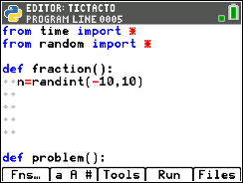
- For this game, we do not want to allow the numerator to be a zero.
You’ll write a loop that generates a new value for n while it equals zero.
Add the lines: while n==0:
n=randint(-10,10)
**while is in the menu Fns Ctl while
**You can type n = randint(-10,10) or you can copy and paste the line you already coded. To copy, Tools 6 Copy Line. To past, Tools Paste Line Below
- The denominator should be an integer between 2 and 10. Because we are not making zero an option, we won’t need a loop to make sure it doesn’t happen. Add a line of code that creates a variable d with values between 2 and 10.

- Did you add the line:  d = randint(2,10) |  | 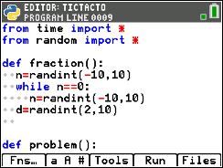
- The last step to creating a fraction is to put the numerator and denominator together. Because this is code is written inside a definition named fraction, we will return the fraction so it can be used in other parts of the code.  You will write return str(n) + “/” + str(d). The numerator and denominator are both integers while the sign “/” is a string. To put these two data types together, you must write str(n) and str(d) to treat the numbers as characters.  Add the line:  return str(n) + “/” + str(d)  **return Fns return  **str() Fns type string  ** “ “ [alpha] [+] |  | 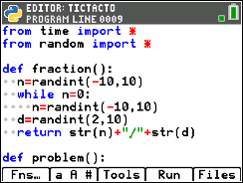
- Now to create a question.  Go to the second function def problem(). Create two fractions, f1 and f2.  Add the lines:  f1 = fraction()  f2 = fraction()  **You can type both lines, or you can copy and paste to get the second line.  Tools6 Copy Line Tools7 Paste Line Below |  | 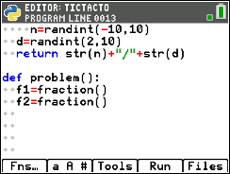
- Now to determine the type of question. The function choice() will select a random item from items within the parenthesis. To randomly select an operation and store the sign choice, type:  s = choice([“+”,“-“,“*”,“/”])  *choice Fns Modul random choice  *[ ] [2nd][*] and [2nd][-] |  | 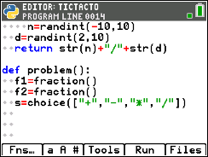
- You have the two fractions, f1 and f2, and an operation s.  Now to print them to the screen.  print(f1 + “ ” + s + “ ” + f2 + “ =”)  **print Fns I/O print |  | 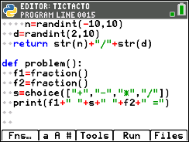
- After printing the fraction question, the user needs to enter an answer.  Ask the user to input the numerator. The result in a variable named un, short for user’s numerator.  un=int(input(“numerator”))  **int Fns Type int  **input Fns I/O input  **If you don’t put int() around the input() Python will treat your answer like characters instead of integers! |  | 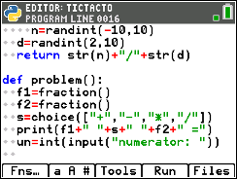
- Add another line to ask for the denominator. Store the result in a variable named ud, short for user’s denominator. (This should look similar to the line from step 11.)
- The last step is to calculate the real answer to the question. The code has already been written to check the real answer against the user’s input. We just need to calculate the correct answer.  Add:  answer=eval( "(" +f1 + ")" + s + "(" + f2 + ")" )  **eval Fns I/O eval  If typed correctly,  All the plus signs should appear in red when you are done.  All the “(“ and “)” should appear in green. |  | 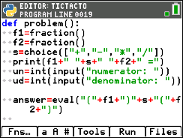
- You’re done! Unless you have errors, when you Run ([Trace])
Play the game several times. Can you beat the computer each time?

